 | MONDAY | TUESDAY | WEDNESDAY | THURSDAY | FRIDAY
BREAKFAST  SNACK | Biscuits with Assorted Jelly  Sliced Peaches  Milk | Scrambled Eggs & Breakfast Potatoes  Apple Slices  Milk | Fruit Pastry  Bananas  Milk | French Toast  Applesauce  Milk | Rice Chex  Melon  Milk
LUNCH | Salisbury Steak with Gravy  Green Beans  Mixed Berries  Milk | Chicken Pasta with Alfredo Sauce  Broccli  Orange Wedges  Milk | Chicken Nuggets  Baked Beans  Peaches  Milk | Beef Pasta with Marinara Sauce  Steamed Green Peas  Mixed Melon  Milk | Turkey Sandwich with Sliced Cheese On Whole Wheat Bread  Cucumbers  Strawberries  Milk
AFTERNOON SNACK | Animal Crackers  Diced Pears  Water | Yogurt Cup  Strawberries  Water | Graham Crackers  Applesauce  Water | Wheat Crackers Sliced Peaches  Water | Soft Oatmeal Cookie  Applesauce  Water
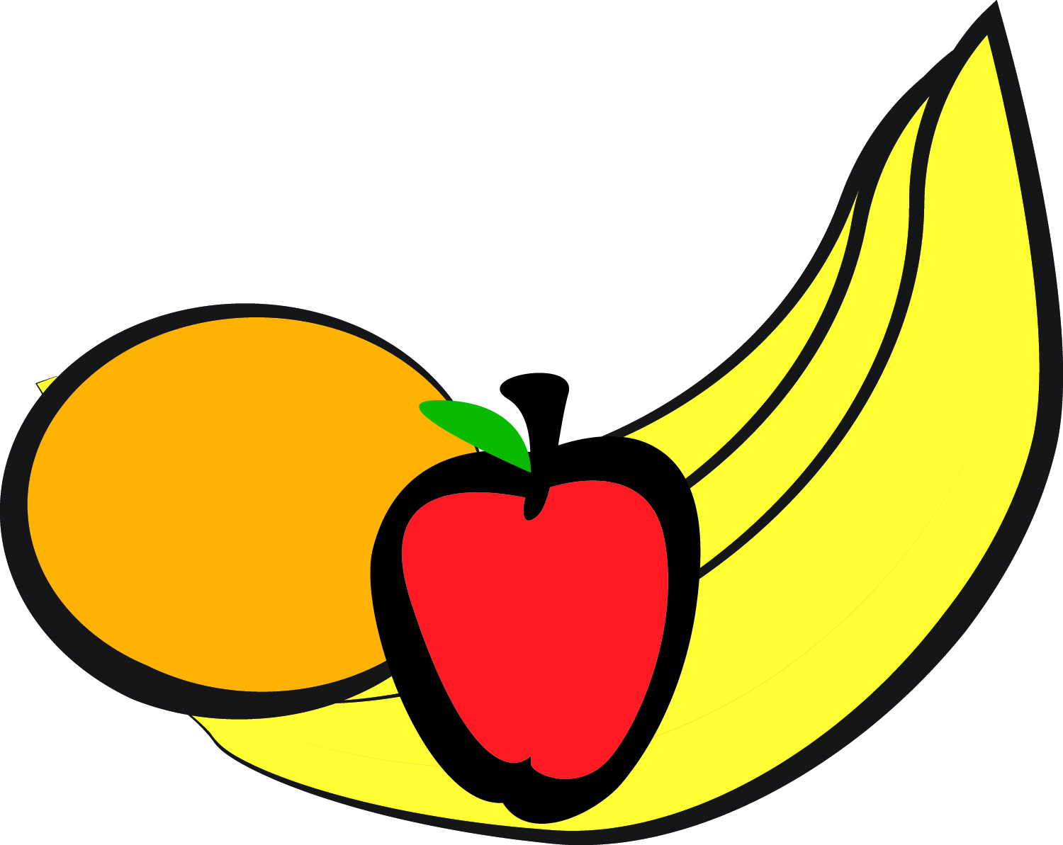
Approved Fruit Substitutions: Melon, Berries, Peaches, Pears,
Bananas, Oranges, Pineapple, Apple Slices, Applesauce

Late Afternoon Snack (After 5:30 pm) – Gold Fish, Wheat Crackers, Fruit Bars, Trail Mix, Cheerios
Menu #2
Spring/Summer Menu

