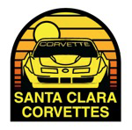
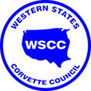
Cool Weather
Guaranteed!

“Malcolm’s Madness” AUTO-X
ALL CARS WELCOME!!
Saturday and Sunday July 14-15, 2018
MARINA Municipal Airport, Marina, CA
Imjin Road off Reservation Road 93933

TYPE II WSCC AUTOCROSS*
HOST: SANTA CLARA CORVETTES (SCC)
5 runs per driver: Entry fee: $50.00 WSCC Members $45.00
MALCOLM LAWTON – (408) 464-1538 mbl123@hotmail.com
Set-up: 7:00 – 9:00 AM on Saturday
Registration: 8:00 AM – 12:00 PM
Drivers’ Meetings: ~ 9:15 AM & 12:45 PM
Sat. & Sun. Morning Run Groups: ~ 9:30 AM – 12:00 PM
Sat. & Sun. Afternoon Run Groups: ~ 1:00 PM – 3:30 PM
Tear Down Sunday, immediately following completion of
Run Groups All help will be appreciated.
Further details at http://www.sccorvettes.org/Events/Calendar.aspx
or contact Malcolm Lawton
Register ahead at Motorsportreg.com
* Championship Points for WSCC Corvettes – Fun Runs for All Others

