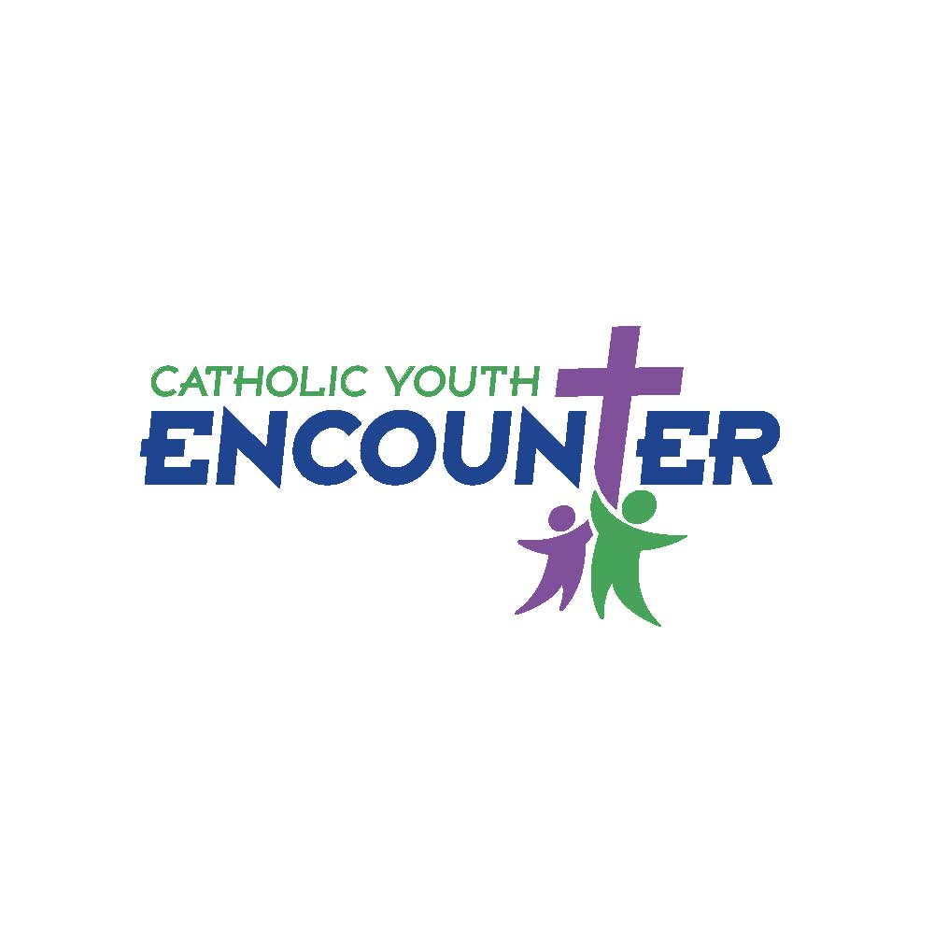

INTENT TO PARTICIPATE FORM

Parish/ School__________________________________________Town_________________________________

Main Contact ____________________________________________ Position ____________________________

E-Mail __________________________________________________ Phone ______________________________

Registration
________ @ $25.00 = _____________ | By June 30th
________ @ $30.00 = _____________ | By August 31st
TOTAL COST: ______________ | Make checks out to: OEEC – CYE
- Intent RECEIVED - Confirmation E-mailed.
- e-mail added to distribution list
- REGISTRATION FEES RECVD - Confirmation e-mail sent

DINNER & ORIENTATION:
Name of group leader or chaperone(s) attending: ________________________________________
(1 minimum, 2 max) ___________________________

OFFICE USE ONLY:
GROUP ASSIGNMENT: ____ (RED) ____(PURPLE) ____(BLUE) ____ (GREEN)

This form must be submitted by April 30, 2018.
Email this form to: Jill.Cost@aohct.org or by Fax: 860-243-9465
Send payment/check to: OEEC – Catholic Youth Encounter
467 Bloomfield Avenue
Bloomfield, CT 06002

