**From the Director**

I want to thank everyone for your support in helping us celebrate our teaching staff during teacher appreciation month. I know our teachers were very grateful for all of the kindness that you showed them.

We have a busy month planned as we jump into summer. Look for information from your child’s classroom about water days and other fun activities your children will be participating in.

Another focus for the month of June is reviewing and updating our security procedures. Every Bright Horizons center has a series of security protocols and procedures to help guard against any threat to the safety of children and staff, and we perform safety drills on a regular basis. We do everything we can to make our centers safe and secure and to ensure that our teachers and staff are well-trained to protect children in the case of emergency.

Our upcoming parent meeting will cover this topic and our partnership with the Smucker security team. We will discuss the strategies we use to keep our center safe and answer any questions you might have. Please join us on June 21st from 12:00-1:00 in R316 on the Smucker main campus.

****Bright Horizons at The Smucker Development Center****

327 N Mill St. Orrville Ohio 44667

330-684-8560 | [smucker@brighthorizons.com](mailto:smucker@brighthorizons.com)

M-F 6:30-6:00

Reasons to Celebrate

Happy Birthday Farrah -3rd

Happy Birthday Jody- 6th

Happy Birthday Amanda- 14th

Happy Father’s Day- 17th

First Day of Summer- 21st

Bright Horizons at   
The Smucker Child Development Center News

2018 | June Newsletter

Important Dates

4th- Summer Camp Starts

6th- Bubble Lady

7th- Crazy Hair Day

12th- Crazy Sock Day

20th- Tie-Dye Day

21st- Parent Group Meeting

25th- Outback Ray

27th- Field Day

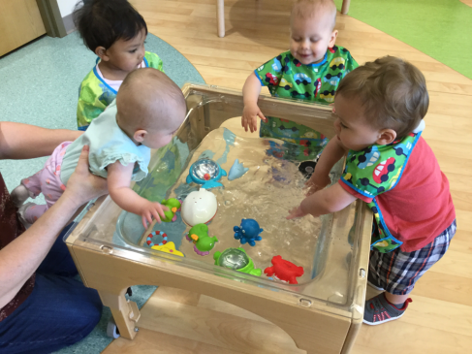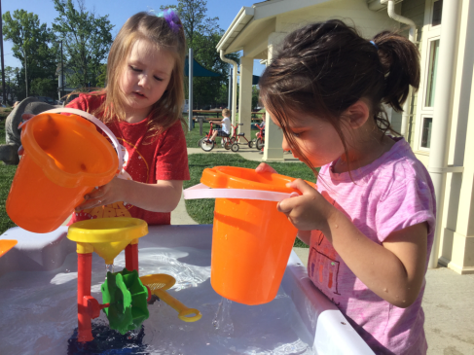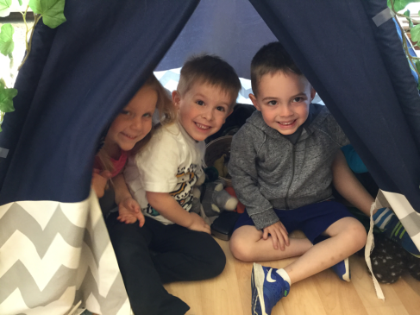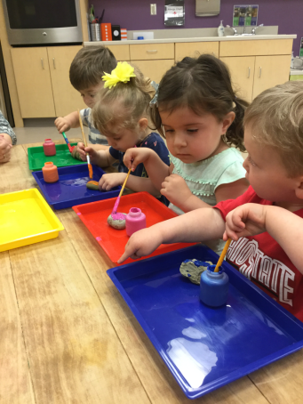

Infant

Room One enjoyed exploring sea animals in their water table. Not only did the children get to explore the wonders of the water, they were also able to squeeze, toss, and watch how the sea creatures floated and moved around in the water.

Toddler

Room Three friends had the opportunity to paint rocks in the project room. The rocks will be placed outside in our garden when they are finished drying. When painting rocks the children are able to express their creativity as well as learning about the properties of natural objects.

Preschool

Preschool friends have been spending a lot of time in their Dramatic Play area while learning about the safari. By incorporating animals they are not familiar with, they learn about new species all over the world. While using props and puppets to act out stories they learn to play cooperatively and be creative all while having fun!

Kindergarten Prep

Warm days usher in fun with water and buckets! Friends used scoops and buckets to make the water wheel spin around and around. As friends had fun in the water, they were discovering the power that water had to make things move when it is being poured or flowing fast.

CLASSROOM HIGHLIGHTS

It’s never too early to start “growing readers”! Research has shown that children who have a close adult who reads to and with them -- especially in the very early years -- learn language and literacy skills, develop an appreciation of books, and experience stronger family relationships.

Reading with your child can be one of the most rewarding and memorable ways to spend time together. In addition to having lasting effects on cognitive, language, and literacy development, sharing books inspires your child’s curiosity and creativity. Cuddling up with a book is an intimate activity that builds strong, loving, lifelong bonds.

**A few tips for reading with your child:**

* Designate a regular time and place to curl up together with a book. Invite your child to select books but also introduce new stories.
* Before you begin a new book, talk about the title, the cover, the author, and the illustrator. Ask thought-provoking questions about the book. "What do you think this story is about?"
* Understand that young children love to hear the same stories over and over again. Repetition provides a level of comfort and enables children to become the experts on the storyline. Also, it allows them to get familiar with the words, and eventually “read” the book to you.
* Make reading interactive; ask questions such as, “What do you think happens next in the story?” Or "How would you handle this situation?” It’s interesting to hear your child’s impression of the story.
* Expand your child’s horizons. When your child develops a new interest, go to the library and find books on that subject.
* Have fun and be playful! When you read aloud, try to make your voice exciting and dramatic for the different parts of the story.

There is so much multicultural, informative, historical, traditional, silly, experiential, and even futuristic literature for young children these days. Refer to “Bright Horizons Growing Readers” to access family resources, books suggestions, at-home reading activities, and tips on reading aloud.

[**www.brighthorizons.com/childrenbooks**](http://www.brighthorizons.com/childrenbooks)





Homegrown Readers

Ready for school News

Learning at Home: Summer Activity

BRIGHT HORIZONS NEWS

Our Learning at Home ideas offer parents fun ways to extend their child's learning opportunities beyond the classroom to take advantage of teachable moments that naturally emerge from everyday life situations.

**Beach in a Bottle** – *Suitable for Kindergarten, Multi-Age, Preschool, School Age, Toddler, Twos*

**You will need:**

A trip to the beach, lake or creek, and supplies: plastic bottle, super glue, permanent marker, and a label

**Directions:**

Have your child fill the bottle with sand and water from the beach, along with their favorite sea shells or small pieces of driftwood. Seal the top using super glue (keep the glue out of your child’s reach and let the bottle dry before using it with them). Label with the date and location of your outing.

[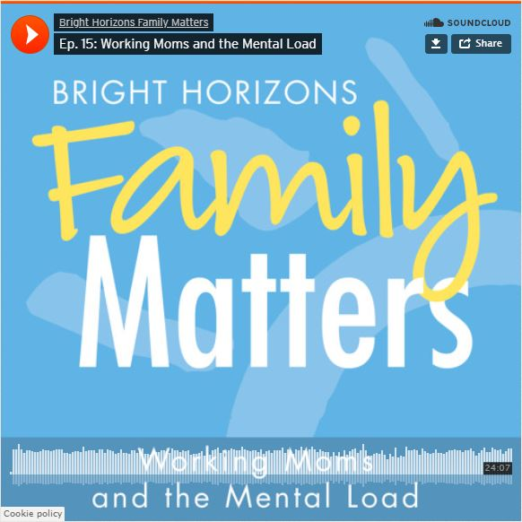](https://www.brighthorizons.com/family-resources/podcasts/working-moms-mental-load)

**New Parenting Podcast Episode!**

Peaceful Parenting on Busy Workdays

We’ve all been there… the get-out-the-door chaos, the after-work frenzy, those toddler-parent moments when things just seem to go kaboom! Is there a better way? Parenting expert and psychologist Jennifer Gillette says unequivocally… yes.

On this episode of the *Work-Life Equation*, Gillette has the tips, tricks, and strategies to tame the tantrums and put what she calls Peaceful Parenting back into your busy day.

[**Ep. 17: Peaceful Parenting on Busy Workdays**](https://soundcloud.com/user-48566546/ep-17-peaceful-parenting-on-busy-workdays)[www.brighthorizons.com/peacefulparenting](http://www.brighthorizons.com/peacefulparenting)



Check out all the places you can connect with us!

