

|  |  |  |  |  |  |  |  |
| --- | --- | --- | --- | --- | --- | --- | --- |
| **July 2019** | | | | | | | |
| **ADVENTURE TOPIC** | | **MONDAY** | **TUESDAY** | **WEDNESDAY** | **THURSDAY** | **FRIDAY** | |
| **STEM Works**  ***Space*** | | 1 | 2 | 3  4th of July parade | 4  Center Closed in Observance of Independence Day | 5  MOSH Visit/  Planetarium | |
| **STEM Works**  ***Space*** | | 8  STEM project/Building a space shuttle | 9 | 10  Moon Craters Experiments in MPR | 11 | 12  Displaying our space shuttles in the MPR | |
| **STEM Works**  ***Ooey Gooey*** | | 15  Explore the Mad Scientist lab! | 16  Ooey Gooey Oily Art | 17 | 18  Slime Time/Making our own slime | 19  Alligator Farm visit | |
| **STEM Works**  ***Ooey Gooey*** | | 22  Magic Color bags | 23  What can blow a bubble? -Experiments | 24  Beekeeper visit 10am/Honey Tasting | 25  Camp snack: Honey Roasted Carrots | 26  Jiggly Gelatin Excavation | |
|  | | | | | |

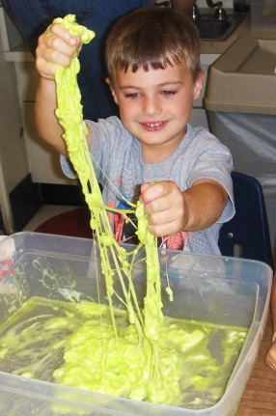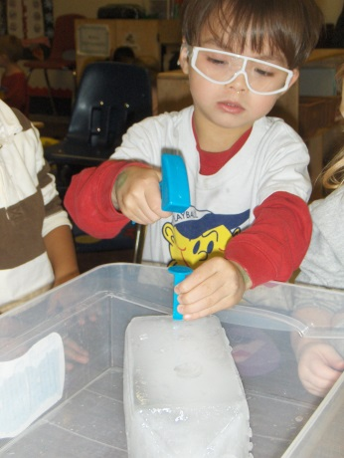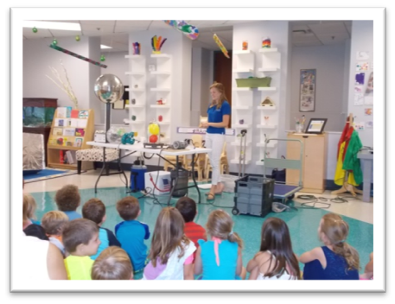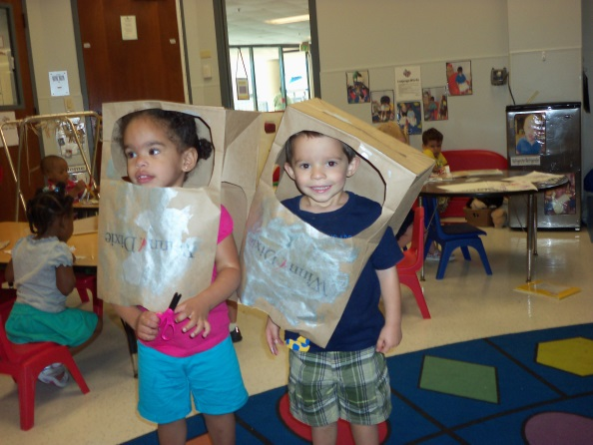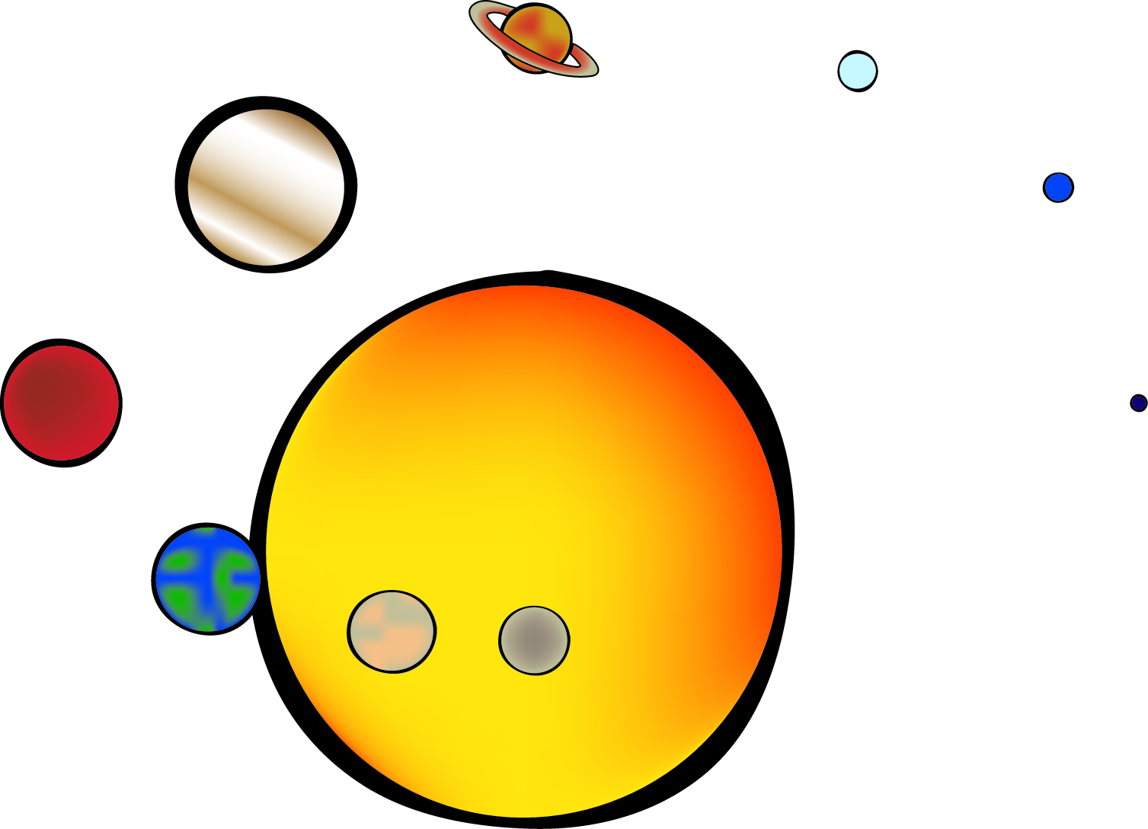­­­

Out of this world. Look up at the sky, explore stars and planets, and imagine alien life and what it would it look like.

So much slime, so little time! There are sensory experiences galore exploring old favorites with a new twist. Be prepared to get gooey up to your elbows!

Bright Horizons at the Avenues | 9000 Southside Blvd, Bldg 1100   
Jacksonville, Fl 32256 | 904-613-5688

avenues@brighthorizons.com | brighthorizons.com/avenues