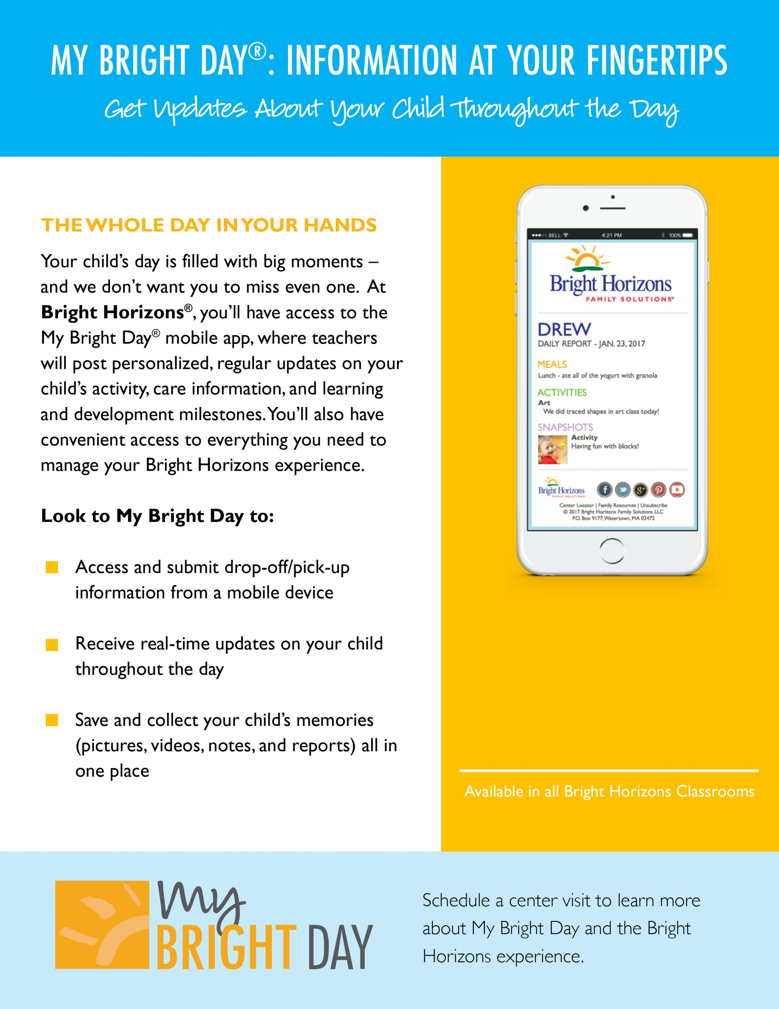

Schedule a center visit to learn more about My Bright Day and the Bright Horizons experience.

Bright Horizons at Courthouse Station  
2000 14th St.  
North Arlington, VA 22201  
(571) 305-5104 courthousestation@brighthorizons.com www.brighthorizons.com/courthousestation