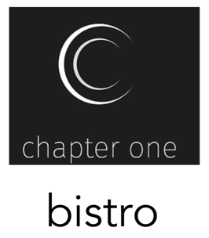

MENU

Home-baked Bread and Salted Butter £3.50
Home-baked Bread, Herb Butter, Tapenade and Aioli £4.50
Nibbles; Sun Kissed Tomatoes, Olives and Smoked Almonds £3.50

Carrot and Coriander Veloute and Home-baked Bread £4.50
Smooth Chicken Parfait, Red Currant and Orange Jelly, Warm Brioche £6.50
Pan Fried Scallops and Monkfish Medallions, Pancetta, Samphire and Lemon Butter £9.50
Steamed Mussels, Confit Garlic and Shallots, Cream and Parsley £7.50 Small £12.50 Large
Anti Pasti Board, Mediterranean Meats, Olives, Tomatoes and Bread £6.50 Small £12.50 Large
Peas and Ham, Ham Haugh, Pea and Ham Cream £6.50
Glazed Figs, Parma Ham, Fruity Balsamic dressing, Wild Rocket £7.50

Catch of the Day, Asparagus, Buttered New Potatoes, Hollandaise Sauce £14.50
Pork Fillet Medallions, Apple, Chorizo, Chilli, Courgette, Potatoes, Cider Gravy £14.50
Egg and Parmesan Dipped Chicken Escalopes, Fettuccine, Marsala and Broccoli £14.50
Cataplana; Mussels, Monkfish, Scallops in Spicy Chorizo and Tomato Broth, Bread £17.50
8 Oz. Rib-eye Steak, Slow Roast Vine Tomatoes, Mushrooms and Rooster Wedges £18.50
Cauliflower and Chick Pea Roulade, Summer Vegetables and Herb Potatoes £14.50
Braised Shin of Beef “Bourguignonne” Style, served with Dauphinoise Potatoes £14.50
Crisp Gressingham Duck Breast, Pakchoi, Noddles, Glazed Plums and Plum Sauce £16.50

Vanilla Creme Brûlée, Summer Berries and Shortbread £6.50
Warm Blueberries, Almond Ice Cream £6.50
Peaches Melba, Poached Peach, Panna Cotta, Almond Crumb, Raspberries £6.50
Scottish Cheese Board, Oatcakes and Grapes £8.50

please make any allergies known prior to ordering

all prices include VAT at the current rate

