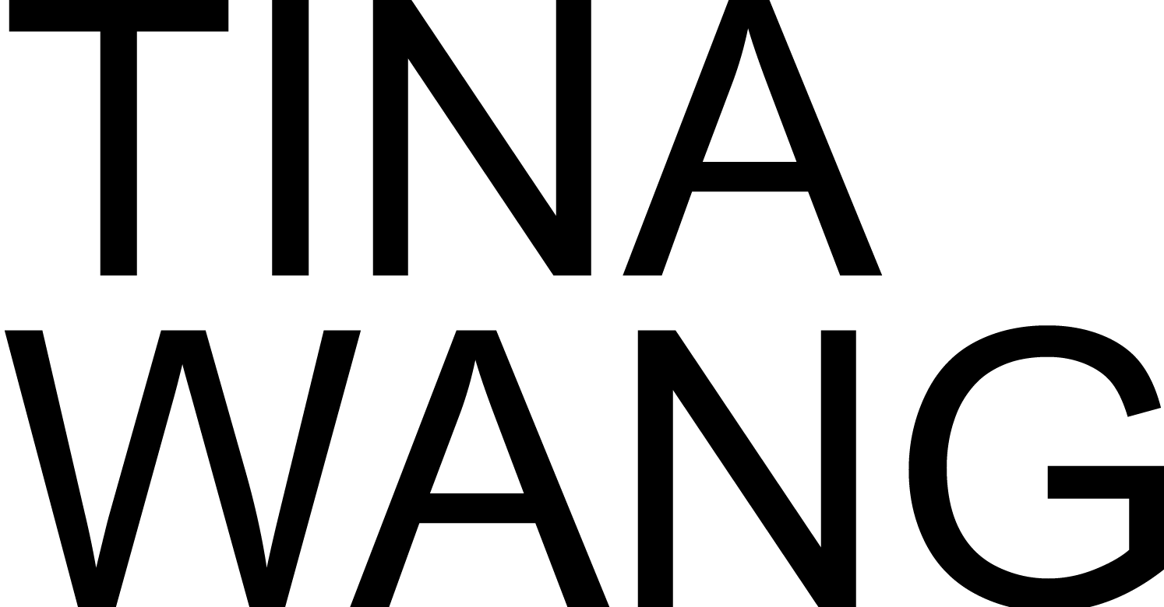
Phone Number: 626-375-7700
Email Address: wanyin.wangx.x@gmail.com

EDUCATION

BACHELOR OF FINE ARTS, ILLUSTRATION 2022
ArtCenter College of Design - Pasadena, California

ACADEMIC PROJECTS

Inventive Drawing December 2020
ArtCenter College of Design - Pasadena, California
● Designed Characters of Beauty and the Beast

Character Design November 2021
ArtCenter College of Design - Pasadena, California
● Collaborated with a team to design the characters of Cabaret
● Design characters on the basis of existent characters

Style April 2022
ArtCenter College of Design - Pasadena, California
● Designed covers and scenes in a variety of styles

SKILLS

Language Mandarin(Native)
Software ● Adobe Photoshop ● Adobe Illustrator
● Maya, Blender ● PaintTool SAI

