Stand out Skills
Image for sharing
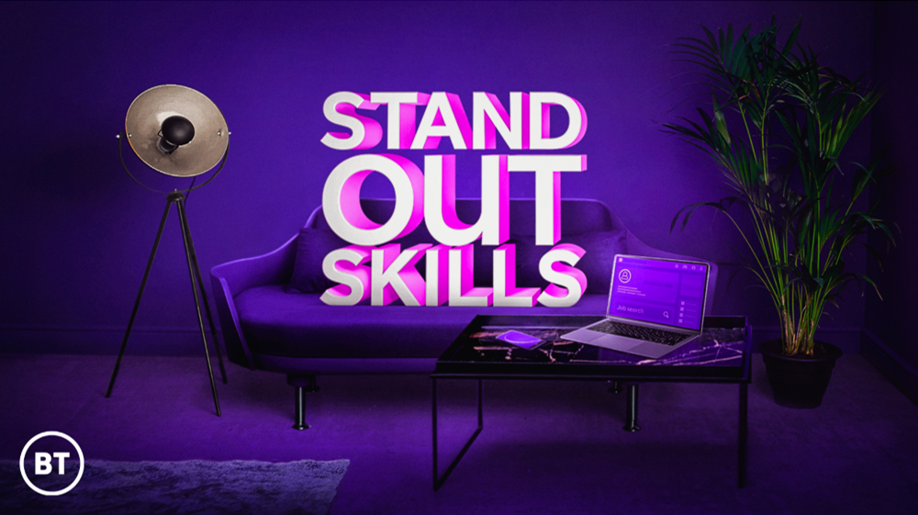

Accessing the content and materials
All content and materials will be available on BT’s new Stand out Skills hub : www.bt.com/StandOutSkills

Stand out Skills will also run on BT’s social media accounts daily for 28 days:

Twitter: @BT_UK
Facebook: https://www.facebook.com/BTUK/
Instagram: https://www.instagram.com/bt_uk/?hl=en
LinkedIn: https://www.linkedin.com/company/bt
YouTube: https://www.youtube.com/watch?v=ltR3cV_RDRE&feature=youtu.be

The campaign introduction can be viewed here.
Social media content for Twitter, Instagram and Facebook
Twitter:
- Need support in your job search? @BT_UK is providing unmissable advice to help you STAND OUT. Check out [visit BT.com/StandOutSkills] for free tips and tricks to help you in your job search. #StandOutSkills #SkillsForTomorrow

- Struggling for leads in your job search? @BT_UK has got free tips and advice to make sure you stand out and shine in your job search. Visit their profile [visit BT.com/StandOutSkills] #StandOutSkills #SkillsForTomorrow
Instagram:
- Need help with your job search? @BT_UK has got free tips and advice to make sure you STAND OUT. Check out their profile /[visit BT.com/StandOutSkills] to help you stand out and shine in your job search. #StandOutSkills #SkillsForTomorrow
Facebook:
- Unsure where to begin your job search? Stand out from the crowd with @BT_UK Stand Out Skills. Check out /[visit BT.com/StandOutSkills] for free unmissable advice to help you in your job search. #StandOutSkills #SkillsForTomorrow
Social media content for LinkedIn
Stand out and shine with BT Stand Out Skills
Stand Out Skills is providing unmissable daily support to jobseekers for 28 days from 19th January 2021.
BT Stand Out Skills has what jobseekers need for every stage of their search. It has ways to help you discover your potential, make you own luck, write job applications that can stand out from the crowd and advice on how to interview with confidence and stay resilient through it all.
Presenter Anita Rani, Comedian Iain Stirling and Drag Queen Divina Di Campo feature in the content including the campaign introduction which you can watch here.

To access BT’s free must-have tips, resources and advice to help you stand out in your job search visit BT.com/StandOutSkills
#StandOutSkills #SkillsForTomorrow #Jobsearch #Jobhunt #Opportunities #BT

