Week 2
Day | Morning Snack | Lunch | Afternoon Snack
Monday | Oatmeal Bars with Bananas  Milk  Water | Baked Ziti with Turkey Meat Sauce  Green Peas  Dinner Roll  Fresh Pineapples | Applesauce  Sweet Potato Crackers  Water
Tuesday | Yogurt and Granola  Milk  Water | Cheese Burgers  Baked Steak Cut Fries  Baked Beans  Sugar Free Jell-O | Rice Cakes  Fresh Fruit  Water
Wednesday | Whole Grain Cereal  Milk  Water | Chicken Parmesan  Cheese Tortellini  Peas and Carrots  Diced Pears | Cheddar Cheese Cubes  Wheat Crackers  Water
Thursday | Cinnamon Raisin Bread with butter  Fruit  Milk | Pizza  Corn  Mandarin Oranges | Trail Mix with Dried Fruit  Water
Friday | Biscuits with Jelly  Fruit  Milk  Water | Swedish Meatballs with  Egg Noodles  Steamed Corn  Diced Peaches | Fruit Yogurt  Graham Crackers  Water
Milk is served at each of these meals
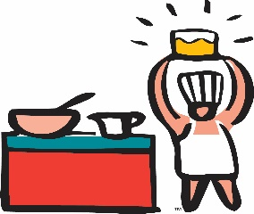
Whole Milk to Toddlers, Low-fat for Twos, PS, KP
This menu is subject to change without notice due to deliveries and emergencies

Revised 8/22/2022

