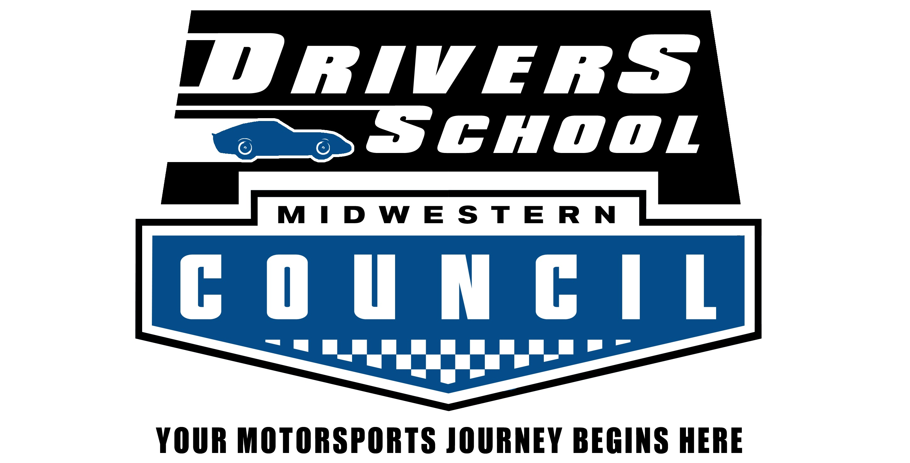

Midwestern Council Driver School – Blackhawk Farms Raceway
July 5th & 6th, 2019
Wheel-to-Wheel Student Registration Information

Midwestern Council strives to make your Driver School experience as easy as possible. We know how overwhelming some of the requirements can be so we designed this page to help you through the process. This document will instruct you on the four simple steps to process your Driver School paperwork. Don’t worry – it’s not too painful!

- Join a Midwestern Council club, if you haven’t already. A list of clubs is available at www.mcscc.org. Once there, click on a “Member Club” logo to get more information about each - including how to join. You can either join a club directly or choose to join a club when you register online for the school (at Step 2 below). Contact the Chief Instructor (school-chief@mcscc.org) for help with the registration process and for any questions that may come up. He can also connect you with a Club Steward to provide more assistance if needed. If you are under 18, make sure to read the “Minor” requirements later in this document.

- Go to http://msreg.com/MCJulySchool and register for the Driver School. Payment is due at the time of registration. If you are not yet a user, you will need to create an account. This is where online sign-up is available for all MCSCC events, so it will be time well spent!

- Fill out and mail the ORIGINAL Medical Form, and ORIGINAL Driver School Permit Application (both in this document).
  - The Medical Form must be completed and signed by your physician.
  - The Driver School Permit Application is completed by you.
  - Mail both to the School Registrar, no later than June 28th, 2019.

- Attend the MANDATORY CLASSROOM SESSION that will be held at 6:30 PM on Friday July 5th in the bottom of the Bridge at Blackhawk Farms Raceway.

That isn’t so bad, but remember to get the paperwork done and on its way. These are the deadlines you need to meet:
June 28th, 2019 |  | Registration for the school completed at www.motorsportreg.com and the Original Medical and Driver School Permit Forms both in the hands of the School Registrar.
July 5th, 2019 |  | Be at Blackhawk Farms Raceway before 6:00 PM to sign in and to get your car through Technical Inspection and attend the class at 6:30 PM. Registration will be open 4:30 PM to 6:00 PM and Tech will be open 5:30 PM to 6:30 PM.
Midwestern Council Clubs

Club | Located Near | Club Steward | Phone | Email
Chicagoland Sports Car Club | Addison, IL. | Dan Ibrahim | (309) 530-3976 | danibrahimracing@gmail.com
Great Lakes Sport Car Club | Milwaukee, WI. | Bruce Vollbrecht | (414) 350-6958 | brucevee@sbcglobal.net
Lakeshore Sports Car Club | Oak Creek, WI. | Jeff Willert | (262) 642-2330 | teamlb52@yahoo.com
Madison Sports Car Club | Madison, WI. | Rob Woelfle | (608) 712-4605 | rewoelfle@gmail.com
North Suburban Sports Car Club | Rolling Meadows, IL. | John Saccameno | (708) 209-9050 | saccameno@aol.com
Salt Creek Sports Car Club | Downers Grove, IL. | Jared Cromas | (630) 464-5999 | mc-integra111@sbcglobal.net
Sports Car Club of Rockford | Rockford, IL. | Michele Carlson | (815) 633-5302 | michelec741@aol.com

Wheel to Wheel Driver School Officials

Contact | Name | Phone | Email
Your Club Steward | See above!
Chief of School + Registrar | Ralph Hansen | (847) 840-7366 | school-chief@mcscc.org
MC Competition Director | Ralph Hansen | (847) 840-7366 | compdirector@mcscc.org
MC Licensing Director | John Boldt | (715) 362-0527 | licensing@mcscc.org
Chief of Tech | Ray Goff | (708) 705-8763 | tech@mcscc.org

Mandatory Classroom Session & Written Test

New Wheel-to-Wheel students are REQUIRED to attend the classroom session and take the written exam.

The classroom session includes:
There are a LOT of rules and regulations. PLEASE download the (free) GCR from http://www.mcscc.org/ (follow the link on there to open the GCR) and read it. A few pages a day and you’ll be done in no time!
Rules and Regulations
Rules of the Road
Rules of the Pits
Grand Prix Technique
Flags and Hand Signals
Licensing Procedures
Written Exam

No race engines after 4:30pm on Friday and before 8:00 am on Saturday.

Any request for special appointments MUST be made through the MCSCC Driver School Registrar.

Track Time Only Drivers & Novice Drivers

A limited number of openings will be available to current Midwestern Council Full Competition license holders for restricted test and tune time. SCCA Full Competition license holders who are members of Midwestern Council may also apply for this limited registration. Register and pay at www.motorsportreg.com – make sure you select the correct option or you will be taking the school again!

Novice License holders are encouraged to take additional schools for the education, experience, and fun. Register and pay the entry fee at www.motorsportreg.com – select the option for “Novice – Additional School.” Remember – you do not need to pay for a Driver School Permit if you hold a Midwestern Council license of any type. You may attend the Classroom Session if you wish but your attendance is not required. (Please indicate your intent to attend the Classroom Session using the “Note to Registrar” field on the online registration form.)

Midwestern Council July Driver School Schedule

Friday, July 5th 2019
4:00 pm – 6:00 pm Driver School Registration
5:30 pm – 6:30 pm Driver School Tech
6:30 pm – 9:00 pm Driver School Classroom session and Test

Saturday, July 6th 2019
7:00 am to 8:00 am Driver School Tech available by appointment only!
8:00 am Race Staff Meeting at Tower
8:00 am Driver School Drivers Meeting at Start/Finish

8:20 am – 8:40 am Driver School Station Wagon Runs
8:50 am – 9:05 am AX
9:10 am – 9:25 am Driver School Session 1
9:30 am – 9:45 am AX
9:50 am – 10:05 am AX
10:10 am – 10:30 am Driver School Session 2
10:35 am – 10:50 am AX
10:55 am – 11:10 am AX
11:15 am – 11:40 pm Driver School Session 3
11:45 pm – 12:00 pm AX

12:00 pm – 12:55 pm Lunch
12:10 pm – 12:30 pm Driver School Station Wagon Runs

12:55 pm – 1:15 pm Driver School Session 4
1:20 pm – 2:05 pm AX
2:10 pm – 2:30 pm Driver School Session 5
2:35 pm – 3:20 pm AX
3:25 pm – 3:50 pm Driver School Session 6
3:55 pm – 4:40 pm AX
4:45 pm – 5:00 pm Driver School Session 7 – 5 Lap Race
5:05 pm – 5:50 pm AX

* No race engines after 4:00pm on Friday and before 8:00 am on Saturday *

Midwestern Council Driver School Supplemental Regulations

- General Event Regulations
  - This event is sanctioned by the Midwestern Council of Sports Car Clubs, and insurance conforms to MCSCC requirements. This event will be held under the MCSCC General Competition Regulations, Track Regulations and all Supplemental Regulations.
  - No race engines after 4:00pm on Friday and before 8:00 am on Saturday.
  - Drivers are responsible for notifying crew and guests of the hours Registration is open. Entry may not be available beyond posted hours.
  - Minor guests must be under adult supervision at all times.
  - A slow and safe speed shall be maintained in the paddock at all times. Riding on the exterior of vehicles is prohibited.
  - No alcoholic beverage may be consumed by drivers, crew or guests before the end of the last race or other on-track activity. There may be General Admission spectators not registered with event sponsors which are not subject to this rule.
  - No illegal drugs or controlled substance shall be tolerated on the track premises at any time.
  - Any and all protests, questions or complaints against any competitor car or driving or against any race specialty should be made to the Event Chief Steward or his/her designated assistant as stipulated in the GCR. In no case should complaints be directed to any race worker in any specialty.
  - All race support vehicles (ATVs, golf carts, etc.) must bear a legible placard with the entrant's car number and class designation.
- Wheel-to-Wheel Supplemental Regulations
  - Race Entry & Registration
    - Midwestern Council Driver Schools are open to members in good standing of any Midwestern Council club, 18 years or older.
    - 14 to 17 year olds may participate only if they have the Notarized Minor Waiver on file with Midwestern Council, and conform to all procedures required of that waiver. 14 and 15 year olds may participate only by prior approval based on a review of previous experience. Contact the Chief of School prior to online registration to initiate the approval process.
      - Persons entering this event with an MCSCC Minor Participation Driver School Permit must personally present this permit to the Event Chief Steward accompanied by the attending parent/guardian before the Mandatory Drivers Meeting (see schedule).
      - It is the responsibility of the Minor Participant and the attending parent/guardian to attend the license presentation ceremony at the end of the school day, where the Minor Participation Driver School Permit will be returned along with the Minor Participation License.
      - Before the attending parent/guardian leaves the track property AT ANY TIME, he/she must report to the event Chief Steward before leaving and again upon returning to the track property. The minor participant will NOT be allowed on the race track if the attending parent/guardian is not present.
    - All Novice Sign-Off and Track Time drivers must be prepared to show at registration:
- A current approved competition license.
  - Race officials reserve the right to alter the schedule or race groups for good and sufficient reason, and to re-assign car numbers where required.
- Race Tech & Impound
  - To be allowed on track, all cars are to display a sticker issued by the Chief of Tech or his/her designated assistant indicating that, in his/her opinion, the car conforms to all safety regulations and marking requirements as detailed in the MCSCC GCR.
  - Drivers whose competition vehicles have logbooks issued by other sanctioning bodies must present all logbooks at any technical inspection.
- Race Timing & Scoring
  - AMB TransX 260 transponders are required for all wheel-to-wheel entries. A limited number of transponders will be available for rental. Rental Fee is $50 for the weekend and requires a $300 Security Deposit (refundable.) Rental Fee and Deposit requires cash, or two separate checks (no credit cards.) Rentals will be handled at registration. Renters will be notified where to return the transponder and retrieve the deposit. DO NOT take transponders into the building which houses Timing and Scoring. Transponders are also available for purchase online at www.mylaps.com, as well as from other sources.
  - All cars must display registration assigned numbers per the GCR.
- General Regulations
  - All drivers, with their cars, involved in metal to metal contact will be directed to impound immediately upon exiting the track with or without assistance. A Steward will meet them there to inspect the vehicles and collect reports from the drivers involved. The car and driver will remain in impound until released by the session Operating Steward.
  - Sound control - All cars are required to comply with the decibel limit established by the track (see track regulations). If a car is recorded in excess of the limit during an on track session, the first two times driver will be notified of the infraction as the car enters the paddock and instructed to make repairs. If the car is subsequently recorded in excess of the limit it will be Black Flagged and disqualified from further competition.
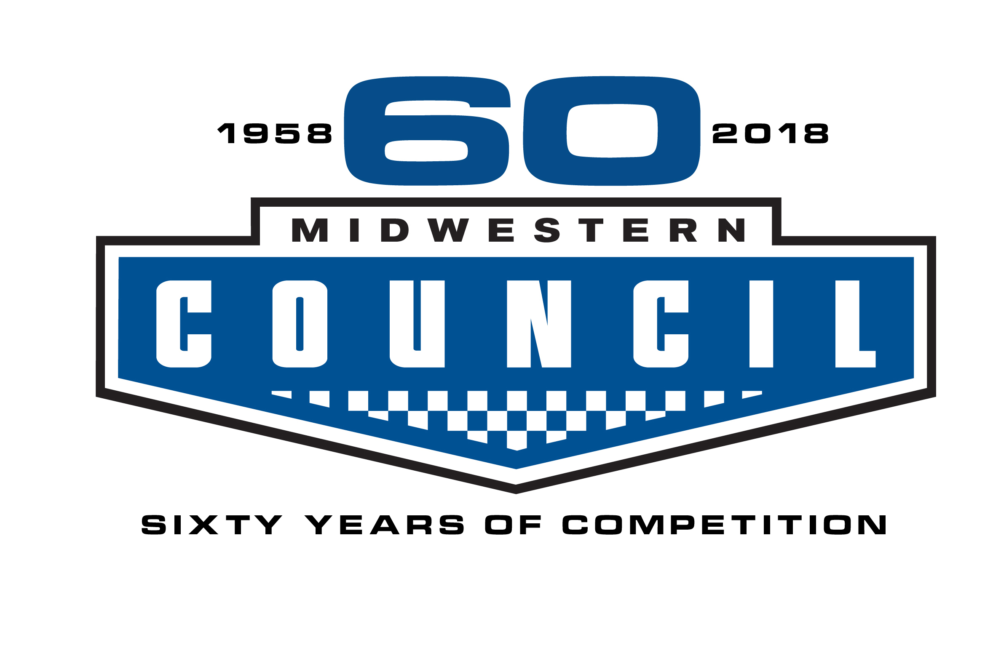
MEDICAL FORM
Note: If you are 70 years old or older, you must submit a Medical ANNUALLY for W2W competition.
2018 - 2019

Name: | ______________________________ | MC License #: | ______________________________
Address: | ______________________________ | MC License Type: | ______________________________
City, St Zip: | ______________________________ | Date of Birth: | _____________________(mm/dd/yy)

MEDICAL HISTORY: Have you ever had, been treated for, or now have any of the following?

Fainting Spells Epilepsy/seizures Asthma Head injury Heart Trouble Heat Stroke

Loss of consciousness High blood pressure Diabetes Kidney Disease Chest Pain Take Insulin

IF YES, EXPLAIN__________________________________________________________________________________

Do you take any medications, either prescription or over the counter? YES NO

IF YES, EXPLAIN__________________________________________________________________________________

Do you have any allergies? YES NO

IF YES, EXPLAIN__________________________________________________________________________________

Any operations/hospitalizations in the last 12 months? YES NO

IF YES, EXPLAIN__________________________________________________________________________________

THE FOLLOWING TO BE COMPLETED AND SIGNED BY AN MD, DO, PA-C, or NP
Attention Examiner: While preforming this exam, please keep in mind that racing cars is very stressful, both mental and physical. The
driver can be in a confined space, experience an elevated heart rate and be exposed to temperatures approaching 140 degrees

Fahrenheit while wearing multi-layer flame retardant clothing.

Blood Pressure __________ V Uncorrected Corrected Field of Vision
I Right 20/_____ 20/_____
Resting pulse __________ S Right __________ I Left 20/_____ 20/_____
With exercise __________ O Left __________
N Both 20/_____ 20/_____
2 min later ___________

Do you recommend the driver wear corrective lenses when driving? YES NO

Neurological (reflexes, motor, equilibrium, coordination) ___________________________________________________

Heart _____________________________ Abdomen ________________________________

Lungs _____________________________ Hernia ________________________________

Urine Sp. Gr___________________ Alb______________________ Sugar________________________
(To be done if hypertension, diabetes or renal disease is present).

(Physician’s option: Electrocardiogram results NORMAL ABNORMAL)

Explain _________________________________________________________________________________________

It is my opinion that the above applicant IS NOT physically fit to drive an automobile at high speeds.

SIGNED____________________________________________ Date____________________________

Address__________________________________________________________________________________________
2019 Driver School Permit Application
for
Wheel-To-Wheel Competition

Name: | __________________________ | Home phone: | __________________________
Address: | __________________________ | Work phone: | __________________________
City, State, Zip: | __________________________ | E-mail: | __________________________
 |  | MC Club: | __________________________

Have you ever held an MC license? Y N
How did you find Midwestern Council?

MEDICAL HISTORY
Please circle any that may apply.

RHEUMATIC FEVER HIGH BLOOD PRESSURE HEAD INJURY HEART TROUBLE
EPILEPSY KIDNEY DISEASE DIABETES FAINTING SPELLS

Have you had any medical problems in the last 12 months? YES NO

If YES please list: _____________________________________________________________________________

I CERTIFY THE ABOVE INFORMATION IS CORRECT AND VALID

DATE: ________________________ SIGNATURE:________________________________________ AGE:________

INSTRUCTIONS FOR FILING:
1. |  | Be sure to send your membership application or renewal to your club of choice, or join a club at online registration.
2. |  | Schedule a physical – remember to take the form.
3. |  | Answer all the questions on both forms.
4. |  | Sign and date the application
5. |  | Register for the Driver School at www.motorsportreg.com
6. |  | Make copies of all documentation before mailing.
7. |  | Mail ORIGINAL License Application and ORIGINAL Medical Form to the School Registrar.
 |  | THANK YOU!

Mail with Medical Form to
School Registrar:

Ralph Hansen
229 Bridgewood Drive
Antioch, Illinois 60002

Minor Participation Procedures

Midwestern Council (MC) allows Minors, 14-17 years of age, to compete in Wheel-to-Wheel (W2W) and High Speed Autocross (HSAX) events.

Note – 14 and 15 year-old participants are only eligible if they can provide sufficient and verifiable experience prior to the school date. Contact the Chief of School for additional information.

All Minor participants must comply with the following procedures:

All Minor participants in W2W and/or HSAX MUST successfully complete a full day MC Driver School for the type of competition in which they wish to participate. Driver school may be waived by the Competition Director with an acceptable and verifiable current racing resume. Upon successfully completing a Driver School, or waiver by Competition Director, a Minor Participation License (MPL) or HSAX Minor Participation Certificate will be issued.

A “MINOR RELEASE AND WAIVER OF LIABILITY AND INDEMNITY AGREEMENT” (Minor Release) form must be signed by one parent/legal guardian and in the possession of the MC Competition Director prior to a Minor being allowed to participate in a Midwestern Council event. To receive a blank Minor Release, the applicant must join a MCSCC club and contact the Steward of the club he/she joins, or the Chief of School. Notarized releases are valid until December 31st of the year in which they are signed and must be submitted each year until the Minor attains 18 years of age. The Competition Director will supply copies of this form to the MC President and Competition Licensing Director. A copy of the form will be provided to each event Chief Steward and Registrar for signature comparison with the form that will be completed by the Minor and attending parent/guardian at the events entered.

All Minors applying for a W2W Novice License must submit a Midwestern Council medical form; no other medical forms will be accepted.

At registration of each event entered, a Minor Release for that event shall be filled out and signed by the minor and attending parent/guardian. (Only one parent/guardian need attend events.) The Registrar will compare the signatures to those on the copied form. If believed to be the same, the Registrar is to sign and date the event release as a witness.

If at any time the attending parent/guardian intends to leave the track property, that parent/guardian is to inform the Chief Steward of intent to leave. Upon returning, the parent/guardian is to report to the Chief Steward. While the parent/guardian is away, the minor will not be allowed in restricted areas.

Minor W2W participants shall only be eligible for a “Minor Participation License” (MPL). While holding an MPL the participant shall conform to all regulations for both Novice and Probation licenses as detailed in the GCR. In addition, the driver must personally present the MPL to the event Chief Steward accompanied by the attending parent/guardian. Renewal of an MPL is similar to that of a Novice license. HSAX Minor Participation Certificates are to be sent to the Competition License Director for second year renewal as would the MPL.

Upon reaching 18, Minor Participation License holders are eligible to upgrade to the license level appropriate for the number of races completed while on the MPL.

