 | MONDAY | TUESDAY | WEDNESDAY | THURSDAY | FRIDAY
WEEK 1  10/24 – 10/28 | AM: Cereal with Milk  PM: Nutri Grain with Milk | AM: Blueberry Muffins and Milk  PM: Rice Cakes with Milk | AM: Fruit Yogurt with Graham Crakers  PM: Animal Crackers and Milk | AM: Cheese Sticks with Crackers  PM: Applesauce and Crackers | AM: English Muffins and Jelly  PM: Fruit Cup and Crackers
WEEK 2  10/31 – 11/04 | AM: Cereal with Milk  PM: Applesauce with Crackers | AM: Bagels with Cream Cheese/Jelly  PM: Blueberry Lemon Crispy Bites | AM: Blueberry Muffins with Milk  PM: Fruit Cup and Graham Crackers | AM: Waffles with Syrup  PM: Bananas with Wafers | AM: Nutri Grain Bar  PM: Cheese Sticks with Crackers
WEEK 3  11/07 – 11/11 | AM: Cereal with Milk  PM: Naan Bread with Sunbutter | AM: Cinnamon Raisin Bagel w/Cream Cheese  PM: Animal Crackers with Milk | AM: Nutri Grain Bar and Milk  PM: Fruit Yogurt and Granola | AM: Bananas and Milk  PM: Rice Cakes and Milk  d Wheat Crackers | AM: Waffles with Milk  PM: Applesauce with Crackers
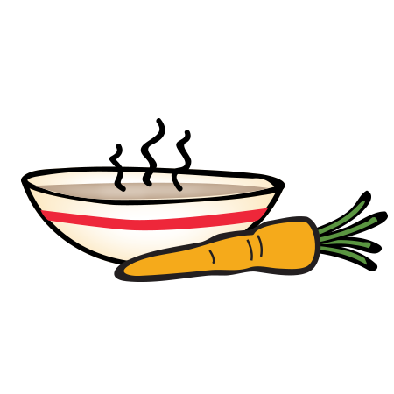
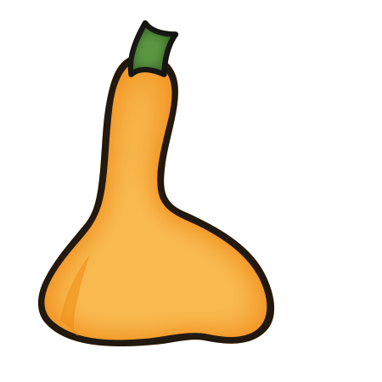
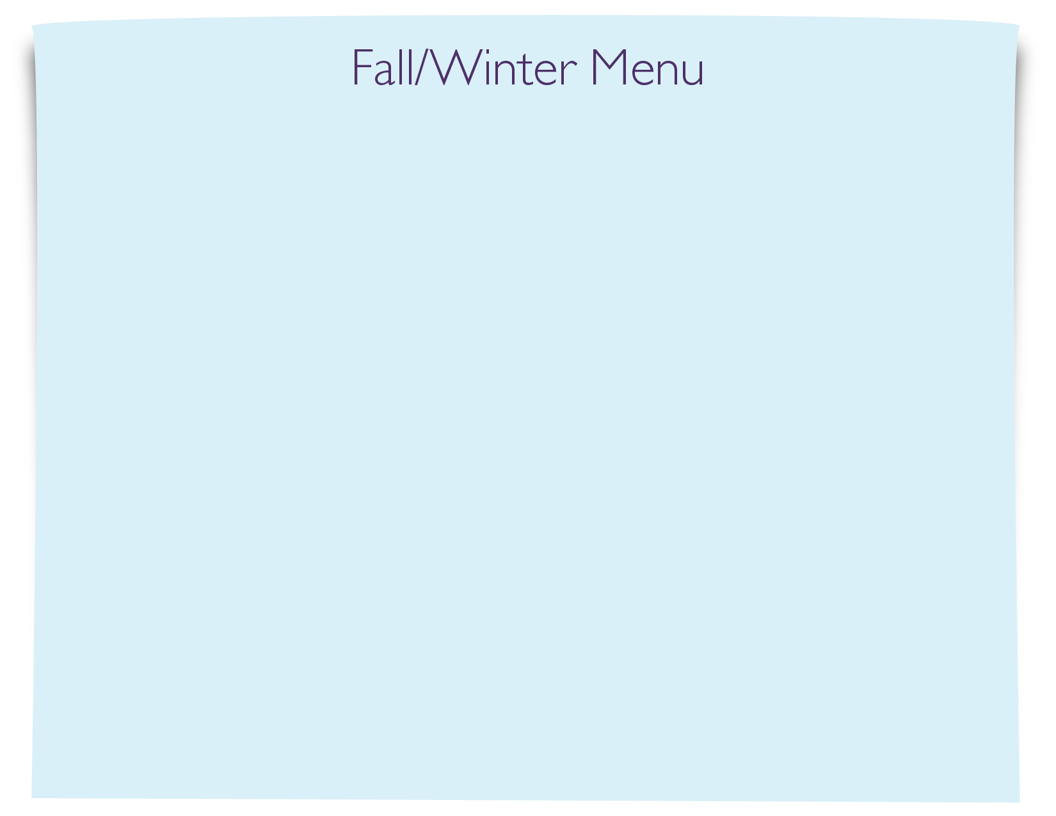
Snack Menu

