****MC900133301[1]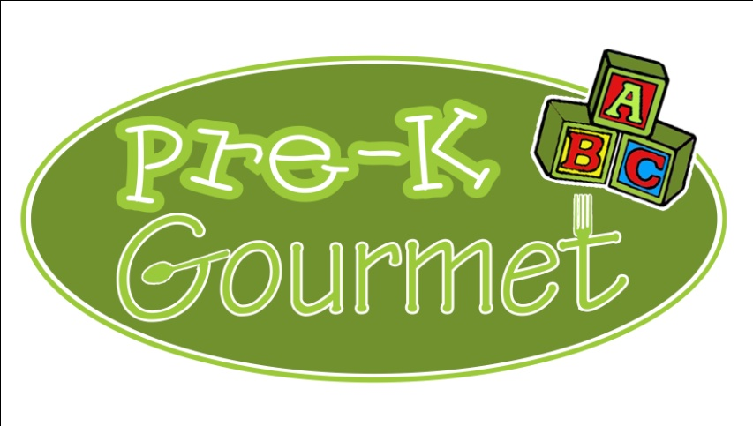

MC900301500[1]**Lunch Menu**

**December 2017**

**-All meals include milk-**

|  |  |  |  |  |
| --- | --- | --- | --- | --- |
| **MONDAY** | **TUESDAY** | **WEDNESDAY** | **THURSDAY** | **FRIDAY** |
|  |  |  |  | **1**  **Mini Cheese Pizza**  **Carrots**  **Apple Sauce** |
| **4**  **Mac n Cheese**  **Mixed Vegetables**  **Sliced Pears** | **5**  **Chicken & Vegetable Rice casserole**  **Winter Vegetable Medley**  **Banana Half** | **6**  **Cheese quesadilla**  **Tossed salad/peas (T)**  **Pineapple** | **7**  **Pasta w/ Turkey Tomato Sauce**  **Green Beans**  **Melon Salad** | **8**  **Sloppy Joe on a wheat roll**  **Mashed Potatoes**  **Banana Half** |
| **11**  **Beefy Mexican rice**  **casserole**  **Green beans**  **Peaches** | **12**  **Turkey noodle casserole**  **Mixed vegetables**  **Sliced Apples** | **13**  **Honey ham Dinner**  **Stuffing/ Mashed Potatoes**  **Corn/Peas** | **14**  **\*Whole wheat pasta w/meat sauce**  **California Vegetables**  **Banana half** | **15**  **Chicken BBQ on a wheat roll**  **Winter vegetable medley**  **Apple Sauce** |
| **18**  **Cheeseburger Noodle Casserole**  **Carrots**  **Pineapple** | **19**  **Grilled Cheese Sandwich**  **on Wheat Bread**  **Peas n Carrots**  **Melon salad** | **20**  **Beefaroni**  **Tossed Salad/Peas(T)**  **Sliced Apples** | **21**  **Sweet & Sour Chicken and Rice Casserole**  **California Vegetables**  **Banana Half** | **22**  **Veggie Mac n Cheese**  **Green Beans**  **Apple Sauce**  **MC900432177[1]** |
| **25**  **CLOSED** | **26**  **Turkey BBQ on a whole wheat roll**  **Mixed Vegetables**  **Pineapple** | **27**  **Beef Soft Tacos**  **Tossed salad/peas (T)**  **Apple sauce** | **28**  **Mini Cheese Pizza**  **Green Beans**  **Sliced Pears** | **29**  **Chicken Pot pie**  **Carrots**  **Banana Half** |