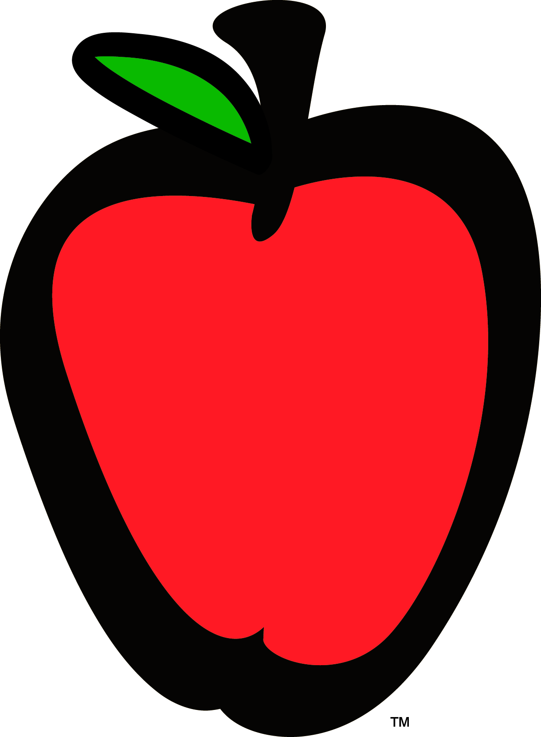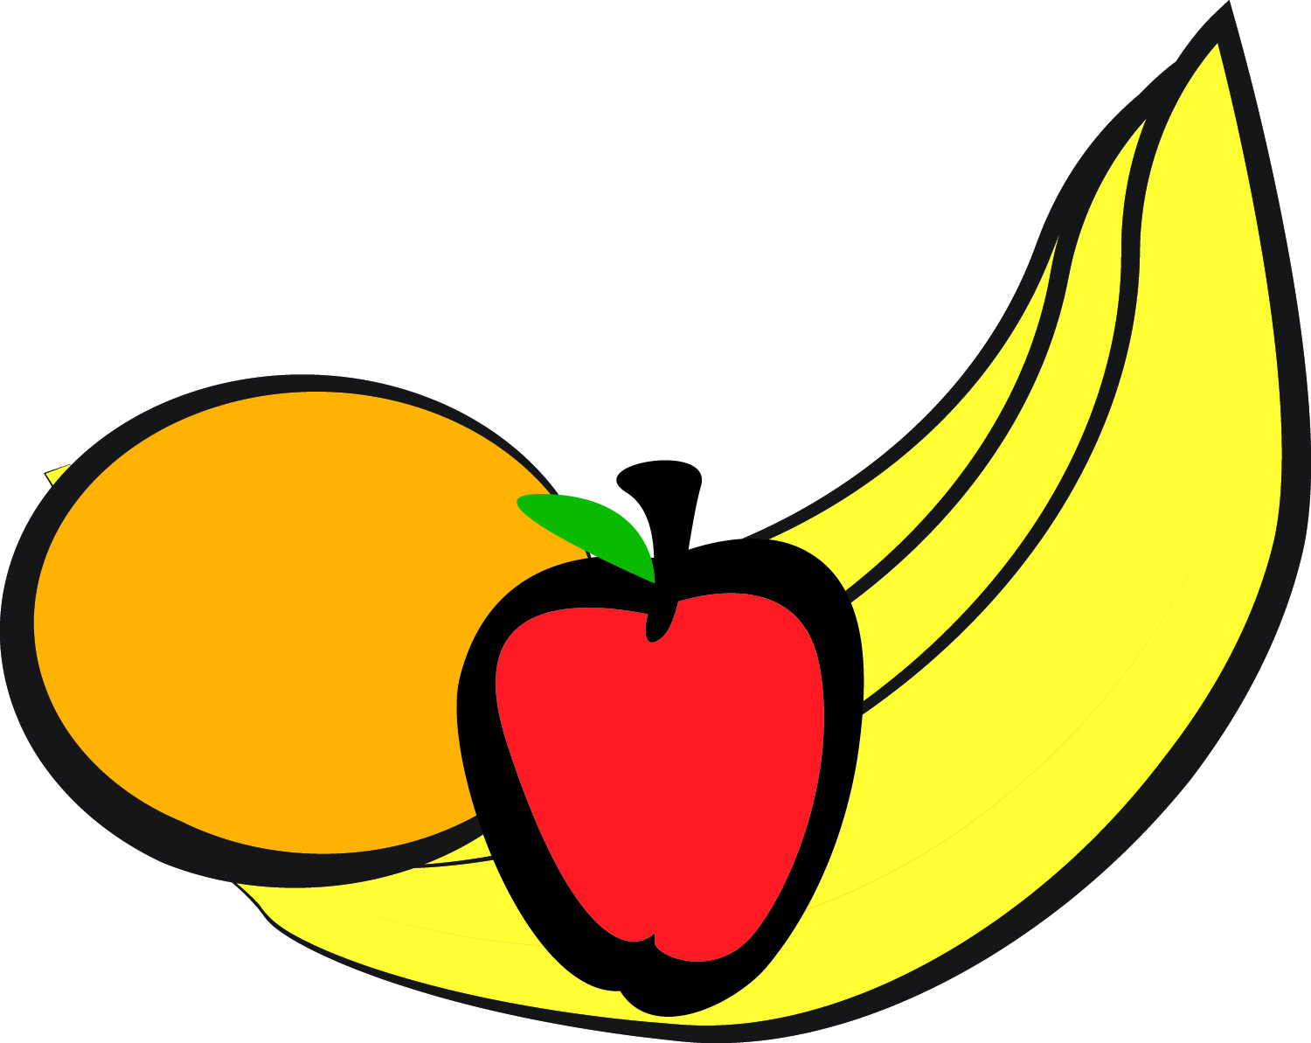

Little Apron Academy

May 2018

|  |  |  |  |  |
| --- | --- | --- | --- | --- |
| **MONDAY** | **TUESDAY** | **WEDNESDAY** | **THURSDAY** | **FRIDAY** |
|  | **1**  **AM Snack: Oatmeal**  **Strawberries**  **Lunch: Chicken Teriyaki w/ Vegetables**  **Brown Rice**  **Pineapples**  **PM Snack: Yogurt**  **Apricots** | **2**  **AM Snack: Hash browns**  **Turkey Sausage**  **Mixed Fruit**  **Lunch: Herb Roasted Chicken**  **Mashed Potatoes**  **Glazed Carrots**  **Tropical Fruit**  **PM Snack: Sliced Oranges**  **Vanilla Wafers** | **3**  **AM Snack: Bagel w/ Cream Cheese**  **Pineapple**  **Lunch: Spaghetti & Mini Meatballs**  **Squash & Zucchini**  **Pears**  **PM Snack: Cottage Cheese w/ Seasonal Fruit** | **4**  **AM Snack: Breakfast Burrito Casserole**  **Fresh Melon**  **Lunch: Chicken Enchiladas**  **Spanish Rice**  **Chuck wagon Corn**  **Tropical Fruit**  **PM Snack: Homemade Guacamole w/ pita chips** |
| **7**  **AM Snack: English Muffins**  **Turkey Sausage**  **Bananas**  **Lunch: Cheese Lasagna**  **Bermuda Vegetables**  **Tropical Fruit**  **PM Snack: Graham Crackers**  **Pineapple** | **8**  **AM Snack: Whole Grain Cereal**  **Orange Slices**  **Lunch: Chicken, Broccoli Casserole w/ Basmati Rice**  **Peaches**  **PM Snack: Wheat Crackers**  **String Cheese** | **9**  **AM Snack: Cheese Toast**  **Turkey Sausage**  **Baked Apples**  **Lunch: Baked Spaghetti w/ Turkey Meat sauce**  **Glazed Carrots**  **Pears**  **PM Snack: Apple Muffins** | **10**  **AM Snack: Blueberry Muffins**  **Mixed Berries**  **Lunch: Chicken Tenders**  **Green Beans**  **Wheat Rolls**  **Mixed Fruit**  **PM Snack: Peach Crisp** | **11**  **AM Snack: Cheese Grits**  **Turkey Sausage**  **Fruit Medley**  **Lunch: Sweet Tangy Chicken**  **Basmati Rice**  **Capri Vegetables**  **Pineapples**    **PM Snack: Vanilla Wafers**  **w/ Sun Butter Jam** |
| **14**  **AM Snack: Biscuits**  **Turkey Sausage**  **Banana**  **Lunch: Spaghetti w/ Marinara**  **Normandy Blend**  **Fruit Medley**  **PM Snack: Sliced Apples/ Cheese Sticks** | **15**  **AM Snack: Oatmeal**  **Strawberries**    **Lunch: Corn Taco Shell w/ Ground Turkey**  **Pinto Beans**  **Baked Apples**  **PM Snack: Graham Crackers w/ Peaches** | **16**  **AM Snack: Breakfast Sausage Quiche**  **Fruit Medley**  **Lunch: Roasted Chicken**  **Lima Beans**  **Corn Muffins**  **Tropical Fruit**  **PM Snack: Cottage Cheese w/ Seasonal Fruit** | **17**  **AM Snack: Cream of Wheat**  **Bananas**  **Lunch: Chicken Enchilada Casserole**  **Pineapple**  **PM Snack: Vanilla Yogurt**  **Peaches** | **18**  **AM Snack: Bagels Cream Cheese**  **Fresh Melon**  **Lunch: Turkey Burgers**  **Sweet Potato Fries**  **Pineapples**  **PM Snack: Tortilla Chips w/ Salsa** |
| **21**  **AM Snack: Oatmeal**  **Pears**  **Lunch: Baked Chicken**  **Mashed Potatoes**  **Green Peas**  **Fresh Cantaloupe**  **PM Snack: Graham Crackers w/ Bananas** | **22**  **AM Snack: Apple Muffins**  **Applesauce**  **Lunch: Turkey Meatloaf**  **Normandy Blend**  **Mashed Potatoes**  **Pears**  **PM Snack: Vanilla Wafers**  **Fresh Melon** | **23**  **AM Snack: Cream of Wheat**  **Strawberries**  **Lunch: Oven Baked Tilapia**  **Mashed Potatoes**  **Green Peas**  **Pineapple**  **PM Snack: Blueberry Muffins**  **Pears** | **24**  **AM Snack: Cheese Grits**  **Sliced Oranges**  **Lunch: Jambalaya**  **Dirty Rice**  **Corn Muffin**  **Peaches**  **PM Snack: Yogurt**  **Mixed Fruit** | **25**  **AM Snack: Biscuits**  **Turkey Sausage**  **Banana**  **Lunch: Pizza Casserole**  **Green Beans**  **Peaches**  **PM Snack: Cucumber & Tomato Salad** |
| **28**  **C**  **L**  **O**  **S**  **E**  **D** | **29**  **AM Snack: Whole Wheat Waffles**  **Strawberries**  **Lunch: Baked Cheese Tortellini w/ Meat Sauce**  **PM Snack: Spinach Artichoke Dip w/ Pita Chips** | **30**  **AM Snack: Whole Grain Cereal**  **Bananas**  **Lunch: Grilled Cheese**  **Green Beans**  **Peaches**  **PM Snack: Mixed Berry Parfait** | **31**  **AM Snack: Cream of Wheat**  **Pineapples**  **Lunch: Baked BBQ Chicken Sliders**  **Baked Beans**  **Glazed Carrots**  **PM Snack: Fresh Apple Slices w/ String Cheese** |  |

**LAA Serves whole milk to children under two years of age and 1% milk to children over two years of age.**

**Milk is served at AM snack and lunch. Water is served at PM snack**