Daybridge Child Care Center

**Center Highlights**

* Full-time, part-time, and drop-in care (on space available basis)
* An “open door” policy welcomes parents of enrolled children to drop in at any time.
* Everyday Math, Garden Works, Extensive Playground area, Sign Language, and Movement Matters zone, School-age After School Care and Summer Camp
* Family appreciation events, parent/teacher conferences, educational workshops, parenting seminars, and more
* An environment designed for young children to explore their world in a stimulating, healthy, and safe way with quiet spaces for nurturing.
* Classrooms where children can begin to discover the world around them through language, math, science, art, movement, and music.

**Meals**

* Nutritious, lunch and snacks provided daily
* Meals cooked with fresh fruits & vegetables and with whole grains

Security Features

* Secure entryways; extensive evacuation policies and procedures

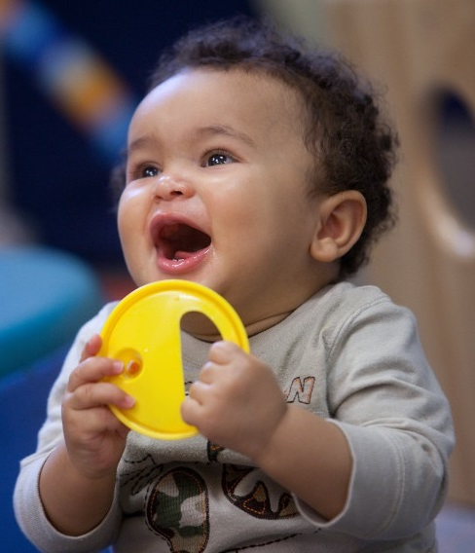



Infant  
6 weeks to 18 months  
Teacher: Child Ratio 1:4

Toddler  
18 months to 30 months

Teacher: Child Ratio 1:5

Twos  
24 months to 36 months  
Teacher: Child Ratio 1:6

Preschool  
3 years to 4 years

Teacher: Child Ratio 1:10

Kindergarten Prep  
4 years to 6 years

Teacher: Child Ratio 1:10

After School School-Age Care  
5 years to 12 years

Teacher: Child Ratio 1:12

**Daybridge Child Care Center**301 Innovation Blvd, State College PA 16803

814-863-6913 | daybridge@brighthorizons.com   
brighthorizons.com/daybridge

**Hours of Operation**

7:00 a.m. to 6:00 p.m., Monday – Friday, year round