 | MONDAY | TUESDAY | WEDNESDAY | THURSDAY | FRIDAY
WEEK 1  9/7- 9/11 | AM: Nutrigrain bar with milk  PM: Rice cakes | AM: Cinnamon raisin bread with jelly  PM: Fresh fruit and wheat crackers | AM: Apple cinnamon muffin  PM: Whole grain cheese crackers | AM: Cereal with milk  PM: Animal crackers with applesauce | AM: Corn muffin with milk  PM: String cheese with crackers
WEEK 2  9/14- 9/18 | AM: Cereal with milk  PM: Naan bread and Sun Butter | AM: Graham Crackers and applesauce  PM: Fresh fruit and wheat crackers | AM: Vanilla yogurt with granola  PM: Cheddar cheese and crackers | AM: Bagel with cream cheese  PM: Graham Crackers with milk | AM: Blueberry muffin with milk  PM: Wheat wafers with applesauce
WEEK 3  9/21- 9/25 | AM: Banana muffin  PM: Rice cakes | AM: Cereal with milk  PM: Apple Oatmeal Bar with milk | AM: Corn muffin with milk  PM: : String cheese with crackers | AM: Cinnamon raisin bread with jelly  PM: Animal crackers with applesauce | AM: Vanilla yogurt with granola  PM: Naan bread and Sun Butter
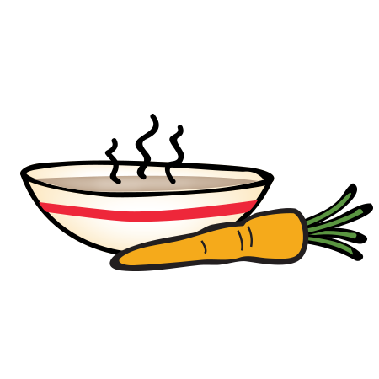
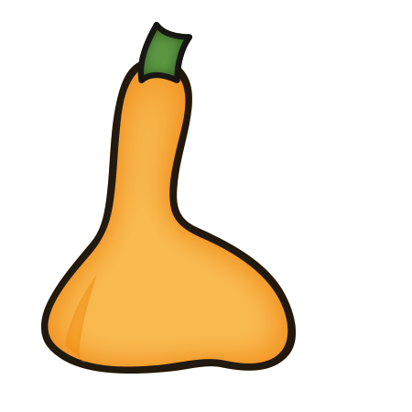
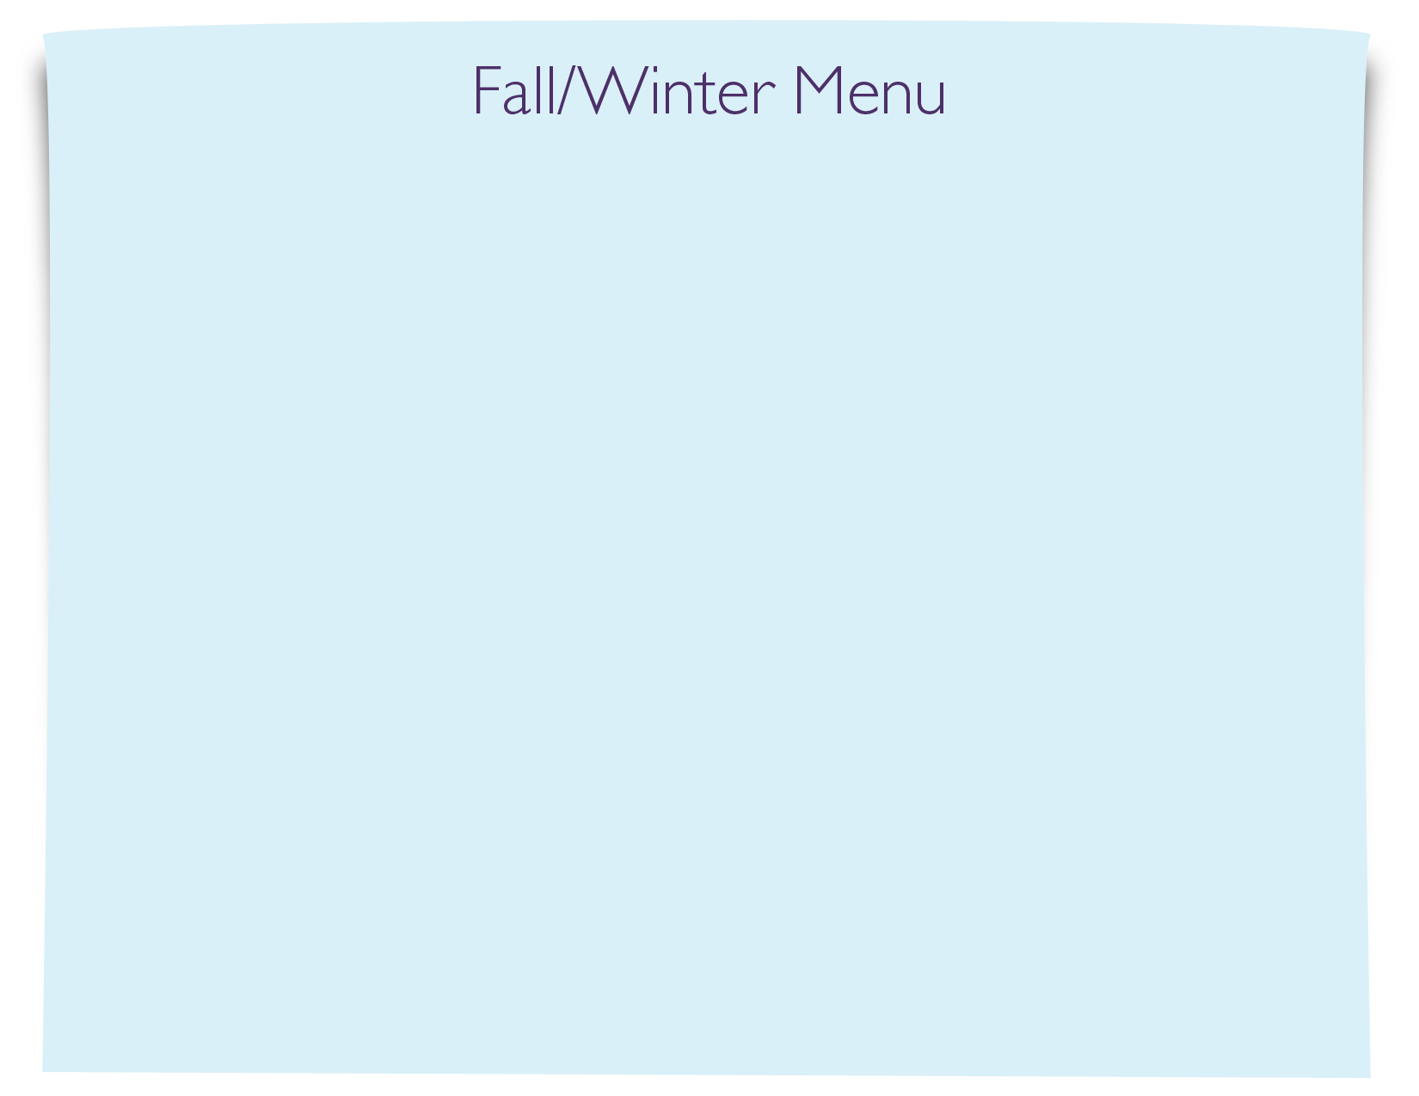
Snack Menu

