2019 Holiday/ Center Closings

Bright Horizons at Woodbury
will be closed in observance of the
following holidays:

Tuesday, January 1st – New Year’s Day
*Monday, January 21st – Martin Luther King Day
Monday, February 18th – President’s Day
Monday, May 27th – Memorial Day
Thursday, July 4th – Independence Day
Monday, September 2nd – Labor Day
*Monday, October 14th – Columbus Day
Thursday, November 28th – Thanksgiving Day
Friday, November 29th – Day after Thanksgiving
Wednesday, December 25th – Christmas Day

*Center closed for faculty training
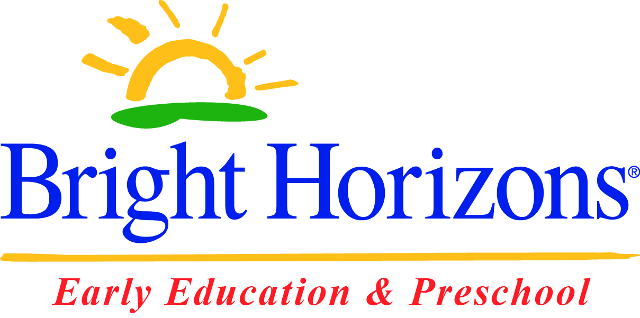
172 Crossways Park Dr. Woodbury, NY 11797
516-921-2317 ext. 201

