Happy Birthday!

Ombeline T. – April 2nd

Nathanael V. – April 2nd

Charlotte M. – April 9th

Ms. Cheyenne – April 14th

Ruby B. – April 16th

Santiago B.C. – April 24th

Ahrin S. – April 24th

Gibson S. – April 24th

Ms. Melanie – April 25th

Ms. Crystal – April 30th

Luna S.G. – April 30th

2018 | April Newsletter

Bright Horizons at   
Adams Street News

**From the Director**

Hello Adams Street Families-

It is hard to believe that Spring is officially here, being that we are still dealing with the snow! With the warmer weather (hopefully) upon us soon, we will be getting the children outside on a daily basis and focusing on our Garden Works curriculum with our garden plots on the second floor.

We would like to officially welcome Ms. Peakiya to our Infant 1 program. We are so excited that you joined our center and look forward to seeing your impact on the classroom. We would also like to welcome back Ms. Chelsey from her maternity leave. We congratulate on you the new addition to your family and are happy to have you back with us!

We thank you for your patience during the broken elevator situation (and the short-lived front door keypad glitch). We understand how frustrating it was, and took way longer than we anticipated, but are happy that it is now resolved.

Please know that my office door is always open for any questions, comments, and/or concerns – I am happy to help!

Thanks TJ McNamara

Important Dates

April 3rd – April 10th: *Scholastic Book Fair*

April 17th – *Family Partnership Group Call*

April 22nd – *Earth Day*

April 24th – *Parent Workshop Webinar*

April 27th – *Re-registration Paperwork Due*

May 28th – *CLOSED for Memorial Day*

July 4th – *CLOSED for Independence Day*

****Bright Horizons at Adams Street****

345 Adams St. Brooklyn, NY 11201

(718)488-7770 | [adamsstreet@brighthorizons.com](mailto:adamsstreet@brighthorizons.com)

Monday-Friday 7:00 am – 6:30 pm

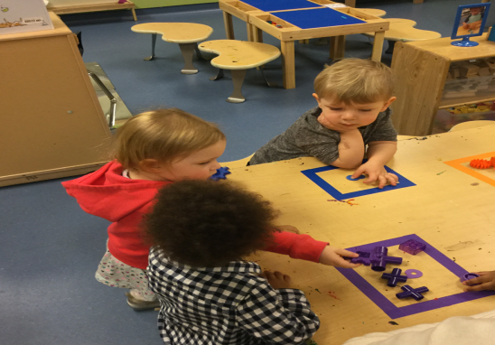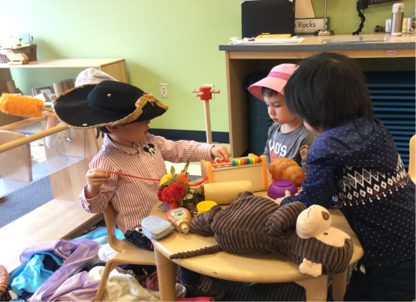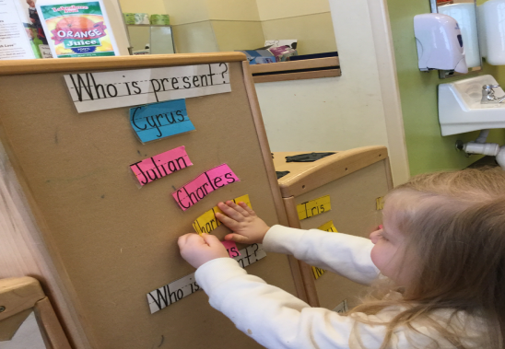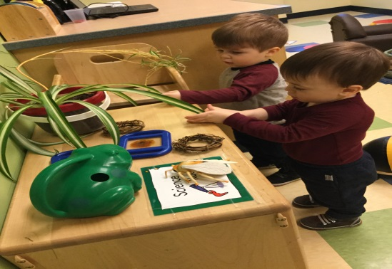

Science Rocks

Young children are scientists by nature. They are born with a strong sense of curiosity about how things work and an innate desire to make sense of the world. Our Toddlers are learn to question when exploring materials and formulate “why, what, and how” questions. We learn this by exploring materials and activities that engage our sense of touch, taste, smell, sound, and sight. We also learn this by describing our observations and experiences with teachers.

Language Works

Our Young Preschoolers are in an exciting time of robust language development. There is great delight in the numerous ways they can use and enjoy language. We learn to understand that printed and words have meaning and to identify letters and a few sight words. We learn this by identifying classroom signs and labels and looking at items throughout the room that contain common sight words.

Art Smart

Art Smart allows Preschoolers to engage in comprehensive, authentic, and diverse creative experiences in all areas, including dramatic art. In this area they are learning to engage in dramatizations with peers, assign and take on roles, and act out stories and/or plays. We learn this by playing sustained group games with our peers in the dramatic play area and using props to act out a favorite story.

Math Counts

Math Counts offers a framework for developing the skills and abilities of young mathematicians, ensuring that children recognize math in everyday life. We are learning to gather two or more similar objects from a variety of items, sort objects by one or more characteristics, and create and follow simple patters. We learn this by sorting items and making patters with different objects.

program HIGHLIGHTS

Do you consider your child to be a “picky” eater? Do mealtimes become struggles with you coaxing your child to “try one bite”? Most of us have food preferences, although probably not as many as our children. Selective eating is part of a child’s typical developmental process. Making decisions about foods they will try is a part of children asserting themselves.

**Reasons children may be selective eaters:**

* Independence – Children can exercise power by deciding what they eat.
* Sensory discrimination – Children might not welcome unfamiliar tastes, colors, textures, sights, and scents.
* Distraction – Children tend to be active, and there are often more exciting things to do than eat.

**Below are strategies that might help your child eat a wider variety of food:**

* Start introducing a variety of nutritious foods at an early age. Children might have to be exposed to a food numerous times before deciding to try it.
* Give children control by providing nutritious choices but realize it’s up to them whether they eat or not. Coaxing a child to eat may create a power struggle around food.
* Invite children to serve themselves. Young children are becoming more autonomous and independent, and want to do things for themselves.
* Consider how foods affect the senses. For example; many children prefer the bright colors and the crispiness of raw vegetables to cooked veggies.
* Make mealtime’s enjoyable experiences. Engage children in conversation; talk about animals, friends, school activities, family members, plans, favorite books, appropriate current events, or an upcoming family activity. Consider playing “thorns and roses” where everyone shares their best and worst experiences of the day.
* Involve children in planning menus and preparing meals. Children tend to eat what they help cook.
* Create a garden outdoors or inside in pots. Children enjoy selecting seeds, planting, watering, and watching plants grow. They typically love to taste what they have grown themselves.

No need to worry if your child is a picky eater as it is often a phase of life. Consult your pediatrician if you’re concerned about your child’s health. For more information refer to Kids Health by Nemours, Healthy Eating or Partnership for a Healthier America, Tips for Dealing with Picky Eaters.



Is Your Child a Picky Eater?

Ready for school News

Green Activity for Earth Day

Bright Horizons NEWs

Bright Horizons did the research and this is what we found: the “mental load” is weighing down many working women. As a mom, you’re likely more than just a parent; you’re also the unofficial manager of everything your family is doing and when. On this episode of the Work-Life Equation, we discuss the findings of the study which show the mental load is real, and offer tips on how to manage your own load...and maybe even lighten it up.

[**www.brighthorizons.com/mentalloadpodcast**](http://www.brighthorizons.com/mentalloadpodcast)

[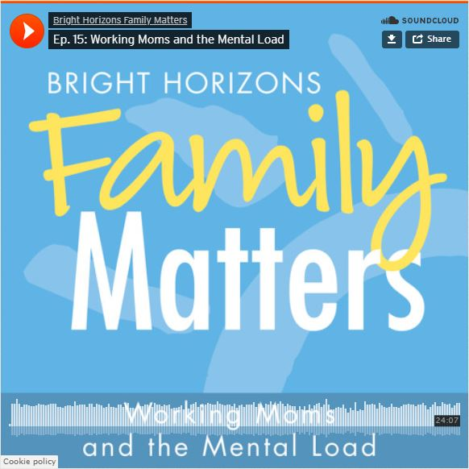](https://www.brighthorizons.com/family-resources/podcasts/working-moms-mental-load)

**New Parenting Podcast Episode!**

Working Moms and the Mental Load

Put on your creative caps and repurpose recyclable items from your household into art supplies. Instead of tossing recyclable materials, re-use them. Gather recycled materials ranging from used bottles, old clothing, cardboard, or anything else you can think of and get busy creating!

Earth Day is April 22nd and is a day dedicated to raising awareness for the importance of keeping our planet healthy and clean.

As Earth Day approaches, your child may be involved in projects and activities that foster an awareness of and appreciation for the earth's resources. To extend the learning that takes place in your child's center or school, and make caring for the earth part of your family culture, we encourage you to make time for some green activities this Earth Day.

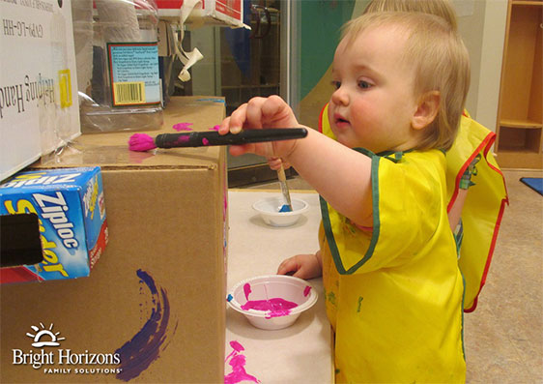



Check out all the places you can connect with us!

