 | MONDAY | TUESDAY | WEDNESDAY | THURSDAY | FRIDAY
WEEK 1  09/12 - 09/16 | AM: Cereal with Milk  PM: Bananas with Milk | AM: Nutri Grain Bar and Milk  PM: Blueberry Lemon Crispy Bites | AM: Naan Bread with Sun Butter  PM: Animal Crackers and Milk | AM: GoGo Squeez Yogurt with Crackers  PM: Cheese Sticks and Crackers | AM: English Muffins and Jelly  PM: Fruit Cup and Crackers
WEEK 2  09/19 - 09/23 | AM: Wheat Bagel with Strawberry Cream Cheese  PM: Applesauce and Graham Crackers | AM: Cereal with Milk  PM: Rice Cakes with Milk | AM: Naan Bread and Sun Butter  PM: Fruit Cup and Crackers | AM: Fruit Yogurt and Granola  PM: Nutri Grain Bar and Milk | AM: English Muffins with Jelly  PM: Teddy Grahams and Milk
WEEK 3  09/26 - 09/30 | AM: Biscuits and Jelly  PM: Animal Crackers with Milk | AM: Cereal with Milk  PM: Naan Bread and Sun Butter | AM: Cinnamon Raisin Bagel with Cream Cheese  PM: Fruit Yogurt and Granola | AM: Nutri Grain Bar and Milk  PM: Teddy Grahams and Milk  d Wheat Crackers | AM: English Muffins and Jelly  PM: Rice Cakes with Milk
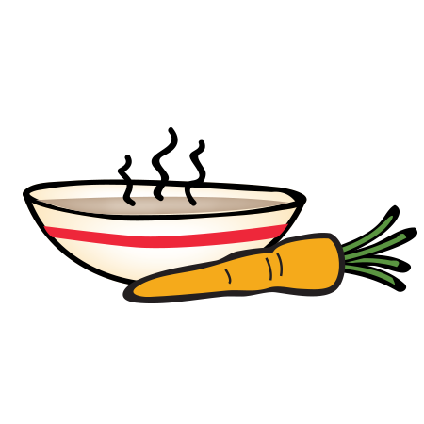
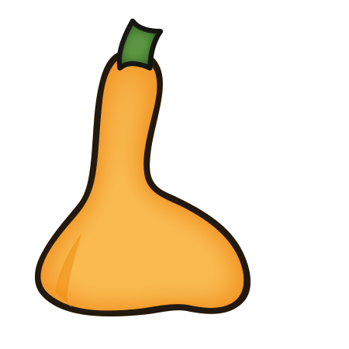
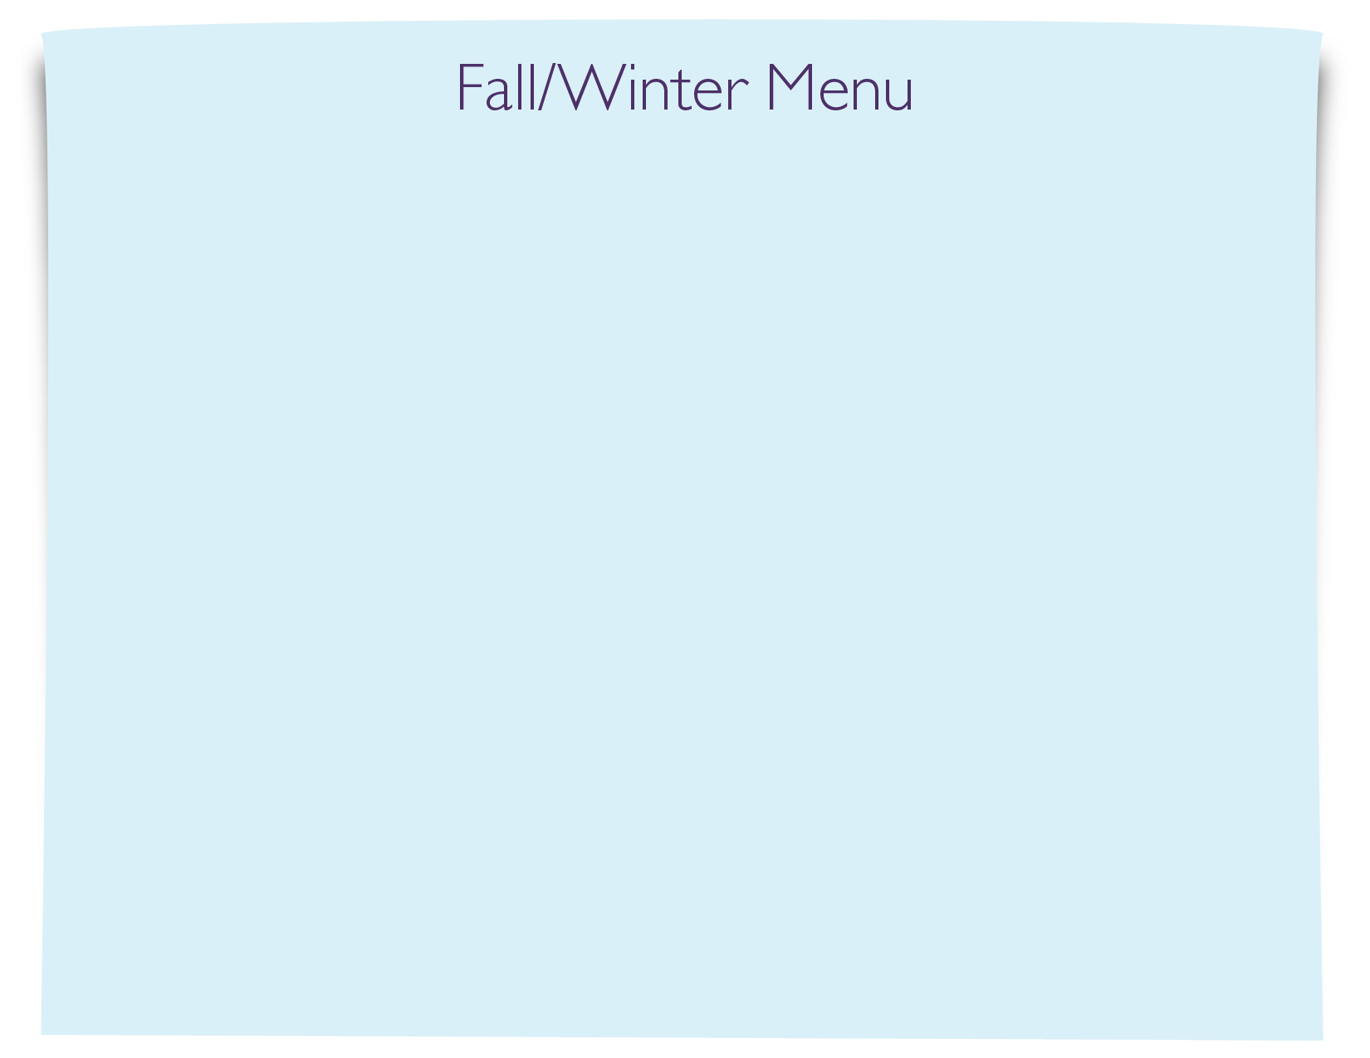
Snack Menu

