 | MONDAY | TUESDAY | WEDNESDAY | THURSDAY | FRIDAY
WEEK 1  12/26 – 12/30 | CLOSED | AM: Cereal and Milk  PM: Fruit Yogurt with Milk | AM: Naan/Bagels  PM: Animal Crackers and Milk | AM: Cheese with Crackers  PM: Applesauce and Crackers | AM: Nutri Grain Bar and Milk  PM: Fruit Cup and Crackers
WEEK 2  1/02 – 1/06 | CLOSED | AM: Blueberry Muffin with Milk  PM: Rice Cakes and Milk | AM: Cereal with Milk  PM: Applesauce with Crackers | AM: Cinnamon Raisin Bagel w/Cream Cheese  PM: Animal Crackers with Milk | AM: Fruit Yogurt and Granola  PM: Nutri Grain with Milk
WEEK 3  1/09 – 1/13 | AM: Cereal with Milk  PM: Fruit Cup with Graham Crackers | AM: Cinnamon Raisin Bagel w/Cream Cheese  PM: Animal Crackers with Milk | AM: Nutri Grain Bar and Milk  PM: Fruit Yogurt and Granola | AM: Wheat Bagel with Milk  PM: Rice Cakes and Milk  d Wheat Crackers | AM: Cheese with Wheat Wafers  PM: Applesauce with Crackers
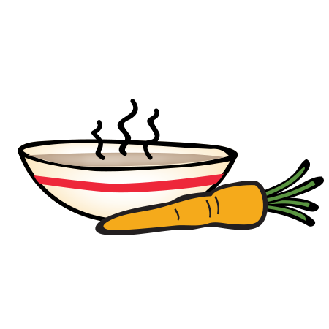
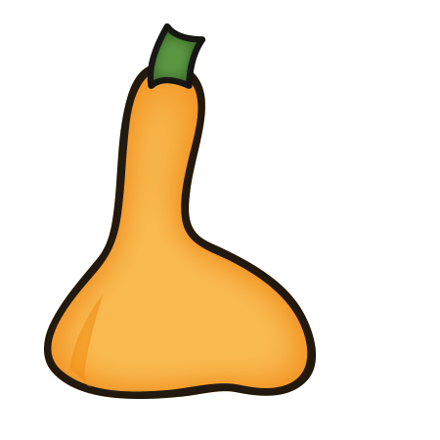
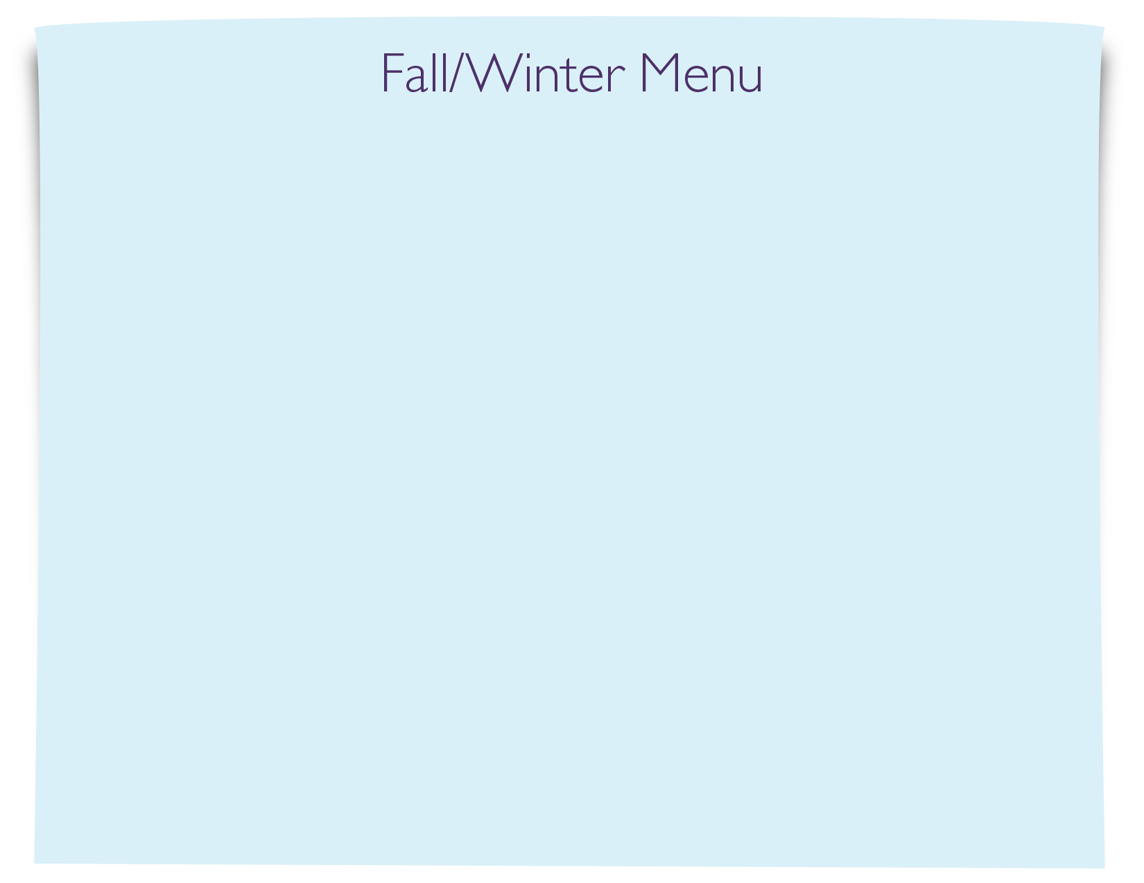
Snack Menu

