 | MONDAY | TUESDAY | WEDNESDAY | THURSDAY | FRIDAY
WEEK 1  05/09-05/13 | AM: Wheat Bagel with Cream Cheese  PM: Rice Cakes and Milk | AM: Muffins and Milk  PM: Fruit Yogurt and Granola | AM: Cinnamon Bagel with Cream Cheese  PM: String Cheese and Milk | AM: Biscuit with Jelly  PM: Applesauce and Crackers | AM: Naan Bread and Sun Butter  PM: Teddy Grahams and Milk
WEEK 2  05/16-05/20 | AM: English Muffins with Jelly  PM: Applesauce and Graham Crackers | AM: Cereal with Milk  PM: Rice Cakes with Milk | AM: Naan Bread and Sun Butter  PM: Fruit Cup and Crackers | AM: Fruit Yogurt and Granola  PM: Nutri Grain Bar and Milk | AM: Cinnamon Raisin Bagel with Jelly  PM: Fruit Yogurt and Graham Crackers
WEEK 3  05/23-05/27 | AM: Cereal with Milk  PM: Animal Crackers with Milk | AM: Biscuits and jelly  PM: Naan Bread and Sun Butter | AM: English Muffins and Jelly  PM: Fruit Yogurt and Granola | AM: Cinnamon Raisin Bagel with Cream Cheese  PM: Teddy Grahams and Milk  d Wheat Crackers | AM: Nutri Grain Bar with Milk  PM: Rice Cakes with Milk
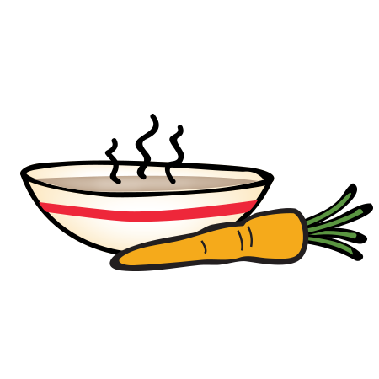
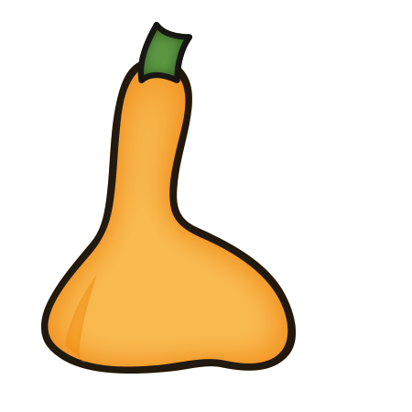
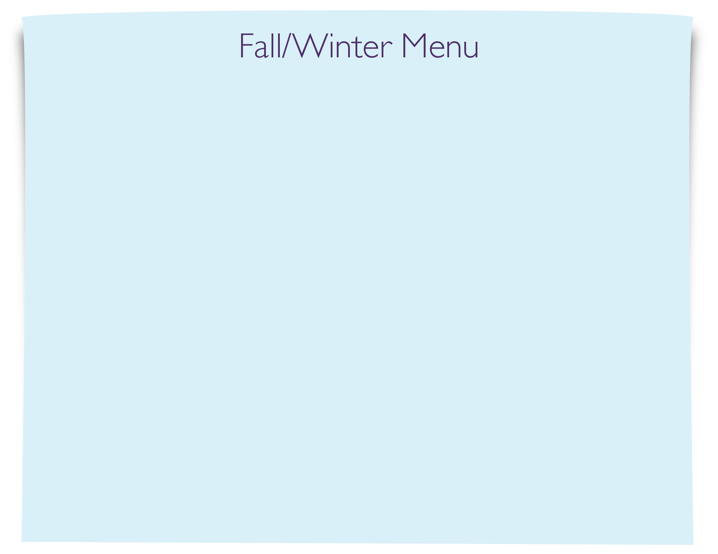
Snack Menu

