**From the Admin Team**

Happy April, families!

We have a very fun month ahead of us, which includes our Open House and The Week of the Young Child.

The Week of the Young Child is an annual celebration of young children that takes place every April all across the nation. Throughout the week, our center will be participating in fun activities that foster many different learning skills! This year, the Week of the Young Child will fall on the week of April 16. We will highlight different activities each day and closing the celebration with a family participation event! Below is a list of our scheduled events.

**4/16- Music and Movement Monday**

* Children will create instruments and join together for a parade.

**4/17- Tie-Dye Tuesday**

* Children and staff will create their very own tie-dye shirts

**4/18- Wacky Wednesday**

* Mix and match clothing, silly socks, crazy hair, or all of the above! Let’s teach the children that it’s okay to be unique

**4/19- Artsy Thursday**

* The children will spend the day exploring the visual arts. Each child will create a special masterpiece to create a beautiful quilt.

**4/20- Family Fun Friday**

* Join us for an afternoon filled with activities for you and your child. Each classroom will be hosting a special event for you to enjoy!

Reasons to Celebrate

We are hosting our second open house event! Please let your overstock friends and colleagues know as this is a great time to learn about Bright Horizons and see what we are all about!

Important Dates

Week of the young child April 16-20

Family Fun Friday April 20

3:30pm-5:00pm

Bright Horizons Open House 23-27

9:00am-5:00pm

**PLEASE BRING IN 2 PLAIN WHITE T-SHIRTS FOR YOUR CHILD BY FRIDAY APRIL 13.**

2018 | April Newsletter

Bright Horizons at   
Overstock News

****Bright Horizons at Overstock.com****

779 W. Coliseum Way, Midvale, Utah, 84047

385-900-7425| [Overstock@brighthorizons.com](mailto:Overstock@brighthorizons.com)

Monday-Friday 7:00am-6:00pm

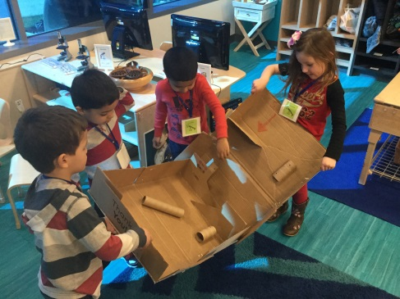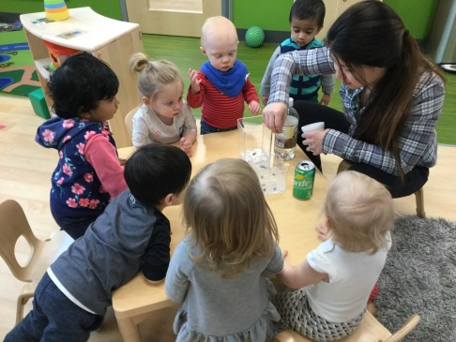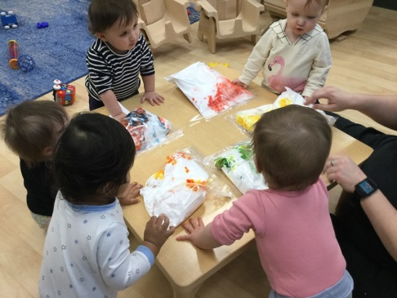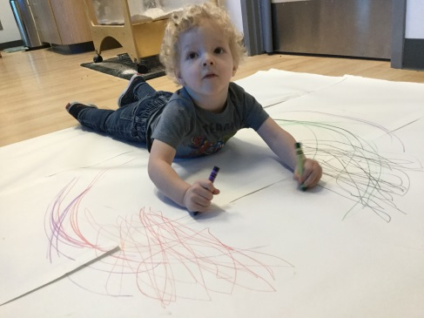

Infant

This March we used the Art Smart Curriculum to help us learn to experiment with and explore colors. As we squished shaving cream and food coloring in a bag, we were able to make the colors red, orange, yellow, green, and purple. We used our small muscles in our hands to squeeze and rub the bag. We also learned to explore materials that engage our sense of touch, smell, and sight.

Toddler

This month in the Toddler class, we learned so many new things! We engaged the children in many activities to touch on our Art Smart, Language Works, Movement Matters, and Science Rocks curriculum. One of our favorites was the dancing raisins experiment. We used a can of sprite in one container and baking soda and water mixed with vinegar in another. We watched as the raisins danced up and down. We talked about what up and down mean and copied the raisins, dancing up and down in the containers. The children are encouraged to use the words up and down, when asking to get up from the table and sitting down next to friends.

Twos

Our Twos class has been demonstrating the want to use all their bodily powers! To accommodate this, we have spent a week on large motor movements in the hopes of teaching our friends what they can do to safely get their wiggles out here at school. This week we have participated in large body coloring, number and shape hopping, watching paper dance and also finding new, fun and interactive ways to get from one place to another. By participating in these types of activities, we are able to strengthen and refine our large muscles.

Preschool/KP

This month in preschool, we worked hard on our Box Challenge! With help from some of our families, who brought in cardboard boxes for us to use, we were able to come up with lots of different creations! As a class, we read the book “Not a Box”, by Antoinette Portis, to get us started thinking creatively of all the different things we could build, and the different ways that we could use our boxes. Using the boxes, we were able to create a rocket ship, a marble run, and a mailbox, to name just a few!  We have also been participating in our Stretch and Grow classes every week this month we got to do fun gross motor activities like using bouncy balls to take part in an “egg hunt,” and using pool noodles to paint rainbows for leprechauns. These classes help us to learn the importance of being active and taking part in physical exercise.

CLASSROOM HIGHLIGHTS

Do you consider your child to be a “picky” eater? Do mealtimes become struggles with you coaxing your child to “try one bite”? Most of us have food preferences, although probably not as many as our children. Selective eating is part of a child’s typical developmental process. Making decisions about foods they will try is a part of children asserting themselves.

**Reasons children may be selective eaters:**

* Independence – Children can exercise power by deciding what they eat.
* Sensory discrimination – Children might not welcome unfamiliar tastes, colors, textures, sights, and scents.
* Distraction – Children tend to be active, and there are often more exciting things to do than eat.

**Below are strategies that might help your child eat a wider variety of food:**

* Start introducing a variety of nutritious foods at an early age. Children might have to be exposed to a food numerous times before deciding to try it.
* Give children control by providing nutritious choices but realize it’s up to them whether they eat or not. Coaxing a child to eat may create a power struggle around food.
* Invite children to serve themselves. Young children are becoming more autonomous and independent, and want to do things for themselves.
* Consider how foods affect the senses. For example; many children prefer the bright colors and the crispiness of raw vegetables to cooked veggies.
* Make mealtime’s enjoyable experiences. Engage children in conversation; talk about animals, friends, school activities, family members, plans, favorite books, appropriate current events, or an upcoming family activity. Consider playing “thorns and roses” where everyone shares their best and worst experiences of the day.
* Involve children in planning menus and preparing meals. Children tend to eat what they help cook.
* Create a garden outdoors or inside in pots. Children enjoy selecting seeds, planting, watering, and watching plants grow. They typically love to taste what they have grown themselves.

No need to worry if your child is a picky eater as it is often a phase of life. Consult your pediatrician if you’re concerned about your child’s health. For more information refer to Kids Health by Nemours, Healthy Eating or Partnership for a Healthier America, Tips for Dealing with Picky Eaters.



Is Your Child a Picky Eater?

Ready for school News

Green Activity for Earth Day

Bright Horizons NEWs

Bright Horizons did the research and this is what we found: the “mental load” is weighing down many working women. As a mom, you’re likely more than just a parent; you’re also the unofficial manager of everything your family is doing and when. On this episode of the Work-Life Equation, we discuss the findings of the study which show the mental load is real, and offer tips on how to manage your own load...and maybe even lighten it up.

[**www.brighthorizons.com/mentalloadpodcast**](http://www.brighthorizons.com/mentalloadpodcast)

[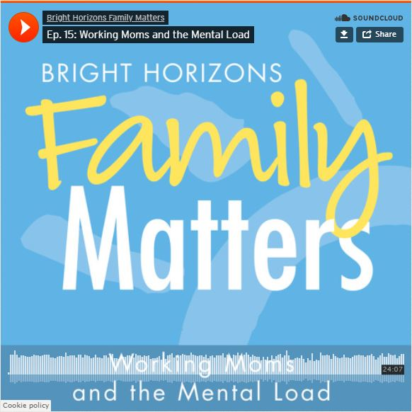](https://www.brighthorizons.com/family-resources/podcasts/working-moms-mental-load)

**New Parenting Podcast Episode!**

Working Moms and the Mental Load

Put on your creative caps and repurpose recyclable items from your household into art supplies. Instead of tossing recyclable materials, re-use them. Gather recycled materials ranging from used bottles, old clothing, cardboard, or anything else you can think of and get busy creating!

Earth Day is April 22nd and is a day dedicated to raising awareness for the importance of keeping our planet healthy and clean.

As Earth Day approaches, your child may be involved in projects and activities that foster an awareness of and appreciation for the earth's resources. To extend the learning that takes place in your child's center or school, and make caring for the earth part of your family culture, we encourage you to make time for some green activities this Earth Day.

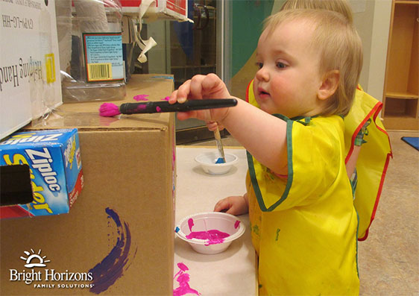



Check out all the places you can connect with us!

