 | MONDAY | TUESDAY | WEDNESDAY | THURSDAY | FRIDAY
WEEK 1  11/14 – 11/18 | AM: Cereal with Milk  PM: Nutri Grain with Milk | AM: Blueberry Muffins and Milk  PM: Rice Cakes with Milk | AM: Fruit Yogurt with Graham Crakers  PM: Animal Crackers and Milk | AM: Cheese Sticks with Crackers  PM: Applesauce and Crackers | AM: English Muffins and Jelly  PM: Fruit Cup and Crackers
WEEK 2  11/21 – 11/25 | AM: Cereal with Bananas  PM: Applesauce with Crackers | AM: Blueberry Muffin with Milk  PM: Blueberry Lemon Crispy Bites | AM: Fruit Yogurt  PM: Baked Cinnamon Rolls | CLOSED | CLOSED
WEEK 3  11/28 – 12/02 | AM: Cereal with Milk  PM: Fruit Cup with Graham Crackers | AM: Cinnamon Raisin Bagel w/Cream Cheese  PM: Animal Crackers with Milk | AM: Nutri Grain Bar and Milk  PM: Fruit Yogurt and Granola | AM: Wheat Bagel with Milk  PM: Rice Cakes and Milk  d Wheat Crackers | AM: Cheese with Wheat Wafers  PM: Applesauce with Crackers
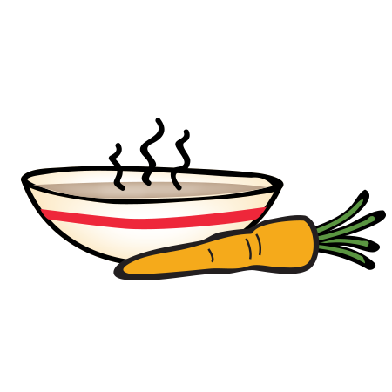
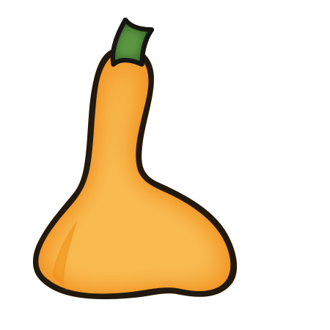
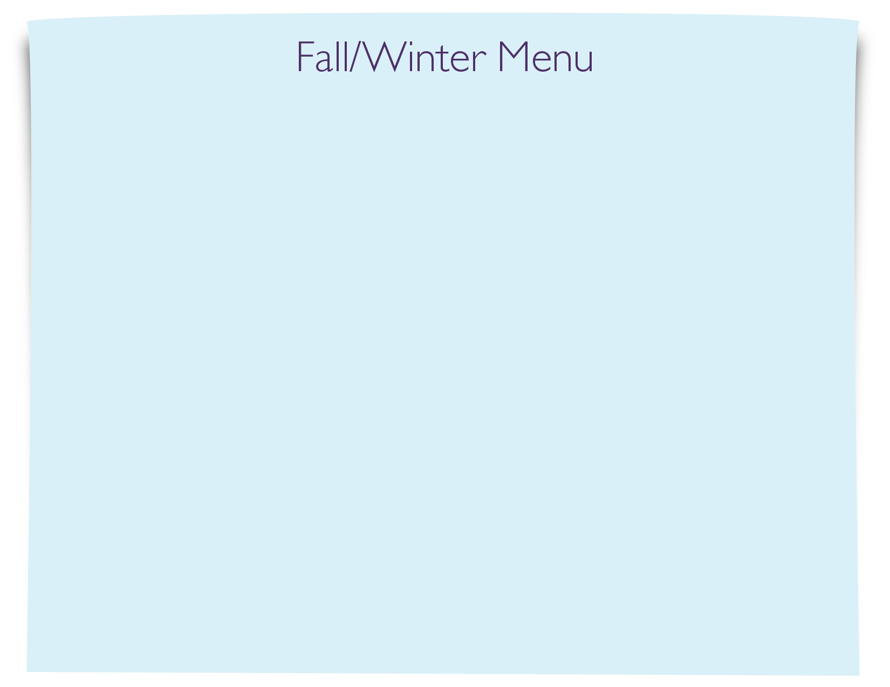
Snack Menu

