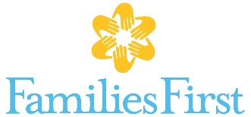 What we’re wishing for….
Father Engagement
- Baby gates
- Adult bicycles
- Car seats and booster seats
- Gift cards for transportation: Uber, Lyft, gas, weekly or 30-day IndyGo bus pass
- Gift cards for kid-friendly restaurants, ice cream, etc.
- Passes to kid-friendly entertainment for supervised visitation: 2 adults plus at least 1 child to zoo, Conner Prairie, Children’s Museum, swim parks etc.

Parent education, Parent Café
- Post-It Self-Stick Easel Pad
- Disposable cups, plates, forks, tablecloths
- Source material for parenting education – up-to-date, evidence-based worksheets, workbooks, games
Domestic violence and sexual assault programs
- Legal services for clients – particularly family-law
- Snacks for children’s groups and one-on-one counseling
- Snacks for adult program groups
- Craft items for adults and children
- Gift cards for transportation: Uber, Lyft, gas, weekly or 30-day IndyGo bus pass
Homebased family preservation
- Baby gates
- Source material – up-to-date, evidence-based worksheets, workbooks, games
- Gift cards for kid-friendly restaurants, ice cream, etc.
- Gift cards for transportation: Uber, Lyft, gas, weekly or 30-day IndyGo bus pass
- Zoo membership
Crisis & Suicide Intervention Service
- Snacks for hotline/text line volunteer training

Chemical Dependency

- Gift cards for transportation: Uber, Lyft, gas, weekly or 30-day IndyGo bus pass

