Updating your browser on your Samsung Phone
If you are using an older Samsung phone to connect to our software, it may not support TLS 1.2.

To make sure you are able to continue using our site on your device, please update your browser.

Google Chrome
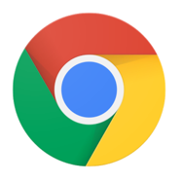
We recommend using Chrome as your default browser on your phone. If you already have it installed, make sure you have the most updated version from the app store. If you do not use Chrome and would like to, you can download it here (or search for “Chrome” in the Google Play app store).

Samsung Internet Browser
If you are using the default Samsung browser and would prefer to continue doing so, click this link on your device (or go to the Google Play app store and search for “Samsung Internet Browser”) and install the most updated version. Depending on how old your device is, this may or may not be sufficient to fix the problem, so we recommend using Chrome instead if it still does not work after you have updated.

