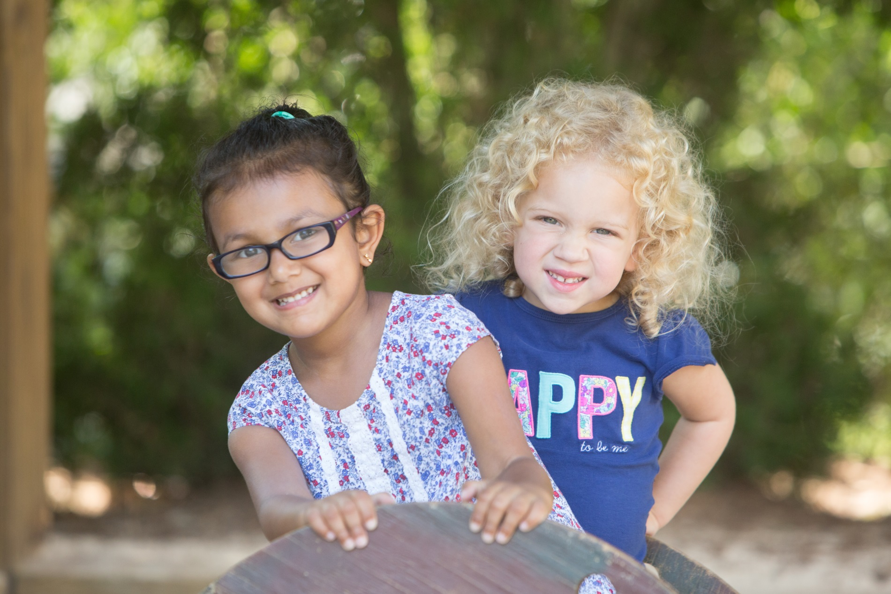

Through Camp Explorations, our summer camp program at **Bright Horizons**®, your child will have the opportunity to enjoy everything summer has to offer. During action-packed days, your child will experiment with science and technology, engage in the creative arts, discover nature, and explore the world. With experienced teachers, a curriculum based on each child’s interests, engaging projects and activities, special visitors, and more, summer will be fun and educational at the same time.

* + And much more!
  + St. Johns River Keeper
  + Lark Bee Company

**Camp Explorations Highlights**

* Fun and educational programs for our Preschool and Kindergarten Prep children
* Age-appropriate, engaging themes that incorporate children’s interests
* Weekly water play, daily fitness activities, and special guests such as;
  + MOSH
* Flexible weekly schedules with full- and part-time options
* Health, safety, and security policies that meet or exceed local, state, and national standards
* NAEYC accredited in Jacksonville for 25 years

Bright Horizons at the Avenues

9000 Southside Blvd, Bldg #1100   
Jacksonville, Fl.32256 | 904-519-8560

avenues@brighthorizons.com | brighthorizons.com/avenues