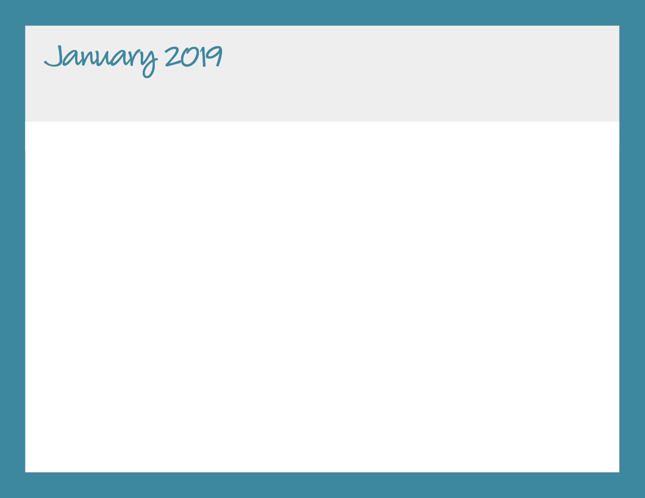

|  |  |  |  |  |
| --- | --- | --- | --- | --- |
| **Monday** | **Tuesday** | **Wednesday** | **Thursday** | **Friday** |
|  | 1  New Year’s Day | 2 | 3 | 4 |
| 7  Baked Chicken Nuggets, Roasted Seasonal Veggies, Fresh Fruit | 8  Lean Beef Tacos, Rice & Beans, Fresh Fruit | 9  Turkey Sandwich, Baked Chips, Fresh Fruit | 10  Mac & Cheese, Roasted Seasonal Veggies, Fresh Fruit | 11  Pizza by Papa John |
| 14  Baked Chicken Nuggets, Roasted Seasonal Veggies, Fresh Fruit | 15  Cheese Tortellini w/Tomato Sauce, Roasted Seasonal Veggies, Fresh Fruit | 16  Baked Chicken Piccata, Roasted Seasonal Veggies, Roll, Fresh Fruit | 17  Mac & Cheese, Roasted Seasonal Veggies, Fresh Fruit | 18  Pizza by Papa John |
| 21  **NO YUMMY LUNCHES**  Martin Luther King Day | 22  Baked Chicken Nuggets, Sauteed Broccoli & Garlic, Fresh Fruit | 23  Lean Beef Sloppy Joe's, Roasted Seasonal Veggies, Fresh Fruit | 24  Maple Mustard Glazed Sliced Turkey, Roasted Seasonal Veggies, Roll, Fresh Fruit | 25  Pizza by Papa John |
| 28  Pasta w/Lean Beef Meatballs & Tomato Sauce, Roasted Veggies, Fresh Fruit | 29  Chicken Caprese, Roasted Seasonal Veggies, Roll, Fresh Fruit | 30  Philly Cheesesteak, Roasted Seasonal Veggies, Fresh Fruit | 31  Mac & Cheese, Roasted Seasonal Veggies, Fresh Fruit | 2/1  Pizza by Papa John |

**Bright Horizons at Military Trail**

**561-969-9025 | mili@brighthorizons.com | brighthorizons.com/mili**