 | MONDAY | TUESDAY | WEDNESDAY | THURSDAY | FRIDAY
BREAKFAST  SNACK | Oatmeal with Fruit Topping  Milk | Egg and Sliced Cheddar Cheese Biscuits  Bananas  Milk | Bagel & Cream Cheese  Strawberries  Milk | Egg Scrambler with turkey bacon and cheese  Diced Pears  Milk | Cheerios  Mango Chunks  Milk
LUNCH | Teriyiki Chicken with Rice  Broccli  Oranges Wedges  Milk | Roast Turkey  Mashed Potatoes  Whole Wheat Roll  Watermellon  Milk | Maccaroni and Cheese with Ham  Mixed Veggies  Mixed Berries  Milk | Lasagana with Beef  Carrots  Pears  Milk | Turkey  With Sliced Cheese on a Crossiant  Cucumbers  Strawberries  Water
AFTERNOON SNACK | Cheese Its  Melon Chunks  Water | Nutri-Grain Bar  Apple Slices  Water | Multi-Grain Crackers  Diced Apricots  Water | Yogurt Cup  Mixed Berries  Water | Oatmeal Muffin  Applesauce  Water
Spring/Summer Menu 2017
Menu #3
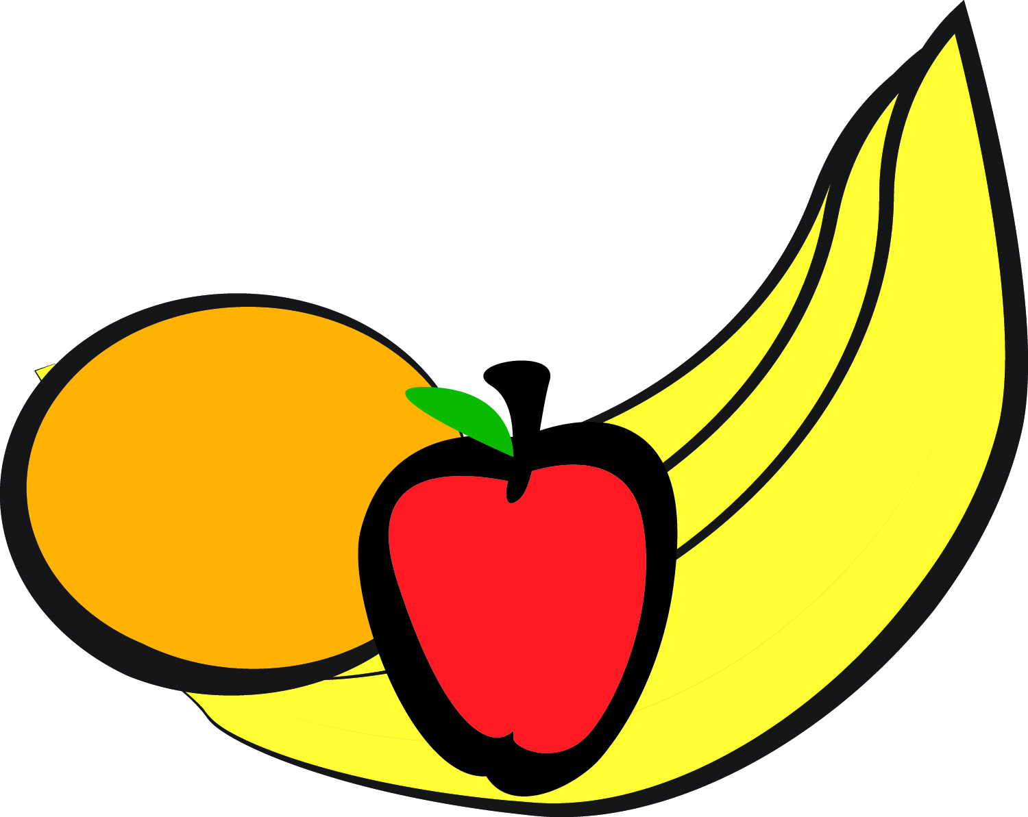
Approved Fruit Substitutions: : Melon, Berries, Peaches, Pears,
Bananas, Oranges, Pineapple, Apple Slices, Applesauce

Late Afternoon Snack (After 5:30 pm) – Gold Fish, Wheat Crackers, Fruit Bars, Trail Mix, Cheerios

