Petits Sprints de Juin
SCCA Road Racing & High Performance Track Driving
La Junta Raceway
June 8 & 9, 2019

Schedule
Express Tech:
Fri., 6/7 6:30 pm - 8:30 pm
Classroom Bldg.

Tech / Scales:
Sat., 6/8 8:00 am - 5:00 pm
Sun., 6/9 8:00 am - 3:00 pm
Paddock / North.

HPTD:
Sat., 6/8 & Sun., 6/9 7:00 am
Raised Paddock South of Classroom Bldg.
Tech Inspection
Meetings

Workers Muster
Sat., 6/8 8:00 am
Sun., 6/9 8:00 am
At the big tree.

Drivers Meeting
Sat., 6/8 After each groups first session
In Impound.

HPTD Drivers Meeting
Sat., 6/8 & Sun., 6/9 7:30am
Raised Paddock South of Classroom Bldg.
Registration Hours

Fri., 6/7 6:30 pm – 8:30 pm

Sat., 6/8 7:30 am – 12:00 pm

Sun., 5/5 8:00 am - 12:00 pm

Classroom Bldg.

Run Groups

Regional Group 1: Closed Wheel - AS, GT1, GT2, GT3, GTL, T1, T2, T3, T4, EP, FP, HP, STL, STU, B SPEC, SM, Spec M3, SP, ITA, ITB, ITC, ITE-O, ITE-U, ITR, ITS, SPEC 944, SPEC E30, S7, Pro7, GTX

Regional Group 2: Open Wheel - FA, FB, FC, CC, FE, FE2, FM, ASR, P1, P2, FS, FF, CF, SF, FS, FV, CV, FST, F5, SRF, SRF3

High Performance Track Driving (HPTD)

Saturday, Jun. 8, 2019
9:00 am – 9:15 am Regional: Closed Wheel – Practice (15min)
9:20 am – 9:35 am Regional: Open Wheel – Practice (15min)
9:40 am – 10:00 am High Performance Track Driving (HPTD)(20min)
10:05 am – 10:20 am Regional: Closed Wheel – Qualifying (15min)
10:30 am – 10:45 am Regional: Open Wheel – Qualifying (15min)
10:45 am – 11:00 am Worker Break
11:00 am – 11:30 am Regional: Closed Wheel – Race #1 (25min)
11:35 am – 12:05 am Regional: Open Wheel – Race #1 (25min)
12:05 pm – 1:05 pm Lunch
1:05 pm – 1:25 pm High Performance Track Driving (HPTD)(20min)
1:35 pm – 2:10 pm Regional: Closed Wheel – Race #2 (27 Laps)
2:15 pm – 2:50 pm Regional: Open Wheel – Race #2 (27 Laps)
2:55 pm – 3:10 pm High Performance Track Driving (HPTD)(15min)
5:00 pm - Dinner & Evening Party

Sunday, Jun. 9, 2019
9:00 am – 9:15 am Regional: Closed Wheel – Practice (15min)
9:20 am – 9:35 am Regional: Open Wheel – Practice (15min)
9:40 am – 10:00 am High Performance Track Driving (HPTD)(20min)
10:05 am – 10:20 am Regional: Closed Wheel – Qualifying (15min)
10:30 am – 10:45 am Regional: Open Wheel – Qualifying (15min)
10:45 am – 11:00 am Worker Break
11:00 am – 11:30 am Regional: Closed Wheel – Race #1 (25min)
11:35 am – 12:05 am Regional: Open Wheel – Race #1 (25min)
12:05 pm – 1:05 pm Lunch
1:05 pm – 1:25 pm High Performance Track Driving (HPTD)(20min)
1:35 pm – 2:10 pm Regional: Closed Wheel – Race #2 (27 Laps)
2:15 pm – 2:50 pm Regional: Open Wheel – Race #2 (27 Laps)
2:55 pm – 3:10 pm High Performance Track Driving (HPTD)(15min)

SANCTION NUMBERS TBD

GENERAL
Event Facility: La Junta Raceway Phone: 719-469-1424
30267 1st Ave.
La Junta, CO 81050

Length of the Racetrack: 1.3 mile, 7 turn road course
Direction of the Race: Clockwise
Pole Position: Chosen by Pole Sitter
Location of Race Control: Tower
Start Line: On the Front Straight
Finish Line: On the Front Straight

ADDITIONAL REGULATIONS

This event is governed by the current General Competition Rules (GCR) and Category Specifications, as amended by “FasTrack.
Track Event portions of this event are governed by the current Track Event Rules.

Name of the Event: Petits Sprints de Juin
Close of Entries: Tue., Jun., 4 2019, or as extended by registration officials

ENTRY FEES:
- Weekend: $350
- Single Day: $225
- Enterprises Compliance(SRF,SRF3,FE,FE2): $30
- Double Dip: $300
- High Performance Track Driving (HPTD) $150 Weekend, $75 Single Day

- Double Dip: A driver wishing to register with additional cars or in multiple classes. Applies to each additional registration. Driver agrees to comply with the published groupings and group order. Please use the double dip option at the time of registration.
- A change in any entry after the start of the event requires re-registering and may involve additional fees.
- Spectator entry at La Junta is FREE.

REGISTRATION: Online registration is held at http://coloradoscca.motorsportreg.com. Acceptable payment includes Visa, MC, Discover, Check, or PayPal. If you need help registering, please contact the race chair or the registrar.
- Online registration will close at midnight of the Tuesday prior to the event, unless extended by registration officials.
- Event payments will be processed the Wednesday prior to the event. A $50.00 late fee will be assessed after registration closes. A $50.00 fee will be assessed on returned checks/bankcards.
- Cancellations may be made through the Chief Registrar prior to the event. Cancellations made after payment processing shall incur a $50 processing fee. Refund requests without prior notice must be made to the region treasurer teri.massey@comcast.net within 7 calendar days following the event.
- Refunds due to mechanical failure will be considered by the Chief Registrar for cars that have not been on the racing surface as verified by the Chief of T & S. Requests must be submitted to the Chief Registrar before the end of the event.
- Approved refunds will be issued via MotorsportReg.
- Registration check-in will be held in the Registration/Hospitality building in the paddock. All drivers, volunteers, and officials must check-in to complete registration and receive credentials, even if you have signed an annual SCCA waiver.
- Only members who hold a current SCCA membership may be credentialed for the hot areas. Weekend memberships can be purchased at Registration, during posted hours, for a fee of $15.00.

DRIVER ELIGIBILITY: Drivers must have a current SCCA membership with a current SCCA Full Competition License, SCCA Pro License, SCCA Vintage License, or SCCA Novice Permit. In addition, Colorado Region welcomes ALL organizations whose licenses are currently approved by SCCA for competition as listed in the GCR, Appendix C, 2.8.B (pages 109 & 110). Download GCR. Proper credentials must be presented to complete event registration.

CAR ELIGIBILITY: This competition is open to all cars conforming to the GCR, as amended.
- Colorado Region also recognizes Regional and Spec Classes specific to the Rocky Mountain Division as follows: Club Ford (CF), Club Formula Continental (CC), Club Vee (CV), ITE Everything (ITE-0, ITE-U), Spec RX-7 (S7), Spec 7 with 13B (Pro 7), Spec 944 (S944), Spec E30 (SE30), Spec M3, Spec Formula F (SF), and Super Production(SP). Class rules and information for these classes can be found at http://www.coloradoscca.org/rulesforms.php
- Rocky Mountain Division Regional Championship rules are available online at http://www.coloradoscca.org/rulesforms.php

COMPETITION NUMBERS: Preference will be given to numbers assigned through the Rocky Mountain Division numbering program. Unreserved numbers are on a first-come, first-served basis. All numbering assignments are subject to race group configurations.

TECH: Tech inspection hours are posted on the event schedule.
- Express Tech is available for drivers with both a current annual tech and a current year helmet sticker. Drivers should bring their vehicle logbook and registration credential to get their event stickers.
- Drivers without a current year helmet sticker must present all driver gear as required by the GCR, vehicle logbook, and registration credential to Tech. If your car requires an annual tech, you must also bring the car to tech. An event tech sticker will be issued after everything is examined and approved.
- The order of inspection at the track will be:
  - Express Tech
  - Re-inspection, logbook notation
  - Annual inspection
  - Cars with no logbook (new or lost logbooks)
- Competitors needing Annual inspections or New Logbooks must make prior arrangements with the Chief of Tech to have these items performed by tech personnel at the track.

SCALES: Scales will be available each day from 8:00am until the end of competition, except during impound. Driving on or off the scales is prohibited unless otherwise instructed by Tech personnel. Motors must be turned off and competitors and/or crew must push cars on and off scales.

EVENT SCHEDULE / RUN GROUPS: The course configuration for this event will be Clockwise. The event schedule or run groups may be changed at the discretion of the Chief Steward. If changes are made, as much notice as possible will be given to all competitors.
- The schedule as published is for planning purposes. Session start times may vary from the published schedule as the event progresses.
- Saturday and Sunday Races will be based as follows: Race 1 (20 minutes), Race 2 (27 laps or 30 minutes, whichever occurs first).

TIMING AND SCORING: All cars are required to use fully operational AMB transponders.
- It is the driver’s responsibility to make sure their transponder is working AND that the correct transponder number has been provided in the registration system or directly to the registrar. A vehicle without a working transponder or with a missing transponder number may not be scored.
- Additional transponders may be available for rent at the rate of $80.00 for the weekend, along with a $500 retainer on a valid credit card. The retainer will not be charged unless damage or loss of the transponder occurs. These are available on a first-come, first-served basis and should be reserved through the online registration process.
- The clock will continue to run during all flag conditions with the exception of the red flag.
- Personal timing beacons are not allowed within 20 feet on either side of the T & S system, or across track from Start/Finish.

GRID: Starting positions for the first race each day will be determined by the fastest time recorded for each car during the preceding qualifying session. Starting positions for each subsequent race will be determined by the finishing position from the race immediately preceding it. Cars arriving at the grid after their group has been dispatched on track may, at the discretion of the Operating Steward, be held at pit out and released at the end of the pack after the field has completed the pace lap.
- Crew / Guests must leave the grid at the one-minute warning.
- Drivers are prohibited from scrubbing tires in the paddock, grid, pit out to the course and hot pit lane.

RESULTS & AWARDS: Trophies for feature races (Race #2) will be awarded in accordance with the GCR.
- Results and trophies will be available in the hospitality area. Sunday trophies will be available until 1 hour after the last checkered flag. Trophies not picked up will be considered forfeited unless prior arrangements have been made with the race chair.
- Only cars with an SCCA logbook will be eligible for points towards the Rocky Mountain Division Championship Series.

FLAGGING: Applies to Club Racing groups and Track Event (HPTD)
- GCR 6.1.1 flag rules apply to all sessions
- BLACK FLAG station is at corner station 6
- For practice sessions, a CHECKERED FLAG signaling the end of the session may be displayed at BOTH Start/Finish AND Corner 6. Cars receiving the Checkered Flag at Corner 6 must proceed directly to the pit lane/paddock
- Last lap may be a waiving white flag or “1 to go” sign at start/finish.

DESIGNATED INCIDENT INVESTIGATION SITE
- If a driver is involved in significant body contact, the driver and car shall stop at the designated incident investigation site for review of the incident by the stewards before going to their paddock area.
- The designated incident investigation site for La Junta Raceway is in pit lane immediately before the exit to the paddock.
- “Significant body contact” includes but is not limited to: contact resulting in 2 or 4 wheels off course, spins, loss of position, or repairs to suspension or bodywork.

DISABLED CARS: Disabled or damaged cars may be removed from the course and delivered to a central location. If the car has sustained body/chassis damage it will be taken to impound and will be released to the driver/crew after tech has made appropriate notations in the vehicle log book. Cars disabled due to a mechanical failure will be released to the driver/crew immediately. If the car requires wrecker support to return to its paddock location, there may be a delay depending on the availability of wreckers or flat tows.

RADIO FREQUENCIES: The region frequencies below shall not be used for communications by any participant.

451.2875 | 451.3125 | 451.3375 | 451.3625 | 451.3875 | 461.5125
463.2625 | 466.2125 | 466.5875 | 468.3125 | 469.1250

PADDOCK
- Access ways for general paddock traffic and Emergency Vehicles must be kept clear at all times or vehicles will be towed.
- You must have a valid motor vehicle license to operate any 2, 3, or 4-wheeled motorized or non-motorized vehicles in the paddock.
- Skateboards, skates, and rollerblades are prohibited.
- The paddock speed limit is 10 M.P.H. Vehicles in the paddock must be operated in a safe manner.
- Entrants are responsible for the conduct of their crew, guests, minors, and pets. All minors must be under direct adult supervision at all times. Pets in the paddock must be leashed and under direct supervision of an adult at all times.
- Minors and non-members must remain behind any barrier paralleling the Hot Pit lane. No one will be allowed to view from in front of the Race Control and Timing structure.

GENERAL: Participants must display proper credentials at all times.
- The organizers reserve the right to postpone, abandon or cancel the event, or any part of the event. Entry fees will be refunded to those offered no opportunity to compete.
- Any test day or session not on the official schedule is NOT sanctioned by SCCA and is NOT covered by SCCA Insurance.
- Vendors wishing to display or sell any items must obtain prior approval from the race chair.
- The consumption of alcohol is prohibited until after the daily on track activities are concluded. In addition, GCR 2.3.1.B shall be in effect as it relates to Narcotics and Dangerous Drugs.
- The organizers reserve the right to refuse entry and/or issuance of credentials to the premises or event for any reason except race, color, creed, sex, or national origin.
- Unmanned aerial vehicles, also known as drones, shall not be used anywhere in the airspace over the property.
- All on track body contact (including contact during drafting) that causes a car to act erratically and results in a change of position or a car leaving the course will be investigated.
- Drivers are only permitted to scrub tires on the course, while under control of the pace car or if no pace car is being used, during a full course
yellow status on the course.
- Club racing penalty guidelines can be found online at http://www.coloradoscca.org/documents/2019_penalty_guidelines.pdf

High Performance Track Driving (HPTD): Sessions will be governed by the current track event rules. Rules can be found at https://www.scca.com/pages/scca-track-events and additional information can be found at http://www.coloradoscca.org/hptd.php
- Pre-registration is required. Participants are required to have a valid driver license and either an Annual or Weekend SCCA membership prior to taking part in the event. Annual memberships can be purchased through www.scca.com. Weekend memberships will be available during online registration.
- If you do NOT have a signed tech form, please see the HPDT chief of tech to have your car inspected during the HPTD Tech times and location as listed on the schedule.
- Participants must attend the mandatory track event Driver’s meeting at the time and location listed on the schedule. In addition, drivers will attend a short debrief with the HPTD chief after each on track session.
- Volunteers can participate in one FREE HPDT session during each day worked as coordinated with their chief of specialty and the HPTD event chief.

EVENT OFFICIALS:

Event Chief Steward | TBD | Chief of F & C | Ed Kajko  303-650-1590  zydecolds@gmail.com
Chairman of SOM | TBD | Chief of Course | William Carter  303-827-8721  Turnandburn86@gmail.com
 |  | Chief Starter | Leah Street  208-360-0448  moonstonelvs@gmail.com
Regional Executive | Kevin Carter  720-999-2439  ftokev1@yahoo.com | Chief of Hospitality | Chris Frank  303 478-7874  chrsfcdr4@comcast.net
Race Chair | Michelle McColl  303-898-2597  mccollteam@comcast.net | Chief of Sound Control/Radios | Nancy Foster  303-304-6661  nlfradioqueen1@comcast.net
Chief Registrar | Ann Marie Stinehelfer  720-339-0991  amstine45@gmail.com | Chief of ES | Chris Framel  719-248-4886  cframel45@gmail.com
Chief of Tech | Lois Peterson  602-616-4598  scca.techgirl@gmail.com | HPTD Event Lead | Kevin Carter  720-999-2439  ftokev1@yahoo.com
Paddock Marshall | Michelle McColl  303-940-9128  mccollteam@comcast.net | HPTD Chief Driving Coach | Kevin Carter  720-999-2439  ftokev1@yahoo.com
Chief of Pit / Grid | Teri Massey  303-913-1142  Teri.massey@comcast.net | HPTD Chief Tech | Kevin Carter  720-999-2439  ftokev1@yahoo.com
Chief of Timing/Scoring | John Frank  303 881-2456  jfcdrts@comcast.net | HPTD Chief Safety Steward | Kevin Carter  720-999-2439  ftokev1@yahoo.com

MAPS:
La Junta Raceway
1.3 miles
Altitude – 4100 feet
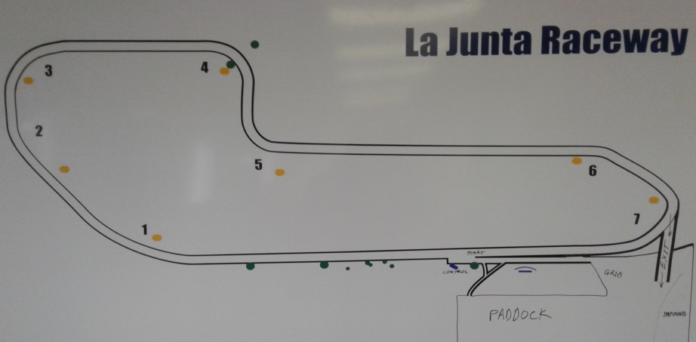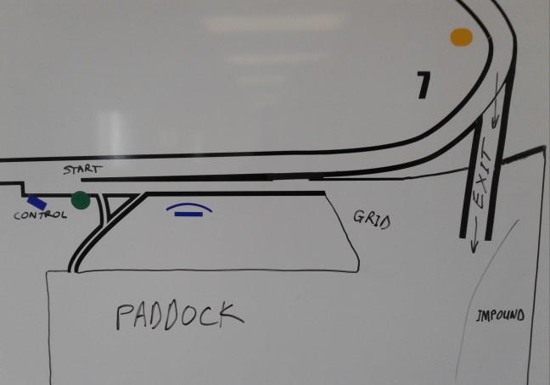

ADDITIONAL EVENT INFORMATION

Race Fuel: La Junta Municipal Airport has 100 low lead AV gas ($4.45/gallon) at the self-serve pump (credit card only), within walking distance of the race track. Loaf n Jug, about 2.5 miles south of the track has 91 octane. There is no other fuel available at the track.

Directions to La Junta Raceway:
La Junta Raceway is on Route 109 (Main Street) about four miles north of US-50 in the Airport Industrial Park of La Junta CO. Enter at the main Industrial Park entrance and turn left onto SOS/Otero Avenue, keeping the golf course to your right. Turn left again at the end of the road, then right on Railroad Avenue, and left again into the track grounds.

Accommodations:
RVs may be parked overnight at the track. A limited number of electrical hookups are available for rent. First Come, First Serviced by pre-arrangement with the Track Manager, Allan Lasater at Allan@lajuntaraceway.net. Rent is 20A - $50/weekend, 30A & 50A - $70/weekend, payable by cash or check at the track.

Other accommodations near La Junta Raceway:

Red Lion Hotel Midtown Motel Hampton Inn Econo Lodge
1325 East 3rd Street 215 East 3rd Street 27800 W US Highway 50 27882 Frontage Road
La Junta, CO 81050 La Junta, CO 81050 La Junta, CO 81050 La Junta, CO 81050
Phone: (719) 383-3946 Phone: (719) 384-7741 Reservations: (844) 275-0458 Phone: (714) 384-4408

Host Hotel:
The Red Lion Hotel is offering an in house racer/volunteer discount. The rate is $59/night. This rate is only available by calling the local desk number (719)383-3946 and is not available for online reservations. The discount Code is VM2019.

Volunteer Incentives:
Volunteers are required to pre-register on MSReg, so arrangements can be made for lunches, Saturday night dinner / party, etc. If you need help with registration, please contact the race chair or registrar.
- A lunch ticket will be given to each volunteer for each day worked.
- Volunteers are invited to participate in one Free HPTD session on Saturday and Sunday. Sessions should be coordinated with the workers specialty chief and the HPTD Chief.
- Volunteers will receive hotel reimbursement for 1 – 3 nights, depending on the number of days worked. Volunteers are required to book their own hotels. The region will reimburse ½ of the hotel room per volunteer. Share a room with another volunteer and get 100% reimbursement. The maximum amount of reimbursement will be based on the nightly rate at the host hotel, though volunteers are not required to stay at the host hotel. Please present the paid receipt to the Race Chair before the end of the event. The treasurer will mail reimbursement immediately after the event.

