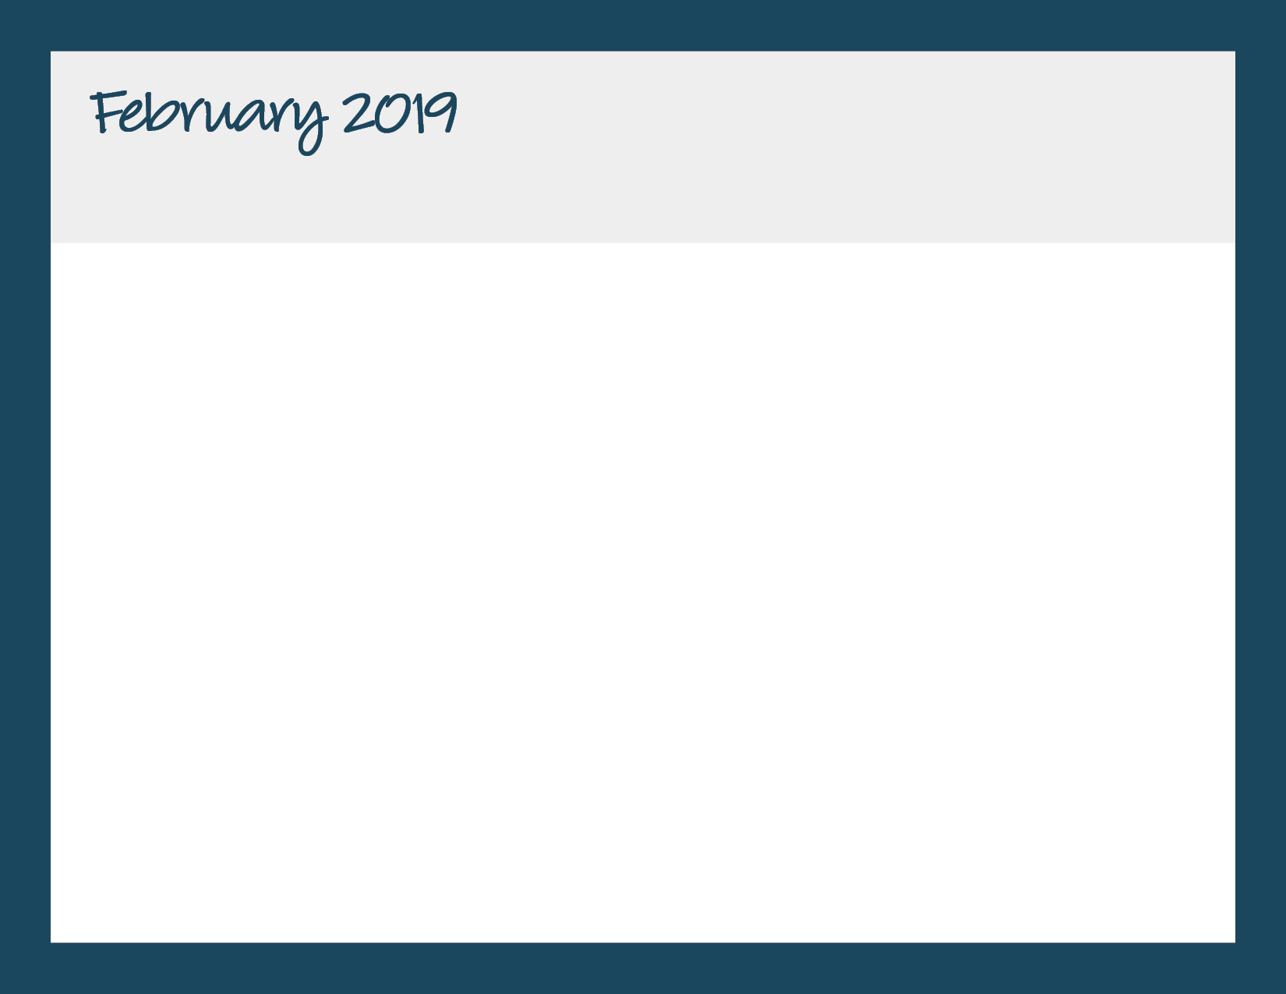

|  |  |  |  |  |
| --- | --- | --- | --- | --- |
| **Monday** | **Tuesday** | **Wednesday** | **Thursday** | **Friday** |
|  |  |  |  | 1 |
| 4  Pasta w/Turkey Bolognese Sauce, Roasted Seasonal Veggies, Fresh Fruit | 5  Breakfast for Lunch--Sweet Potato Pancakes, Eggs, Fresh Fruit  Chinese New Year | 6  Turkey Sandwich, Baked Chips, Fresh Fruit | 7  Mac & Cheese, Roasted Seasonal Veggies, Fresh Fruit | 8  Pizza by Papa John |
| 11  Baked Chicken Nuggets, Roasted Seasonal Veggies, Fresh Fruit | 12  Roasted Chicken w/Smashed Potatoes, Roasted Sweet Peas, Fresh Fruit | 13  Marinated Chicken, Baked Plantains, Brown Rice, Fresh Fruit | 14  Lean Beef Meatballs w/Tomato Sauce, Roll, Roasted Veggies, Fresh Fruit  Valentine’s Day | 15  Pizza by Papa John |
| 18  **NO YUMMY LUNCHES**  President’s Day | 19  Baked Chicken Nuggets, Glazed Carrots, Fresh Fruit | 20  Sweet & Sour Chicken w/Veggie Fried Rice, Steamed Edamame, Fresh Fruit | 2  Grilled Cheese, Roasted Seasonal Veggies, Fresh Fruit  1 | 22  Pizza by Papa John |
| 25  Baked Chicken Nuggets, Roasted Veggies, Fresh Fruit | 26  Maple Mustard Glazed Sliced Turkey, Roasted Sweet Potato Fries, Roll, Fresh Fruit | 27  “Make Your Own Yummy...” Chicken Fajitas, Brown Rice, Black Beans, Fresh Fruit | 28  Baked Fish Cakes w/Slaw (on the side), Roasted Veggies, Fresh Fruit | 3/1  Pizza by Papa John |

Bright Horizons at Military Trail

561-969-9025 | mili@brighthorizons.com | brighthorizons.com/mili