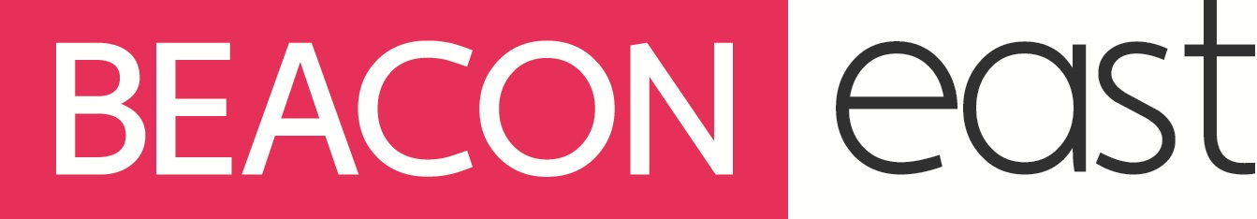

CAREERS GROUP SESSION FEEDBACK

School: Careers Adviser: Group session: Date:

- How useful did you find this group session overall?

Very helpful Helpful Quite Helpful Not helpful

10 9 8 7 6 5 4 3 2 1 0

- How interesting did you find the group session?

Very interesting Interesting Quite interesting Not interesting

10 9 8 7 6 5 4 3 2 1 0

- What type of things did you learn about in the session, that YOU found most helpful?

- Did you feel comfortable to join in with discussions and give your own views and answers?

Very comfortable Comfortable Quite comfortable Not comfortable

10 9 8 7 6 5 4 3 2 1 0

- Do you feel more confident about the support you will receive from the Careers Adviser, over the next few years, regarding your post 16 choices?

Very confident Confident Quite confident Not confident

10 9 8 7 6 5 4 3 2 1 0

- Please explain your answers briefly.

- Any other comments or feedback?

