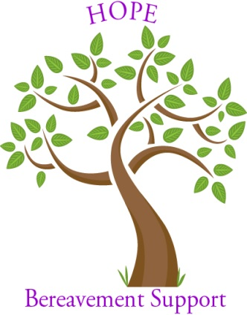
NEW DAY PROGRAM FOR BEREAVED Autumn 2018

St Thomas Church in Southington will conduct a bereavement seminar beginning September 5, 2018. Anyone grieving the death of a loved one is encouraged to enroll and participate at no cost. The New Day process, developed by Sr. Mauryeen O’Brien, OP, will be used. Participants will meet each Wednesday evening from 6 – 8 pm for 10 consecutive weeks. This process has been very successful in helping the bereaved transition to life without their loved one. During each meeting, participants work through one element of the grieving process using prayer, reflection, sharing and journaling. Everything that is shared during the meetings is held confidential. For more information or to enroll please call Deacon Vinny Raby 860-628-9425 or you may call the Parish office 860-628-4713.

