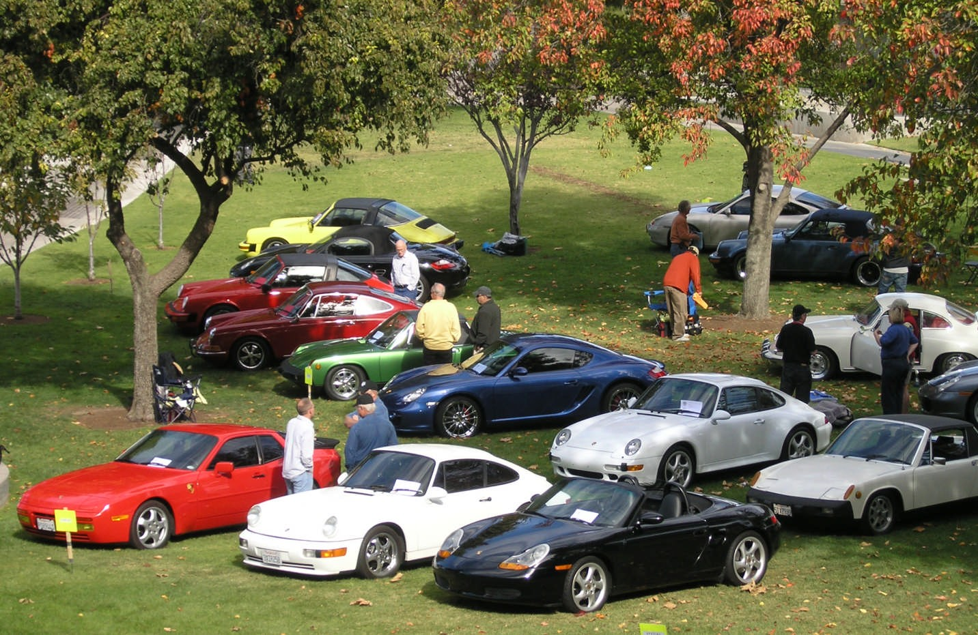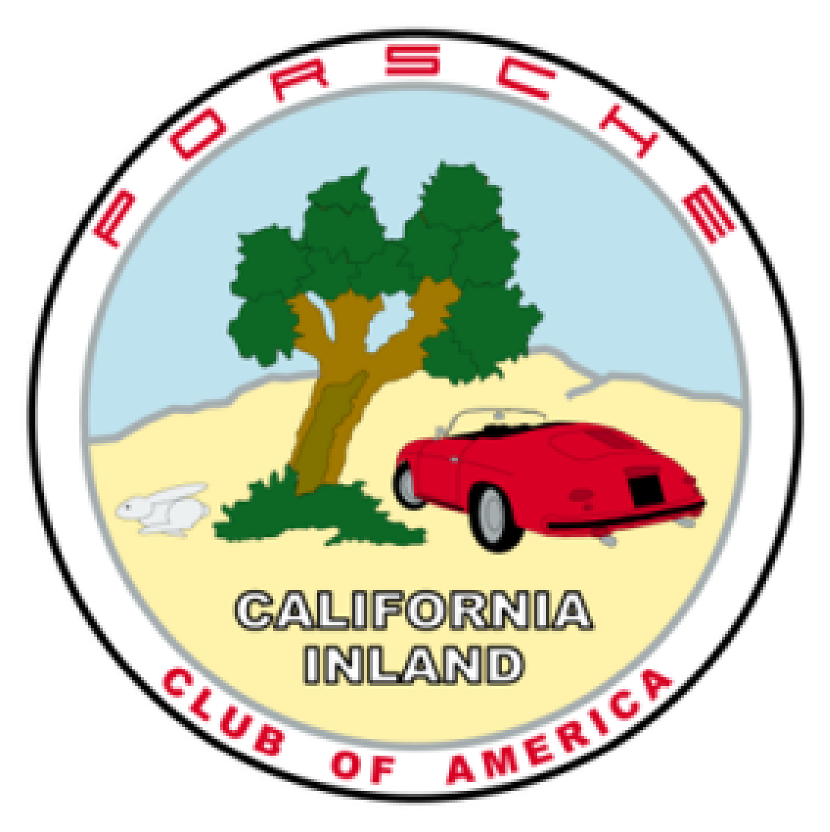

PCA California Inland Region Presents the Zone 8

CONCOURS/CAR SHOW IN THE CANYONS

Date: Sunday, April 29, 2018
Location: College of the Canyons
26455 Rockwell Canyon Road, Santa Clarita, CA.
Exit I5 at Valencia Boulevard proceed eastbound to the first driveway (W Rd.) and follow the signs.

Come on out with your friends and family to our annual all-new Concours/Car Show. All cars will be displayed on grass in a beautiful park-like setting at the College of the Canyons in Santa Clarita. In addition to those Porsches in the Judged Categories, we will also present a “People’s Choice Award” in the Display Category for the Porsche you would most likely want to have in your garage.

If you have one or more friends that have a Porsche and are not yet members, we invite them to register and display their cars in this beautiful setting. Many local visitors will be attending so let’s get prepared to show off our Porsches!

The Concours will be in a tree-lined area adjacent to the campus stadium. Placement will begin at 8 a.m., Judging begins at 10:30 a.m. and awards at 2 p.m. Complimentary lunch (with entry) and bottled water will be available. Additional lunches will cost $15 each.

Registration: http://cai-pca.motorsportsreg.com

Questions: Contact Herman Rijfkogel at herman_rijfkogel@yahoo.com or concours@cai.pca.org
Telephone: 661-810-7054

FULL CONCOURS DIVISION
- C-1  - C-2 | All Closed 356  All Open 356 | - S-9 | All 924, 928, 944, 968 | •  • | W&S-1 W&S-2 | All Closed 356  All Open 356
• C-3 911-912 (1965-1973) UNRESTORED DIVISION • W&S-3 911 , 912 (1965-
- C-4 | 911, 911 Turbo, 930, | - UR-1 | All Closed 356 |  |  | 1973)
 | 912E (1974-1983) | - UR-2 | All Open 356 | • | W&S-4 | 911, 911 Turbo, 930,
- C-5 | 911 Carrera & Turbo | - UR-3 | 911, 912 (1965-1973) |  |  | 912E (1974-1983)
 | (1984-1989) | - UR-4 | 911, 911 Turbo, 930, | • | W&S-5 | 911 Carrera & Turbo
- C-6 | 911 Carrera & Turbo |  | 912E (1974-1983) |  |  | (1984-1989)
 | (964, 993, 1989-1998) | - UR-5 | 911 Carrera & Turbo | • | W&S-6 | 911 Carrera & Turbo,
- C-7 | 911-Carrera & Turbo, |  | (1984-1989) |  |  | (964, 993, (1989-
 | GT2, GT3 (996, 997, | - UR-6 | 911 Carrera & Turbo |  |  | 1998)
 | 1999-2012) |  | (964, 993, 1989-Y-20) | • | W&S-7 | 911 Carrera & Turbo,
- C-8  - C-9 | 914-4, 914-6  All 924, 928, 944, 968 |  | Current year minus 20 years, Y-20 |  |  | GT2, GT3, (996, 997,  991, 1999-On)
- UR-7 Reserved for future use • W&S-8 914-4, 914-6

• S-8 914-4, 914-6
WASH & SHINE DIVISION

STREET DIVISION
- S-1 All Closed 356
- S-2 All Open 356
• S-3 911, 912 (1965-1973)
• S-4 911, 911 Turbo, 930,
912E (1974-1983)
- S-5 911 Carrera & Turbo (1984-1989)
- S-6 911 Carrera & Turbo (964, 993, 1989-1998)
- S-7 911 Carrera & Turbo, GT2, GT3 (996, 997,
1999-2012)
• UR-8 914-4, 914-6
• UR-9 All 924, 928, 944, 968

UBERGANG DIVISION
- UG-1 Boxster
- UG-2 Cayman
- UG-3 911 Carrera (991,
2012-On)
- UG-4 Cayenne
- UG-5 Panamera
- UG-6 Macan

• W&S-9 All 924, 928, 944,
968
- W&S-10 All Boxster, Cayman
- W&S-11 Cayenne, Panamera,
Macan

SPECIAL CATEGORIES DIVISION*
- SC-1 Special Interest
SC-2 Current Competition
- SC-3 Limited Production
.

* See rules book for definitions of Unrestored Stock and Special Categories Divisions

Areas Judged | Division
 | Full | Street | Unrestored | Special | Ubergang | W&S
Exterior | X | X | X | X | X | X
Interior | X | X | X | X | X | X
Storage Compartment | X | X | X | X | X
Engine Compartment | X | X | X | X
Chassis Half (w/o engine) | X
Chassis Half (with engine) | X

-------------------------------------------------------------------------- Cut Here --------------------------------------------------------------------------

Name Address

Phone City

State Zip E-mail Region Porsche Model VIN # Year Body Type Color License No Class

Concours, $45 per car, Display, $30 per car, + $10 if registration is post marked after April 11th or at the event. Make checks payable to “PCA-CAI”.

Extra Lunches: x $15 TOTAL $

Send registration form with payment to:
Herman Rijfkogel, 111 Clearview Ct., Tehachapi, CA 93561

