 | MONDAY | TUESDAY | WEDNESDAY | THURSDAY | FRIDAY
WEEK 1  04/18-04/22 | AM: English Muffin with Jelly  PM: Pita and Hummus | AM: Muffins and Milk  PM: Fruit Yogurt and Granola | AM: Cinnamon Bagel with Cream Cheese  PM: String Cheese and Milk | AM: Biscuit with Jelly  PM: Applesauce and Crackers | AM: Naan Bread and Sun Butter  PM: Fig Newton Bar and Milk
WEEK 2  04/25-04/29 | AM: Nutri Grain Bar with Milk  PM: Applesauce and Graham Crackers | AM: Cereal with Milk  PM: Rice Cakes with Milk | AM: Naan Bread and Sun Butter  PM: Fruit Cup and Crackers | AM: Fruit Yogurt and Granola  PM: Fig Newton and Milk | AM: Cinnamon Raisin Bagel with Jelly  PM: Fruit Yogurt and Graham Crackers
WEEK 3  05/02-05/06 | AM: Cereal with Milk  PM: Animal Crackers with Milk | AM: Biscuits and jelly  PM: Pita Bread and Hummus | AM: English Muffins and Jelly  PM: Fruit Yogurt and Granola | AM: Cinnamon Raisin Bagel with Cream Cheese  PM: Teddy Grahams and Milk  d Wheat Crackers | AM: Nutri Grain Bar with Milk  PM: Rice Cakes with Milk
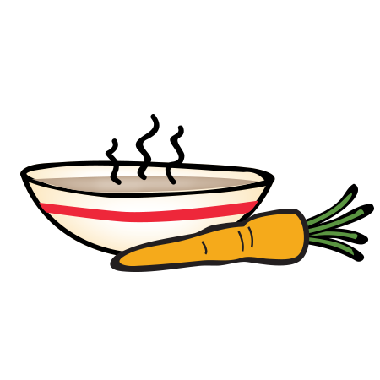
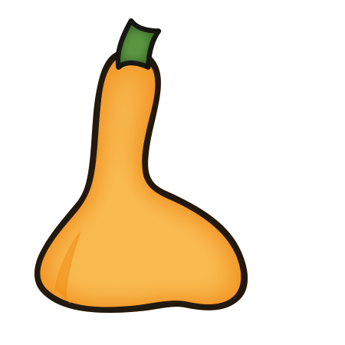
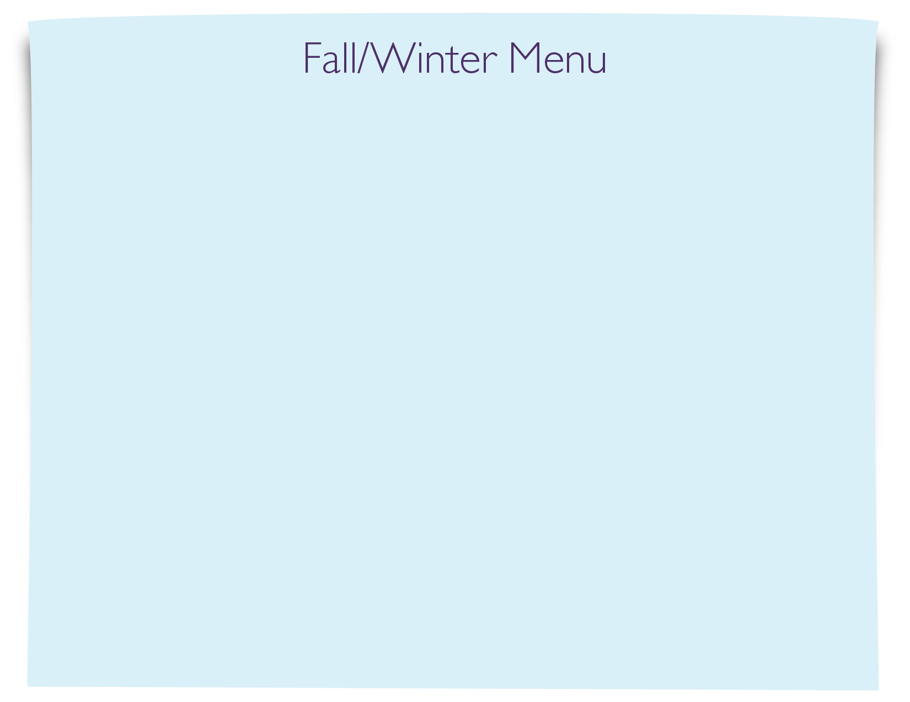
Snack Menu

