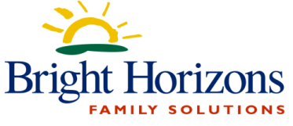
Week 1
Day | Morning Snack | Lunch | Afternoon Snack
Monday | Whole Grain Cereal  Fruit  Milk | Grilled Chicken Breast  Mashed Potatoes  Green Beans  Diced Peaches | String Cheese  Wheat Crackers  Water
Tuesday | Strawberry  Cream Cheese Roll Ups  Water  Milk | Cheese Lasagna  Breadsticks  Steamed Squash  Fresh Pineapples | Yogurt with Granola  Water
Wednesday | Cinnamon Raisin Bread  with Jelly  Milk | Chicken Tenders  Fries  Peas  Mandarin Oranges | Cheddar Crackers  Fruit Cups  Water
Thursday | Blueberry Waffle  Fruit  Milk | Chicken Enchiladas  Rice and Pinto Beans  Green Beans  Diced Pears | Animal Crackers  Fruit  Water
Friday | Bagel with Cream Cheese  Fruit  Milk | Pot Roast  Mashed Sweet Potatoes  Roasted Zucchini  Jell-O | Oatmeal Bars  Fruit  Water
Milk is served at each of these meals
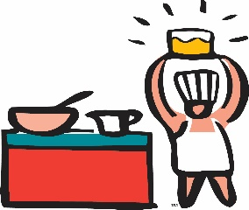
Whole Milk to Toddlers, Low-fat for Twos, PS, KP
This menu is subject to change without notice due to deliveries and emergencies

Revised 8/22/2022

