MONDAY | TUESDAY | WEDNESDAY | THURSDAY | FRIDAY
3 5019  Pierogies  Mixed Vegetables  Cantaloupe | 4 5007  Soft Beef Taco with Cheese and Lettuce  Applesauce | 5 5001  Breaded Chicken Sandwich  Peas & Carrots  Mandarin Oranges | 6 5005  Cheese Ravioli  Rolls  Sliced Peaches | 7 5017  French Toast  Sausage Patty  Banana
10 5021  Chicken & Biscuits  Corn  Peaches | 11 5003  Pancakes  Sausage Patty  Applessuce | 12 5014  Pizza  Broccoli  Mandarin Oranges | 13 5020  Boneless Chicken Wings  Mashed Potatoes  Corn  Gravy  Cantaloupe | 14 5011  Macaroni & Cheese  Peas  Pear Half
17 5000  Chicken Noodle Soup  Fish Sticks  Sliced Apples | 18 5013  Chicken Nuggets  Corn  Cantaloupe | 19 5006  Chicken & Cheese Quesadilla  Mixed Vegetables  Mandarin Oranges | 20 5015  Chicken Tenders  Mashed Sweet Potatoes  Pear Halves | 21 5004  Cream of Tomato Soup  Grilled Cheese Sandwich  Sliced Peaches
24 5020  Boneless Chicken Wings  Mashed Potatoes  Corn  Gravy | 25 5014  Pizza  Broccoli  Applesauce | 26 5019  Pierogies  Mixed Vegetables  Cantaloupe | 27 5001  Breaded Chicken Sandwich  Peas & Carrots  Mandarin Oranges | 28 5017  French Toast  Sausage Patty  Banana
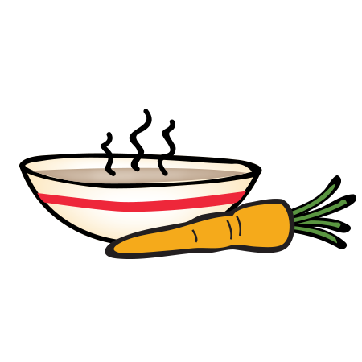
June 2019

