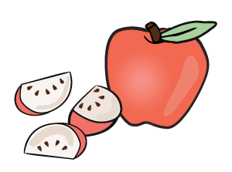**** ­­­

**BRIGHT HORIZONS AT PIONEER SQUARE**

|  |  |  |  |  |  |
| --- | --- | --- | --- | --- | --- |
|  | MONDAY | TUESDAY | WEDNESDAY | THURSDAY | FRIDAY |
| BREAKFAST  8:30-9:00 | Rice Krispy Cereal  Bananas  Milk | Pancakes  Cream Cheese  Strawberries  Milk | Oatmeal  Turkey Links  Bananas  Milk | Scrambled Eggs  Pineapple  English Muffins  Milk | Whole Wheat Toast  Fresh Fruit  Sausages Patty  Milk |
| LUNCH  11:30-12:00 | Chicken Teriyaki  Steamed Veggies  Oranges  Milk | Chicken Tortilla Soup  W/ Black Beans  Watermelon  Milk | Orange Chicken  Cantaloupe  Mixed Veggies  Milk | Whole Wheat Spaghetti  Turkey Meatballs  In Marinara sauce  Honeydew Melon  Milk | Turkey Curry  Mixed Veggies  Brown Rice  Pears  Milk |
| AFTERNOON SNACK  2:30-3:00 | Wheat Crackers  Apple Sauce  Water | Homemade Apple Sauce Muffins  Milk | Homemade Guacamole  Whole Wheat Tortillas  Water | Baby Carrots  Cheese Dip  Water | Yogurt w/cereal  Water |
| LATE SNACK  4:30-5:00 | Mini Bagels  Cream Cheese  Water | Bananas  Cheese Cubes  Water | Jelly Sandwich Bites  Water | Graham Crackers  Cottage Cheese  Water | Homemade Corn Muffins  Milk |

* All meals are baked, not fried
* Vegetarian meal options available
* Fresh fruits and vegetables served daily
* Proteins include chicken, turkey, beef, tofu, cheese, and beans
* Whole milk served to children ages 12-24 months
* 1% milk served to children 24 months and older
* All meals served family style