Important Dates

**July 3rd:** Red, White & Blue Day

**July 4th:** Closed for Independence Day

**July 9th:** Kona Ice Truck

**July 16th:** Yellow Day

**July 19th:** Kona Ice Truck

**July 16th – July 20th:** Alex’s Lemonade Stand

**July 23rd:** Expert Series6:00pm-7:00pm

**July 27th:** Bubble Dance Party

**July 31st :** Ice Cream Social

Reasons to Celebrate

**Birthdays:**

7/8: Amy

7/12: Ms. Brianna

7/13: Hadi

7/19: Francesca

7/29: Riley

**Spotlight Family**

Hi there! We are Stephen, Jill and Chase Skolnick and we have been living in the local area for about 4 years. In our free time, we like to spend time with our families, friends and playing with our dog Rumor. Chase is 8 months old and has been attending Bright Horizons of Spotswood since he was 4 months old.

After visiting several child care facilities, we left Bright Horizons knowing this was the place for our son. The fun and energetic atmosphere along with the amazing teachers and staff made it an easy choice. Chase loves to go to school every day to see all of his friends and awesome teachers. He’s very curious and loves to explore and learn new things. We are so happy with our decision and it definitely makes it easier for Mom and Dad knowing that our son is happy at Bright Horizon and in good hands.

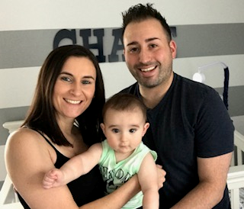

2018 | July Newsletter

Bright Horizons at   
Spotswood News

****Bright Horizons at Spotswood****

410 Main Street, Spotswood, NJ 08884

(732) 251-2686 | [spotswood@brighthorizon.com](mailto:spotswood@brighthorizon.com)

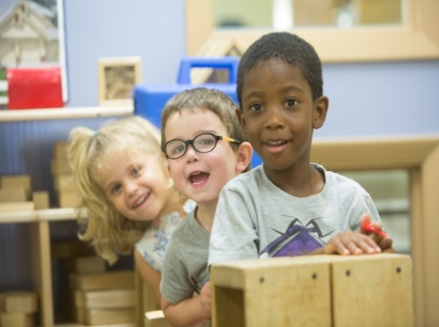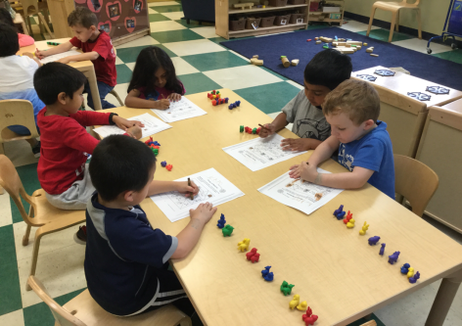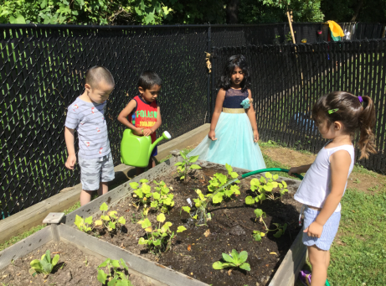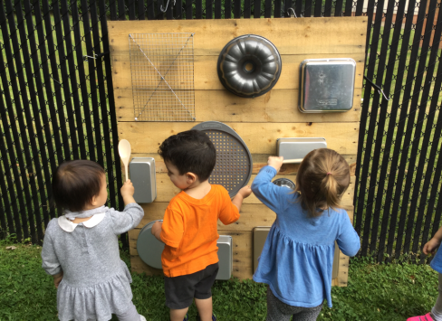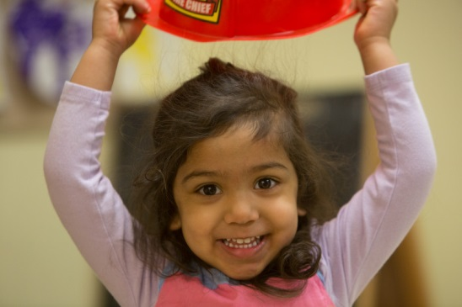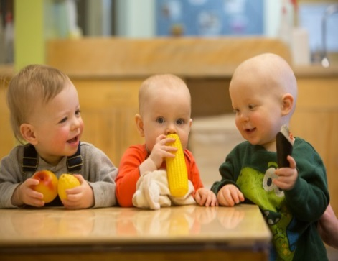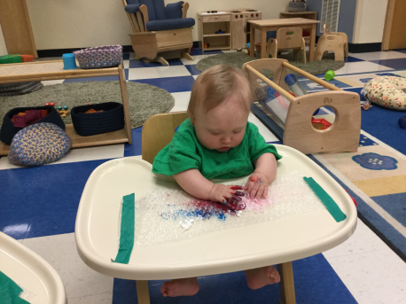

Infant

Infants are adventurous beings who learn about the world, and themselves, through their senses. Ms. Kim and her students explore the arts each day. They learned to use simple tools such has brushes and bubble wrap to create art. They learned this by exploring materials with varied texture colors and patterns.

Toddler

At Bright Horizons, we promise to cultivate curiosity and creativity through exploration and play. Our teachers have added a musical wall to our infant / toddler playground as an enrichment this month! They children learn to experiment with instruments and sounds. They learned this by using wooden spoons to listen to the different tones of sound.

Preschool

Children in all ages groups, infant and above, discover science through exploration of the natural world and gardening as part of our GardenWorks Program. Ms. Melisa and her preschool class has taken ownership of our vegetable garden this summer. They water the plants and vegetables daily!

Kindergarten Prep

Everyday Math is a hand on introduction to math concepts for preschool and above. Ms. Denise and her Kidnergarten Prep students use Everyday Math as an enrichment to our Math Counts Program. This month the students are focusing on creating and repeating simple color patterns.

CLASSROOM HIGHLIGHTS

Regardless of the size of your family, traditions are a meaningful way to create cohesiveness, forge fond memories, and celebrate life. Meg Cox, the author of *The Book of New Family Traditions*, defines family traditions as “any activity you purposefully repeat together as a family that includes heightened attentiveness and something extra that lifts it above the ordinary ruts.”

Many of us smile when we think about our childhood traditions. We might remember Sunday afternoon walks, game or movie nights, holiday preparations, special family hugs, or a secret family handshake. Often the activity is secondary; it’s the being together and sharing a custom that lives in our hearts.

Below are a few ideas for fun family traditions that you can start this year.

**Commemorate a special day by planting a tree.**

Be it Thanksgiving, Earth Day, or to celebrate a holiday, planting a tree together connects us to nature, and produces an everlasting keepsake. Think of the library you can create by videoing and discussing the experience.

**Designate a game night.**

A weekly game night brings everyone together for relaxed fun. Game suggestions include Apples to Apples Junior; Don’t Wake Daddy; Bingo; Dr. Seuss Cat in the Hat; and Guess Who? You might play action games, such as Charades, Twister, Hide and Seek, and Freeze Tag.

**Compose family newsletters.**

Rather than adults writing an annual letter, all family members can participate by talking about their year. Young children might depict their news by drawing, painting, and taking photographs.

**Connect with residents in a nursing home.**

Developing a relationship with people in a nursing home enriches the lives of the residents, makes your family feel good, and helps raise children with grateful hearts. Perhaps plan monthly visits and share stories, make cards, bake treats, or simply sit and hold someone’s hand.

As you plan the tradition, eliminate distractions, and reserve the time as you would any meaningful activity. Remember that family traditions are about enjoying time together. As Michael J. Fox says, “Family is not an important thing. It’s everything.”



Family Traditions Celebrate Life!

Ready for school News

Lemons to Lemonade with Four Ingredients

BRIGHT HORIZONS NEWS

Need help taming your child’s tantrums? Turn those parenting lemons into lemonade!

It might not seem like it, but your child is more predictable than you think—and each stage of your child’s development, along with every meltdown, is a gateway to skill-building for your little one.

Hear from early childhood experts Ellen Galinsky, the Chief Science Officer at the Bezos Family Foundation and Executive Director at Mind in the Making, and Rachel Robertson, the Education and Development Vice President at Bright Horizons, as they discuss common parenting challenges and the science behind parenting that can turn frustration into great skills for life.

You can subscribe to the Bright Horizons Family Matters Podcast through iTunes, Google Play Music, SoundCloud, Stitcher Radio, and RSS. Learn more by visiting the link below.



**Podcast: Lemons to Lemonade with Four Ingredients**

brighthorizons.com/lemonstolemonade





Check out all the places you can connect with us!

