10 A* student lands place at Oxford summer school
|
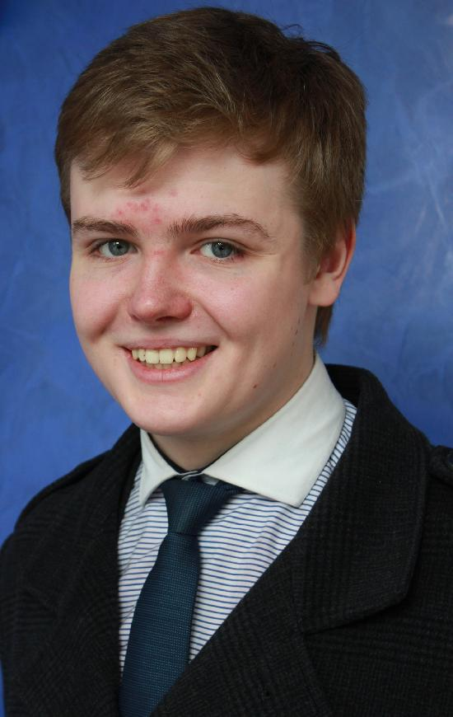 | PHYSICS student Daniel Povey has earned one of just 36 places on a prestigious summer school at Oxford University.  In total 4,500 applicants applied for positions on the summer school courses and Daniel, 17, who is in Year 12 in the Sixth Form, was delighted to secure one of the places. Once he finishes his A-levels he hopes to progress to read physics at Oxford.  To read more follow the link  http://www.aboutmyarea.co.uk/Lancashire/Rossendale/BB4/News/Local-News/247035-Haslingden-High-Ten-A*-Student-Lands-Place-At-Oxford-Summer-School-Studying-Physics

Budding engineers in technology competition
|
TECHNOLOGY wizards from our school flew the flag for Rossendale in a Rotary competition.
Teams from Key Stage 3, 4 and 5 took part in the Rotary Club Technology Competition at Nelson and Colne College when they competed against 17 other schools.
The students have won eight times in the last six years, but this year the top spot eluded them.
However, the runner-up position was the best ever result for the Key Stage 3 students.
To read more follow the link
http://www.aboutmyarea.co.uk/Lancashire/Rossendale/BB4/News/Local-News/247034-Budding-Engineers-In-Technology-Competition

