 | MONDAY | TUESDAY | WEDNESDAY | THURSDAY | FRIDAY
WEEK 1  8/5-8/9 | AM: Nutrigrain bar with milk  PM: Rice cakes | AM: Corn muffin with milk  PM: Fresh fruit | AM: Apple cinnamon muffin  PM: Whole grain cheese crackers | AM: Cereal with milk  PM: Graham crackers and milk | AM: Cinnamon raisin bread with jelly  PM: String cheese with crackers
WEEK 2  8/12-8/16 | AM: Blueberry muffin with milk  PM: Naan bread and hummus | AM: Graham Crackers and applesauce  PM: Cheddar cheese and crackers | AM: Yogurt  PM: Fresh fruit | AM: Bagel with cream cheese  PM: Graham Crackers with milk | AM: Cereal with milk  PM: String cheese and crackers
WEEK 3  8/19-8/23 | AM: Oyster crackers with fruit cup  PM: Rice cakes | AM: Cereal with milk  PM: Apple Oatmeal Bar with milk | AM: Corn muffin with milk  PM: : String cheese with crackers | AM: Graham crackers with vanilla yogurt  PM: Fresh fruit | AM: Bagels with cream cheese  PM: Naan bread and hummus
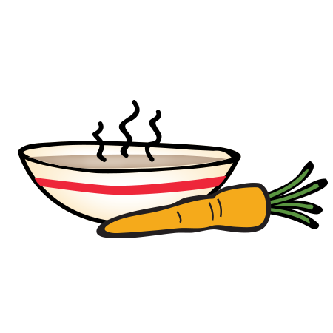
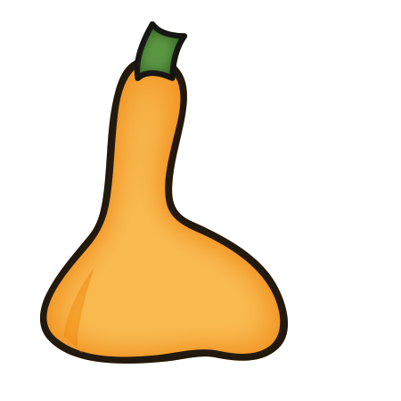
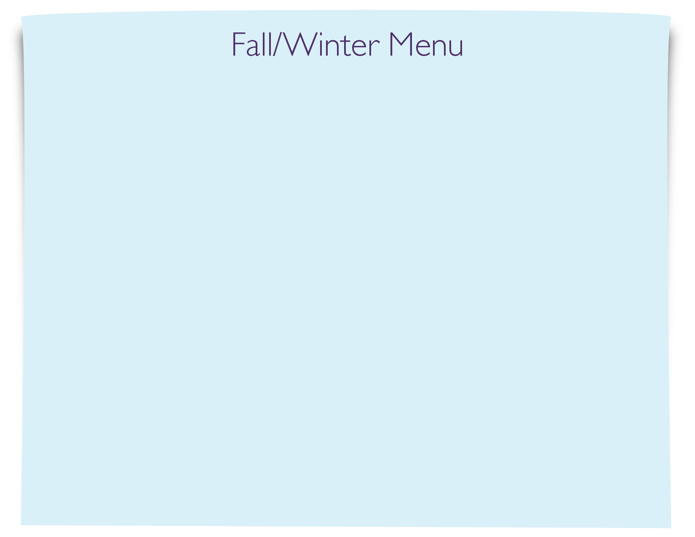
Snack Menu

