PARISH BULLETIN INSERT ANNOUNCING THE
CATHOLIC HIGH SCHOOL COLLECTION 2021

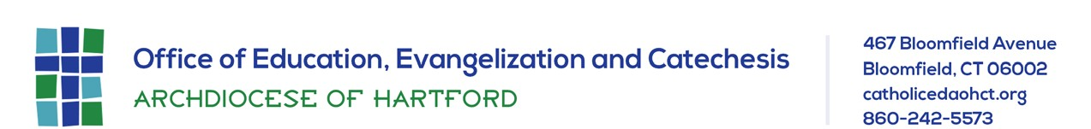

Please place in your parish bulletin on the weekend of JANUARY 16/17, 2021

The Catholic High School Collection, occurring in all parishes of the Archdiocese on the weekend of January 23/24, supports the outstanding education offered at our Catholic secondary schools by providing funds for tuition assistance, technology enhancements, curricular improvements, and marketing, all of which are so critical during this ongoing pandemic. Please consider investing in the exceptional academics, solid faith formation, and spirit of service at our high schools by making a gift to this year’s Catholic High School Collection on January 23/24.

