 | MONDAY | TUESDAY | WEDNESDAY | THURSDAY | FRIDAY
BREAKFAST  SNACK | Pancakes  Applesauce  Milk | Egg & Cheese Frittatas  Berries  Milk | Breakfast Parfait  (Granola, Yogurt, & mixed berries)  Milk | Egg with Turkey Sausage Patties  Pears  Milk | Rice Krispies  Blueberries  Milk
LUNCH | Cheese Manicotti  With Meat Marinara Sauce  Steamed Broccoli  Bannans  Milk | Meatballs with Steamed Rice & Brown Gravy  Steamed Green Beans  Melon  Milk | Chicken, Broccoli, Rice, and Cheese Casserole  Diced Peaches  Milk | Cheese Pizza  Mixed Veggies  Pineapple Chunks  Milk | Turkey & Cheese on a Croissant  Cucumber  Strawberries  Milk
AFTERNOON SNACK | Goldfish Crackers  Strawberries  Water | Fig Newtons  Mango Chunks  Water | Fruit Muffin  Orange Wedge  Water | Trail Mix W/ Cheerios, Granola, Cheez-its, Rice Chex, Dried Fruit  Water | Baked Oatmeal Cookie  Applesauce  Water
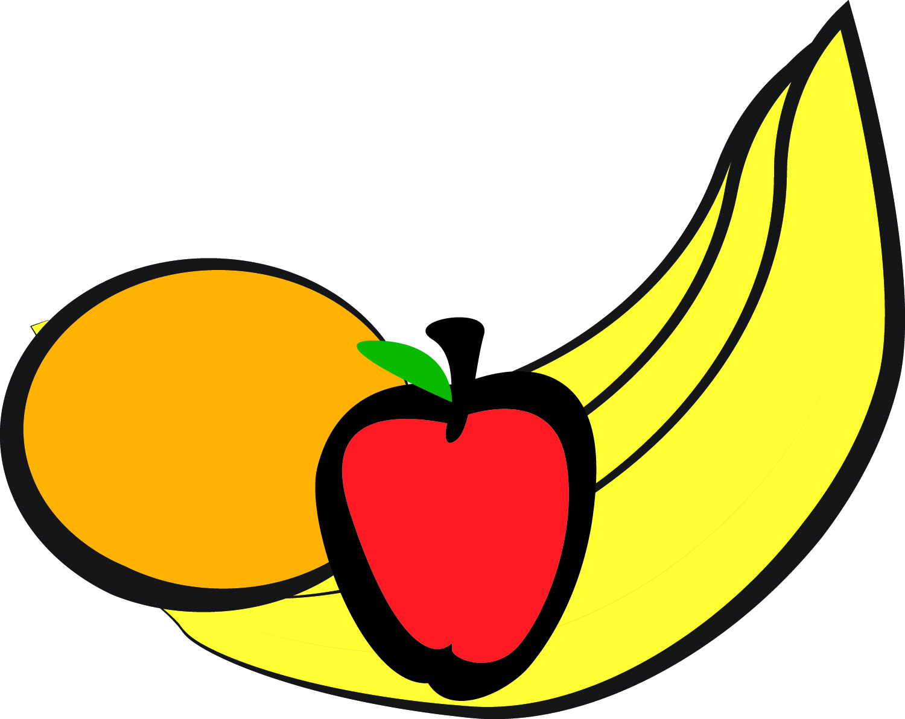
Spring/Summer Menu
Late Afternoon Snack (After 5:30 pm) – Gold Fish, Wheat Crackers, Fruit Bars, Trail Mix, Cheerios
Approved Fruit Substitutions: Melon, Berries, Peaches, Pears,
Bananas, Oranges, Pineapple, Apple Slices, Applesauce
Menu #1

 | MONDAY | TUESDAY | WEDNESDAY | THURSDAY | FRIDAY
BREAKFAST  SNACK | Whole Grain  cheerios Strawberries  Milk | Whole Wheat Pancakes w/Syrup  Blueberries  Milk | Whole Grain Mini Bagels w/Jelly  Hard Boiled Eggs  Mango  Milk | Whole Wheat Bread Slice  Banana/Strawberry  Smoothies  Milk | Whole Grain Bagel w/Cream Cheese  Pears  Milk
LUNCH | Beef Meatballs w/  Mushroom Sauce White Rice  Apricots  Milk | Refried Bean & Cheese Taco on Whole Wheat Tortilla  Salsa  Watermelon  Milk | Five Cheese Lasagna  Broccoli  Kiwi/Banana Mix  Milk | Grilled Chicken Nuggets  Cauliflower Mash  Peaches  Milk | Tuna Salad w/Dill Sandwich on Whole Wheat Bread  Baby Carrots  Kiwi  Milk
AFTERNOON SNACK | Cheddar Cheese Cubes  Wheat Thins  Apple Slices  Water | Multigrain Fruit Snack Bar  Water | Diced Turkey on Whole Wheat Pita  Water | Rice Cake  Cantaloupe  Water | Trail Mix w/ Granola  Orange Slices  Water
Menu #1

