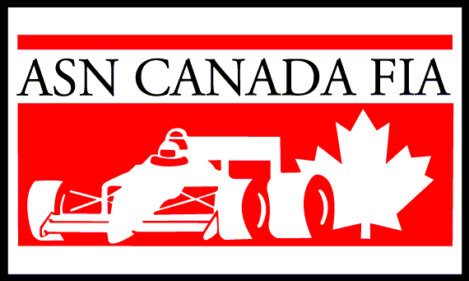
2018 MANDATORY LICENSING PROGRAM
EDMONTON & DISTRICT KART RACING ASSOCIATION
PO Box 11545 Station Main, Edmonton, Alberta T5J 3K7 (780) 732-EKRA www.edkra.ca

Last Name |  | Date |  |  | Kart Racing — Please Circle  Rookie or Experienced
First Name | Date of Birth  MM/DD/YY | Does driver have any  race experience? |  | EDKRA Class  Driver is Entering |  | Signature  [Both parents must sign if driver is a minor]
Address |  |  | City |  | Prov |  | Postal Code
Home Phone # | Work Phone # | Fax # |  | E-mail Address

Mandatory Licensing Program: For the betterment of the sport and in the interest of safety, EDKRA requires all rookie drivers to complete its mandatory licensing program prior to being allowed to race. The program consists of a classroom session as well as on-track activities.
Cost

0$
per person

A completed ASN medical form must be provided by each driver.
A completed ASN parental consent wavier must be provided by each driver 17 years old or younger.

NOTE ALL DRIVERS MUST SUPPLY THEIR OWN KART!!

