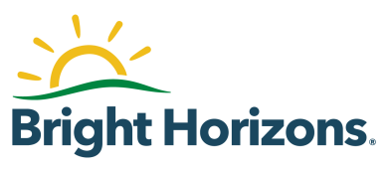[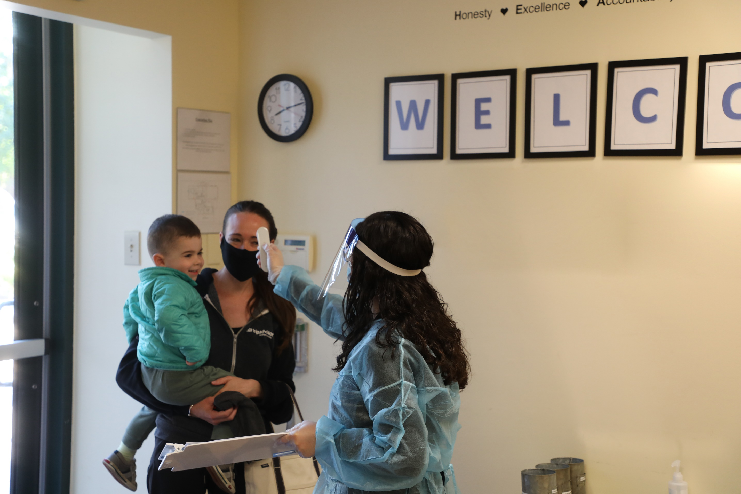](http://www.brighthorizons.com/working-mom-life)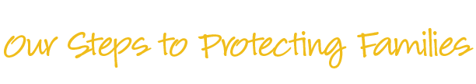

* March 10, 2021 at 3:00 p.m. EST
* April 7, 2021 at 3:00 p.m. EST
* May 5, 2021 at 3:00 p.m. EST
* June 2, 2021 at 3:30 p.m. EST
* July 14, 2021 at 3:00 p.m. EST
* August 11, 2021 at 3:00 p.m. EST
* September 8, 2021 at 3:00 p.m. EST

**March – September 2021**

At **Bright Horizons®** we’ve implemented industry-leading COVID-19 protocols to keep your child, your family, and our staff healthy and safe.

Whether you’re new to Bright Horizons or retuning, join us for one of our monthly sessions to learn all about these measures and get tips on preparing your child for care. Plus, we’ll answer questions about vaccines, masks, health screenings, and more!

[**Register Today!**](https://event.on24.com/wcc/r/3004614/A57EAD4357984A5FDA8EA2F01B52A037/2064322?partnerref=flyerb2c)

Bright Horizons at [Center Name] | Street Address   
City, State, Zip | xxx.xxx.xxxx

Email@brighthorizons.com | brighthorizons.com/Center URLslug

**Healthy & Safe at Bright Horizons**

© 2021 Bright Horizons Family Solutions LLC.