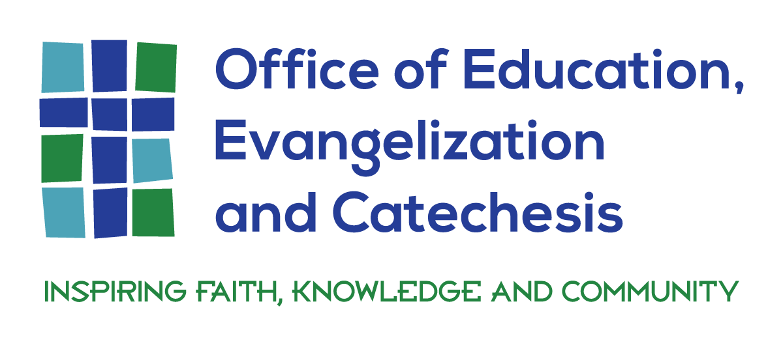
To E-Book or Not to E-Book – THAT is the Question
“Would you like paper or plasma?”
When discussing the benefits and drawbacks of reading digitally or in print, the purpose of the reading must be taken into account, as well as an understanding that our brains process digital reading differently. Collective neuroscience research agrees that humans use different parts of the brain when reading from a piece of paper or from a screen. “So the more you read on screens, the more your mind shifts towards "non-linear" reading — a practice that involves things like skimming a screen or having your eyes dart around a web page.”
Maryanne Wolf, director of the Center for Reading and Language Research at Tufts University reports, “I don’t worry that we’ll become dumb because of the Internet, but I worry we will not use our most preciously acquired deep reading processes because we’re just given too much (online) stimulation. That’s, I think, the nub of the problem.” Students have mastered the art of skimming when reading online, however, that often results in gaps of critical information, clearly not conducive for deep learning and studying. “If you don’t use the deep reading part of your brain, you lose the deep reading part of your brain.”
E-books and e-textbooks have their rightful place in education and in preparing students to be prepared in this digital age of the 21st century. E-textbooks affords students opportunities to delve into hyperlinks and media links to support the content. The question remains if students actually link to other resources and to what extent is comprehension happening. There is a difference between remembering and learning; recall and comprehension.
As educators, we need students to develop both their digital literacy skills as well as their strategies for comprehension, critical thinking, deep analysis of text, and to stimulate the imagination of every learner. Wolf recommends, to keep the deep reading part of the brain alive and kicking, set aside some time each day to deep read on paper. In addition, we need to keep handwriting skills alive. Create active opportunities for students to handwrite study notes, which require a deep understanding and not simply superficial skimming, and to print out typed notes for studying purposes (Salter, 2013). There needs to be balance between reading on paper and reading online; identifying which subjects are more conducive to an e-textbook, and which subjects are best taught with paper print, and when can an interdisciplinary paradigm balance both methods.
The Reading Brain in the Digital Age: The Science of Paper versus Screen, by Ferris Jabr, published by Scientific American, is one of the most referenced and highly recommended pieces of research when exploring the psychological differences between reading on paper and reading on a screen. He asks, “How does the technology we use to read change the way we read?” For more information, the article can be found at https://www.scientificamerican.com/article/reading-paper-screens/.
Integrating technology in our schools, is not synonymous for putting devices in the hands of the students or increasing the number of devices in our schools. Decision making should revolve around how technology can serve education; how technology devices can assist to advance the teaching and learning in the school; how do we educate our students to be both digitally literate as well as information literate for the purpose of the formation of the whole student, developing imaginative, morally conscious and virtuous citizens, competent to discern valid and ethical sources of information as independent learners.

