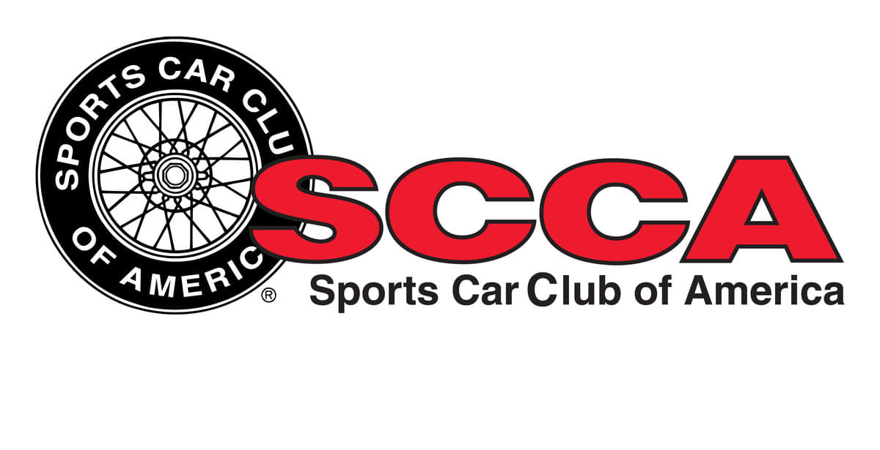

South Jersey Region SCCA

Track Day / Time Trials / Track Sprints

Supplemental Regulations
Bader Field
600 N. Albany Ave. Atlantic City, NJ 08401
Held under the 2020 SCCA Time Trials Rules
Event Date: 6/27/2020 Sanction Number: 20-TTTS-8632

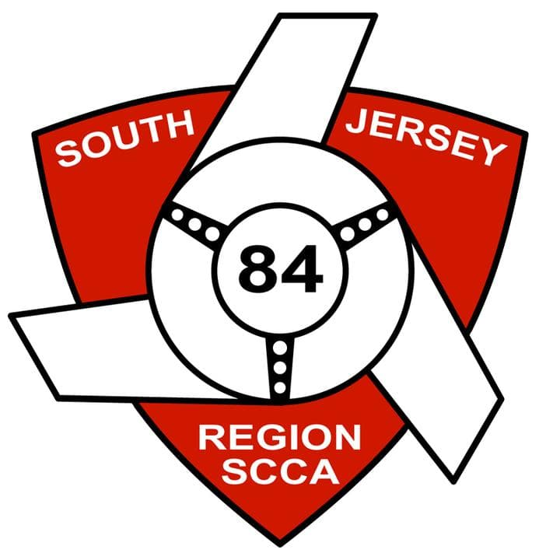
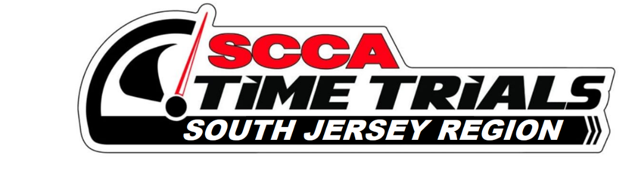

South Jersey Region SCCA COVID-19 Guidelines

General Operations
- We will not provide community beverage coolers. We suggest participants bring their own
- Use disinfecting wipes or disinfectant spray and disposable towels to wipe down equipment, supplies, shared work areas and surfaces between uses, shift changes and frequently throughout the day
- Clean frequently touched surfaces such as tables, counters, doorknobs, light switches, pens, keyboards, and cones (when used)
- As much as possible, staff should keep a single radio with them and not hand off between staff members; before storing or when giving it to another staff member, wipe off the radio with a disinfectant wipe
- Events will be closed to spectators. Racers, crew and family only.
- Drivers shpuld park 6’ away from other vehicles or as far as paddock space allows
- There will be hand washing and sanitizer stations in and around the facility
- Only essential, on-duty workers are allowed in specialty work areas such as timing and scoring; when someone is not working a session, they should remain at their cars or follow social distancing protocols
Social Distancing
- All participants and workers MUST wear masks, for not only their own safety but for the safety of everyone on-site
- Six feet of space should be kept between individuals for the entirety of the event, except in cases of participants that are part of the same household
- Limit physical contact; refrain and discourage hugs, handshakes and high-fives
- Staff may need to gently reinforce this requirement throughout the event
- Anyone who continues to ignore social distancing procedures even after staff input may need to be asked to leave
Registration
- Online registration only. No walk-ups.
- Registrar shall be 6 ft apart.
- If registration is held indoors:
  - Limit the number of people permitted inside based on the size of the room, keep 6 feet apart.
  - Mark the floor indicating where people should stand—use a bright color like blue or green painters tape
  - Use different doors for entrance and exit, when possible
- If available, utilize online waivers through registration software.
- Do not handle clipboards. Have waivers sitting in a place accessible by the participant. Sanitize hands before and after handling the pen.
- Registrars should not handle membership cards or driver’s licenses.
  - Ask member to hold it up and visually check the validity OR
  - Use member look-up in the Member Account Portal to verify membership
- Have wristbands or event credentials on a table for participants to pick up or have registrar just hand it to the participant to put on. Wristbands should be separated prior to opening registration.
Driver & Worker Meetings
- Driver meetings will be held if they are outside and social distancing protocols will be followed.
- Add information about COVID-19 procedures to your normal meeting content and allow for Q&A
Tech
- Self-tech w/oversight
- Have driver perform functions to verify equipment where possible
- Wear nitrile gloves* (nitrile preferred to latex due to allergies)
Pit lane/Black Flag
- all participants and workers to wear masks, for not only their own safety but for the safety of everyone on-site
- All pit lane workers must wear a mask when conversing with drivers or other workers.
- When speaking to drivers use the passenger side whenever possible to allow for extra distance. If the car is particularly loud and makes it challenging to speak from a distance, you may need to ask the driver to turn off the car
Corner workers
- Disinfect shared equipment and supplies before and after each use
- Assign household members together, when possible
- Keep corner teams together at the same station during the entire event
- All personnel drive separately to the station, when possible; if this is not possible, do not fill the transport vehicle to capacity and have passengers wear masks
Trophy presentation
- Hold outside and follow social distancing protocols
- If social distancing cannot be achieved, trophy presentations should be eliminated.
- No physical contact
- Utilize “No Contact” trophy presentation (i.e. set trophies on table/podium steps for pickup)
- If used, do not share the microphone

This Sports Car Club of America (SCCA) event is Held under the SCCA Time Trials Rules (Rules) in
effect at the time of the event. All participants are expected to read and be familiar with the Rules. The
current Rules are available via the SCCA Website at https://www.timetrials.scca.com. The SCCA strives
to ensure all participants at its events and activities enjoy a welcoming environment.

This Time Trial event is hosted by South Jersey Region SCCA. If you have questions that are not answered in the Rules or these supplemental regulations, we’re here to help! Contact Event Lead: Joshua Kuehne Contact Info: JoshuaKuehneSCCA@Gmail.com

Event Description: This event will be a Track Sprint.

Registration: msreg.com/SJRSCCATimeTrialsEvent5

Draft Schedule - A final schedule will be provided at check-in.

Gates open at 8:00 AM on 6/27/2020

Saturday 6/27/2020 Track Sprint
We expect 7 or more runs per driver during the event. We’ll do everything possible to ensure that everyone gets maximum track time.
However, events outside of our control might change the number of sessions we can fit into the schedule.
9:00 AM – 11:00 AM – On site Registration
9:00 AM – 11:00 AM – Tech inspection
9:00 AM – 11:00 AM – Course Walks
11:30 AM - Driver’s Meeting
12:00 PM – First car on track

TIME TRIAL - TRACK SPRINT
1. Event. The event is a point A to point B on a closed section of the track with a standing start and flying finish and no cones. It allows you to experience corners and speeds you wouldn't experience on lapping sessions and help you master parts of the track you might be struggling with.
2. TRACK SPRINT. The Time Trial Track Sprint event is open to all cars meeting the SCCA Time Trials rules: This event is run under the SCCA Time Trials National Rules. The compete rules are listed here in this section plus this link: https://timetrials.scca.com/pages/national-competition-full-rules/

ALL CLUB MEMBERS AND GUESTS
1. EVENT. Track Sprint will be held at Bader Field. This event is held under Sports Car Club of America (SCCA) 2020 Time Trials Rules (Rules) in effect at the time of the event and conducted in accordance with New Jersey Motor Vehicle Racetrack Regulations, Chapter 62. In the event of a conflict, the NJ State Police regulations will supersede all others. The Event Lead has the authority to enforce all rules and Track Regulations.
2. OFFICIALS. See www-sjr-scca.org for complete list of contacts. The primary official contacts for the event are: Event Lead Joshua Kuehne - JoshuaKuehneSCCA@Gmail.com, Safety Steward Sue King - sue1arunit@verizon.net
3. ENTRIES. Event entry registration made online at http://sjrscca.motorsportreg.com/. Online registration will close at 12:00 PM the day prior to the event.
4. WITHDRAWALS AND REFUNDS. Refunds are guaranteed for cancellations received by the Registrar electronically prior to the close of event Sunday. Telephone/verbal cancellations will be accepted if followed by written notice as previously noted. Notifications may be given to the Registrar at the track or mailed to Terri Zane. No refunds can be made if the car has participated in any on-track session. Refunds will be processed promptly the week after the event. 6. MINORS. Minors under 18 years of age must be accompanied by a parent or guardian that will sign a minor waiver or must present a notarized minor waiver or have a current SCCA Annual Minor Waiver. No one under 16 years of age is allowed in the Pit Lane or on the False / Make-Up Grid (Hot Areas). 15 Year old drivers may enter Hot Areas for normal driving activities but otherwise are prohibited from being in hot areas.
IMPORTANT: In order to satisfy New Jersey race regulations under Chapter 62, minor drivers must provide a copy of their birth certificate, an SCCA minor waiver signed by a parent or guardian and a detailed driver resume.
5. TRACK ACCESS. No motorized vehicles are allowed on the race course before the start or after the end of the scheduled competition activities on any day of the event.
6. DRIVER ELIGIBILITY. • Track Events Track Days - Open to all drivers holding a valid driving license from any US state. Drivers must be SCCA members, weekend memberships can be purchased at the event • Time Trials Track Sprint - Open to all drivers holding a valid driving license from any US state. Must be SCCA member with Competition License or time trials permit added (free, just need to request it).
7. SAFETY BELTS - Street legal cars must have a passenger seat with at least a three point seat belt, both meeting DOT standards as a minimum.
8. SAFETY BELTS – Purpose Built Not Street legal cars Your safety belts MUST MEET THIS REQUIREMENT - NJ 62-3.7.c.1 specifies that seatbelts certified under SFI 16.1 or 16.5 expire on 31 December of the second year after the date of manufacture; all other provisions of GCR 9.3.19 apply. Per Chapter 62, the NJMP staff and/or members of the New Jersey State Police (NJSP) may perform random tech inspections to ensure compliance with Chapter 62. All participants are required to comply with any such random inspection and any finding of NJMP and/or the NJSP, and all finding are final and not protestable to SJR-SCCA. No Exceptions.
9. Car Classes: Cars listed in and eligible for National Competition Unlimited, Max, Prepped, Tuner and Sport are permitted to run in this event. Formula Cars, Sports Racers and Specials are not eligible to participate. If you need clarification about your vehicle’s eligibility, review the Rules or contact the Event Chairman.
10. ROLLBARS. Any car that is street legal will NOT require a roll bar/roll cage, except for Convertibles and Targa top automobiles. Convertibles and Targa top automobiles cars must have either an SCCA Time Trial legal roll bar, a non-mechanical factory roll bar/roll over protection (i.e. no pop-ups), or a factory hard top using the factory mounting hardware and mounting points. The height of any vehicle occupant (with helmet) in an open car shall not be higher than the highest point of a roll bar structure. Owners of cars equipped with factory roll bars/roll over protection must present documentation stating that the device is a roll bar or roll over protection at the time of vehicle tech inspection (a factory issued Owners or Shop Manual will fulfill this requirement.). Rollover protection should be such that all vehicle occupants are able to pass the “broomstick” test when properly seated, belted, and helmeted.
11. PERSONAL SAFETY EQUIPMENT. a) All participants must be fully covered by clothing when on track (no shorts, no short sleeves, shoes that fully cover the foot, etc.) Fire resistant suits are not required, but are recommended in all race-prepared cars, and optional in all cars. b) Helmets must meet a minimum of Snell M or SA 2005 or newer requirements. Drivers in open cars must have a full face helmet.
12. DRIVER EXPERIENCE. Each entrant must provide a complete description of prior driving and competition experience to allow the organizers to develop the appropriate groups. The event Credential Committee (Race Chairman, Chief Steward and Chief Instructor) is authorized to waive the student status for qualified individuals. If you are unsure of experience or status contact the Track Events Chairperson or register in the Novice Group.
13. DISQUALIFICATION. Drivers are responsible for their guests, crew, and service vehicles. Vehicles may not operate in an unsafe manner on any track access road before or during the event. Drivers may not have unauthorized passengers in the vehicle to or from any area of the course. Drivers shall only be allowed on track during their designated group or with specific authorization. No alcoholic beverages may be consumed prior to the completion of the day’s on-track activities. Violation of these rules may result in disqualification without refund.
17. PARTICIPANT REQUIREMENTS.
a) Any driver who has the legal authority (license or permit) to operate an automobile on a public road may participate in Track Events, as long as all restrictions of the driving license or permit are met. If those restrictions require a passenger, that passenger must be an event Instructor assigned by the Chief Instructor; the parent/guardian MUST contact the Chief Instructor to discuss the entrant=s experience level PRIOR to the event - NO exceptions
b) All participants, including drivers, workers, crew members and guests must sign the SCCA Release and Waiver of Liability, Assumption of Risk and Indemnity Agreement Form at Registration. New Jersey Motorsports Park also requires their own waiver, signed at the gate, to gain to access their property B this is a separate waiver that is unrelated to the SCCA Waiver. You must sign both waivers! Minors (under 18) are required to have a specific SCCA minor wavier signed and notarized by both parents.
c) Participants must present their completed Tech Form and HELMET to Tech Inspectors for approval.
d) The organizers of this event have the right to refuse an entry at their discretion.

e) TECHNICAL INSPECTION. All entrants must have the attached Technical Inspection Form completed by a mechanic or qualified individual prior to the event. Any vehicles without this form completed may be barred from participation. There will be a brief Tech Inspection confirmation procedure at the event. Cars with completed forms will be given priority over cars which require a full inspection. a) Hardtops and sunroofs must be removed and/or securely fastened. Convertible tops must be fully down and securely fastened. b) Brake lights and DOT tires are required on all cars. c) A restraint system meeting federal standards for the year of manufacture of the vehicle in each of the front seating positions. At a minimum, a three point system must be in place. Competition type 5-point systems are highly recommended and required in cars modified for racing (e.g. Showroom Stock, Touring, and IT). d) Any car that is judged to be in an unsafe operating condition at any time during the event shall be prohibited from further participation until the deficiency is corrected.
f) All loose items in and out of the car must be removed. Passenger seat back and cushion must be secured.
17. TECH INSPECTION FORM. Each participant must present their pre-event Tech Inspection Form and helmet to the Tech Inspectors for approval. An on-site technical inspection is available but will not necessarily be performed in a timely manner (you may miss your first track session of the day). BRING YOUR COMPLETED DOCUMENTS TO TECH INSPECTION.
18. Grid & Pit Lane Rules
a) All cars entering the track during “hot” sessions must have an appropriate Tech Sticker
b) Only participants with the appropriate wristband will be allowed in pit lane and on track.
c) The Grid Steward positioned at the entrance to the Pit area controls traffic through the gate.
d) Drivers must follow the instructions of the Grid Steward before proceeding into the Pit area.
e) Be aware at all times of foot traffic in the Pit and Paddock areas.
f) No uncredentialed minors are allowed on Grid or in the Pit Lane during activities.

TRACK REGULATIONS AND INFORMATION – ALL PARTICIPANTS

1. TRACK HOURS. The track facilities are available to SCCA starting at 8:00 AM on Saturday. All participants must vacate the facility by 6:00 PM on Saturday evening.
2. VEHICLES. The speed limit in the paddock is 5 mph. The speed on access roads is 25 mph. Race cars not licensed for street use may not be driven outside of the paddock. Testing or brake bedding on infield roads is prohibited. NJ State Police have authority to ticket violators
3. PADDOCK. Cars should be aligned in the paddock under the direction of the paddock marshals. No motorized vehicle may be operated by anyone not holding a valid state issued driver license. Children must always be under direct parental supervision. No stakes or holes may be driven into the asphalt; nothing may be painted on the asphalt surface. Receptacles will be available for used oil and other fluids. All trash and hazardous debris must be disposed properly or taken with you when you leave - the facility must be left as we found it. Per Chapter 62, absolutely no alcohol may be consumed in the paddock during the day’s racing events. Since groups not under SCCA control will have access to the paddock, reasonable care should be exercised to protect personal belongings. Remotely piloted air vehicles, sometimes known as drones, shall not be operated.

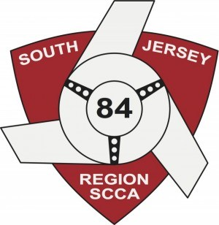
Please check the event or events you are participating in.
Track Day/HPDE __________
Time Trials ______________

SJR SCCA TRACK DAYS TECH SHEET
Please complete this sheet and bring it with you to Check-In or Grid prior to your first run.
Driver: _____________________________________ Car Number: ____________________
Car Make: ______________ Model:_______________ Color:_____________ Year: ______
Helmet Certification and Year: ___________________
The entrant/participant is responsible for the safety of his/her vehicle. Neither the tech inspectors, the event organizers, nor the sanctioning body will be held responsible for the safety of this vehicle. Have a qualified mechanic check over your car and make certain everything is in good working order for an event such as this.

DRIVER SAFETY
____ Helmet (2010 or newer: Snell M/SA, SFI, FIA)
____ Shoes must be solid, closed toe, and in reasonable condition
____ Seatbelts/Harness must be in good condition
____ Any aftermarket harnesses must be current (SFI – 2 years or newer, FIA – 5 years or newer). No 4-point harnesses allowed.
____ Convertibles must have permanent rollover protection as mandated by Chapter 62 race track regulations. Driver and all passengers must pass the broomstick test with helmet on.
____ Rollbar padding
____ Seats bolted securely
____ Interior & trunk clear of loose items; all floor mats removed

BRAKES
____ Pads are less than half worn
____ Fluid is clear, reservoir is full
____ Pedal is firm
____ All brake lights are working
____ Master cylinder/calipers are not leaking
____ Rotors have no cracks or discoloration

TIRES & WHEELS
____ Adequate tire tread, speed rating, good condition
____ All lug nuts present & torqued to spec.
____ Hubcaps removed
____ Wheels - No cracks or structural damage

I, ______________________________________, have inspected all the above on my vehicle, and have read and understand each of the points listed in the Driver’s Meeting document and agree to comply.

Driver Signature_________________________________________ Date_______________________

SUSPENSION & STEERING
____ Wheel bearings - no play
____ Ball joints in good condition
____ No excessive steering play
____ Shocks - no leaking

ENGINE & DRIVE TRAIN
____ Check all fluid levels, belts, and hoses. Tighten all caps and secure all hoses.
____ No fluid leaks (oil, transmission, fuel, water) ____ Battery secured (no bungees)
____ Battery terminals covered
____ Overflow containers present
____ Exhaust system functional (may have to meet sound restrictions)
____ Throttle has quick, positive return
____ Fuel cap tightened

OTHER
____ No severe glass cracks
____ Windshield wipers function properly
____ Outside & Rear View mirrors
____ Video Camera/Recording device securely mount

