Minutes for 2024 Annual Board of Delegates Meeting
Live Hosted at Holiday Inn Express in Dahlgren VA on 9 November 2024
Simulcast via Zoom for remote attendance – Jim Raper managed the Zoom Meeting

- Meeting called to order at 1000 by President Mayo Tabb
- Roll call taken by Marc Briere and Jim Raper. Delegates representing the following clubs attended – SMSA, EYC, DISC, FBYC, HYC, CCV, AYC, HSSA, DSC, CYC, BBSA, MRSA, BYC, NASS, TAYC as well as Northern Bay and Southern Bay Unaffiliated Members. Total members represented was 554 which constitutes enough of the 845 active members to have a quorum and allow us to conduct the business of the association.

OLD BUSINESS

Mayo led off the old business by reading and summarizing his 2024 President’s Report.

It has been a privilege to serve as your President for the 2024 season and I can report that PHRFChesBay is strong and growing but still has room for improvement. Our primary mission is to provide fair ratings for a diverse range of boats racing in the typical conidiations of the Chesapeake. For the first time in nearly a decade we have over 1000 boats with current ratings including new to racing Cruising ratings that now compose nearly 25% of our members. For those holding Cruising certificates encourage your Club race management and OA’s to include one or both cruiser class so you can go out an enjoy the fun without having to compete with race boats.

This would not be possible without the extreme dedication of our 18 handicappers split into a Northern Board headed by Dan Trammell as Chief Handicapper and Southern Board headed by Alan Bomar as Chief Handicapper who meet monthly in person or via Zoom. For those that don’t know how a handicap is created, I want to give a brief overview of the process. It starts when you apply via our Website that goes to your local handicapper who can be found on the Website under Handicappers. He is your guide and advocate for the process who reviews your application, corrects errors and calls you for missing data and in the process if you have any question, he is your contact. After the application is complete, he does initial research and rating suggestion before it is sent to the respective Board. If a Handicapper is your direct competitor can participate in the discussion but does not have a vote on the rating. After the rating is decided, it is sent to the other Board for approval or rejection. If rejected the process is repeated with a modified rating until agreement.

What do the handicapper look at? They look at if the same boat is previously rated by PHRFChesBay, other PHRF regions, ORR and ORC data, other boats with similar characteristics, equipment on the boat and performance out on the water. We have the base rating for windward/leeward courses and the CR rating for a random balance of windward, reaching and downwind legs. For both spinnaker and non-spinnaker configuration. These are all based on average Chesapeake wind conditions of 10 knots. When wind conditions are different there will be some boats favored but usually balances out over the season. If you think that your rating or a competitors is incorrect I encourage you to appeal. This can be a formal appeal per the form on the Website that you totally control and submit. Or it can be via a Handicapper Appeal where you discuss it with your Handicapper, and he submits the appeal, but he is determining what data and points are being made with your help.

For years Charity and other low-key events OAs have taken our rating data for boats and applied is differently from event to event. We have a Delegates item to formalize and standardize the process for the OAs to work thru the local handicapper. These assigned rating are for one time/event use and base rating only and the handicapper will encourage the owner to get an official PHRF rating so they can receive the credits such as RFA, propeller etc. The largest user of informal ratings with 83 boats competing under PHRF was the 2024 Hospice Turkey Shoot Regatta. We would like to help regattas like this, instead of having them pull data off our Valid List and this would also give us the opportunity to expand PHRFChesBay by encouraging these racers to get a formal valid rating with all their credits.

I competed with my 40 year old Farr-Dickerson 37, Excitation in all three of the PHRF co-branded PHRF Championships in the A2 class and can report that they are the best and highlight of PHRF racing on the Chesapeake. It started with Southern Championship/SBRW with 77 PHRF boats, Northern/Screwpile with 19 and Mid-Bay/Stingray with 41. The Southern and Mid-Bay had active Cruising classes as we want to expand those for 2025. For Stingray we broke out the Sports Boats into their own class as their performance is so wind/wave dependent when racing against more traditional designs. For next year there is a Delegate item to make this easier for the OA to do this and a handicapper issue as to how to better handicap Sports Boats competing against traditional heavier designs. Nelson Pemberton, Northern Bay VP has been hard at work and for 2025 shortly we will announce that the 2025 Northern Bay Championship will be in the Annapolis area over Labor Day, so if you are in that area put it on your calendar.

Our newest Board Member Southern Bay VP, Greg Cutter reports strong PHRF racing in the Southern region 4S and with his strong involvement in the CCV organization will be working to get more Cruising Class offerings in the area. For Region 4N there were over two dozen PHRF regattas with the A2 being the strongest fleet with usual turnout of 7-9 boats in the class and Cruising Class offered is most events. The largest regattas were the after mentioned Turkey Shoot with 83 boats and Mid-Bay Championship/Stingray with 41 PHRF racers.

We partnered with CBYRA to offer a series on sailing seminars to members of either organization. Nelson is working with this winter’s offerings and Pat will keep you informed so you can plan of attendance. Pat is working on a communication so as soon one is booked you should receive an e-mail to sign -up, followed by another 1-2 weeks before and a final a few days before the event. We have a new Associate membership class so your crew could sign up. Pat also has gotten several PHRF articles into Spin Sheet and is working on a new Logo for PHRFChesBay as our is quite dated compared to the other PHRF regions. Additionally, as PHRF Communication VP he is updating some of our out of date items on the website along with other members of the Board.

Jim Raper has done an invaluable but to many unappreciated job as Treasurer working thru past deficiencies in State registration and compliance. Additionally, he has handled all payment, finance and membership roster issues. He has been working with our Web suppler who also does PHRF New England to make our Website do more, offer you more and automate as much as possible in the administrative task. We have grown back nearly 30% in membership to now over a 1000 from the low of COVID but we have been operating at a deficit financially for the past 10 years. Thanks to sound financial management in the past, we have had the reserves to weather the shortfall but constantly eating into your reserve is not a sound way to run an organization. Therefore, we have proposed a modest $5 increase in all categories of renewals and a half price for Cruising Certs. Additional By-Laws changes are being proposed to keep us in a strong financial position going into the future.

PHRF and CBYRA have been working to streamline and improve the High Point awards. The PHRF Regions set nearly 30 years ago don’t reflect racing participations as of today. To more evenly balance the regions, we approved Region 1 being north of the Bay Bridge, Region 2 being Maryland south of the Bay Bridge excluding Annapolis, Rigion 3 being Annapolis area and Regions 4N and 4S being Virginia. CBYRA has instituted a computer program to capture the Sanctioned race results replacing a previous very difficult slow and always late manual process. It still has some glitches, but we are getting continuous updates within 2 weeks of the races. For high point trophies we will be following the published CBYRA PHRF rules about number of qualifiers required for issuing of trophies following for First, Second and Third you need 3, 5 or 7 boats that qualify. Under Covid the number of qualifier was waived and continued up thru 2023.

In conclusion, PHRFChesBay is strong as well positioned to grow in the future due to the tireless efforts of the 18 handicappers and 6 Board Members who meet every month to make everything happen. And to Randy Richter our CBYRA Delegate and elder statesman who keeps us focused on the big picture with his timely advice based upon his vast experience. And lastly to our former President Marc Briere who stepped in mid-season to ably serve as out Executive Secretary and organized this Delegates Agenda and Meeting.

Respectfully Submitted,
C. Mayo Tabb Jr
President, PHRF of the Chesapeake

Mayo’s report included additional discussions amongst delegates about the new PHRF logo orchestrated and organized by Pat. There was also discussion about the associate membership allowing crews to become members and participate in online seminars during the off season. Delegates discussed the Region 1-4 locations and the significant reduction and apparent disinterest in inter-club participation and bay-wide competitions and “high point” by the majority of members.

Mayo’s report was followed by the Northern Bay VP report and discussion by Nelson Pemberton.
For 2025 I plan to work with local yacht clubs and OAs to build on the growing participation in events. In 2024 we saw more PHRF entries in all classes. The Cruising Class has seen the most growth, but numbers continue to increase in all classes. I was at two different events over Labor Day this year, both were well attended and successful. I am working with Eastport Yacht Club to run a two-day event over the Holiday weekend.
I believe there is an opportunity for PHRF to create a legacy event over that weekend. We are planning a round- the- buoys race Saturday and a distance race Sunday. There will be two great events over one weekend. This will move a Championship event to the club with the most PHRF members on the Bay.
This will build on an existing event that once was a premier race for the Annapolis area and the Chesapeake region.
I will continue to push for better use of our communication tools within the platform we have. One way is to develop a schedule of upcoming races for members to check. This will also bring them to the website where we can keep them informed of activities in PHRF.
I am working with CBYRA on the winter seminar series. This will give us better opportunities to hold informative seminars that will benefit our members. With the introduction of the Associate Member, this will also give us better connection in the sailing community of the Chesapeake Bay.
As we move the Cruising Class to paying members, add Associate members as paying members, and work to build participation at all events we will be better equipped to promote valuable events and programs while maintaining a balanced budget.

Respectfully Submitted,
Nelson Pemberton
Vice President, Northern Bay
PHRF of the Chesapeake

Nelson noted that Dave Delenbaugh is not as willing to take on the CBYRA seminars so he is looking at other seminars and presenters for this off-season. More to come. Nelson brought up that it would be useful to have a race/event calendar on our website that we can maintain, update and point to in communications with our members.

Next we had Greg present the Southern Bay VP report and discussion.
The Southern Bay continues to have two large PHRF events, Southern Bay Race Week (HYC) and Stingray Point Regatta (FBYC), plus the many local regattas and series led by CCV Racing, Hampton Yacht Club, Broad Bay Sailing Association, Old Point Comfort Yacht Club, and Norfolk Yacht and Country Club. In 2024 SBRW attendance was slightly lower than previous, non-COVID, years and had a total of 64 PHRF boats, of which 11 were PHRF Cruising. The 2024 PHRF Southern Championship was held as part of SBRW for PHRF A, B/C, and NS. FBYC’s Stingray Point Regatta had a total of 39 PHRF boats, including a 4 boat Sport Boat fleet, and a 13 boat Cruising Spin and Non-spin fleet, Stingray’slargest single fleet and larger than SBRW’s Cruising fleet. It should be noted that while virtually all Southern Bay events have PHRF Cruising Class starts in their NORs, SBRW and Stingray were the only events that actually had entries. This is despite PHRF’s large increase in Cruising memberships. The individual club events had attendance in PHRF A + B/C + NS about the same as previous years: CCVR averaged 20 in its 9 days of racing; HYC, not including SBRW, had 19 PHRF racers in Down the Bay, 11 in its overnight Plantation Light, 16 in the Annual Regatta, and Frostbite is only beginning; BBSA’s number of races increased this year, averaging 14 PHRF racers, with its large Cape Charles Cup having 27 PHRF racers in A, B/C, and NS fleets; OPCYC averaged 12 boats in its day race series, while its Round the Lights Race almost equaled BBSA’s Cape Charles with 25 PHRF boats. NYCC’s Dink Vail Regatta results are not publicly available.
Overall, PHRF racing in the Southern Bay is maintaining its participation status, but it is notable that this has not been augmented by more PHRF Cruising boats. The clubs will have to consider how to better market this class for its regattas and thereby increase participation has been seen in the Northern Bay.

Respectfully Submitted
Greg Cutter
VP, Southern Bay
PHRF of the Chesapeake

Greg brought up that the marketing of PHRF Cruising Class in the Cape Charles race brought in 12 boats. Suggested we propose Organizing Authorities use navigational mark, longer races for cruising class starts to follow the successes of Cape Charles race format. Fishing Bay did not see the same successes when they gave Cruising Class windward-leeward courses.

Next we had Pat Seidel present his VP of Communication report.
2024 proved to be another banner year for PHRF of the Chesapeake. We kicked off the winter/spring seasons with two exciting webinars – Dave Perry’s Racing Rules at the Start and Marks and Jahn Tihansky presenting offshore sailing preparations, tactics, strategies and logistics for successful blue water racing. PHRF of the Chesapeake teamed with CBYRA to bring these webinars to ALL Sailors. We used this opportunity to promote the value proposition for both organizations.
In June we kicked of the PHRF of the Chesapeake Regional Championship series teaming with Hampton Yacht Club and the Southern Bay Race Week. Another outstanding regatta. Then it was off to Southern Maryland Sailing Association for the Screwpile Lighthouse Challenge and the PHRF of the Chesapeake Northern Bay Championship in mid-July. The triple crown wrapped up over Labor Day weekend with Fishing Bay Yacht Club hosting their annual Stingray Ray Point regatta along with PHRF of the Chesapeake Mid-Bay Championship. This was a unique regatta with a breakout Sportboat class dominated by Melges 32s and TWO cruiser classes for a total of 13 boats. It clearly shows that our cruisers enjoy getting out on the race course as much as our diehard racers.
Finally, the health of PHRF of the Chesapeake has rebounded from exiting COVID-19 with over 30% membership growth since 2020. This has been accomplished with a focus on our PHRF sailors and working with the yacht clubs to make the racing experience the very best for our fleet. So other data points showing the strong health of the fleet include:
- We have 257 active Cruiser Class certifications which by sheer numbers makes it the second largest fleet behind PHRF of the Chesapeake. Substantially large than ORC and CRCA. Again, the vision of the Executive Board to focus on the Cruiser Class is showing substantial dividends.

- PHRF of the Chesapeake has 946 +/- active certifications which is the largest fleet in CBYRA, by an order of magnitude. With the 30% growth since 2020 our membership has now equaled the number we had in 2012. A strong data point for sustained health.
For 2025 look for more winter/spring webinars. We will continue to work with our yacht clubs to promote the PHRF Regional Championships. Finally, the one new initiative I would like to pursue is a PHRF B Top Gun regatta sailed in the Annapolis area. Open to ALL PHRF B boats. No entry fee. Will look at getting dockage for the out of area boats to allow both Northern and Southern Bay boats to participate. Thinking a September/October window. Windward/Leeward. Full throttle with no quarter!

Respectfully Submitted,
Pat Seidel
VP Communications,
PHRF of the Chesapeake

The “top gun” singevent raised discussion amongst the delegates. He suggested PHRF offset the entry fee cost in order to promote participation.
Next up was the Treasurer’s Report submitted and discussed by Jim Raper. In addition to reading over the 2024 budget, Jim brought up that the association has again expended more than it took in and we consumed more of our financial reserves for another year. Jim has proposed a change to our organizational by-laws for the delegates to limit the amount of financial reserves that can be consumed in any given operating year. This will be discussed and voted on in “new business”. This amplified the budget topic Mayo brought up and is the rationale for the increase in membership/certificate fees starting in 2025 to increase the revenue enough to cover annual expenses.
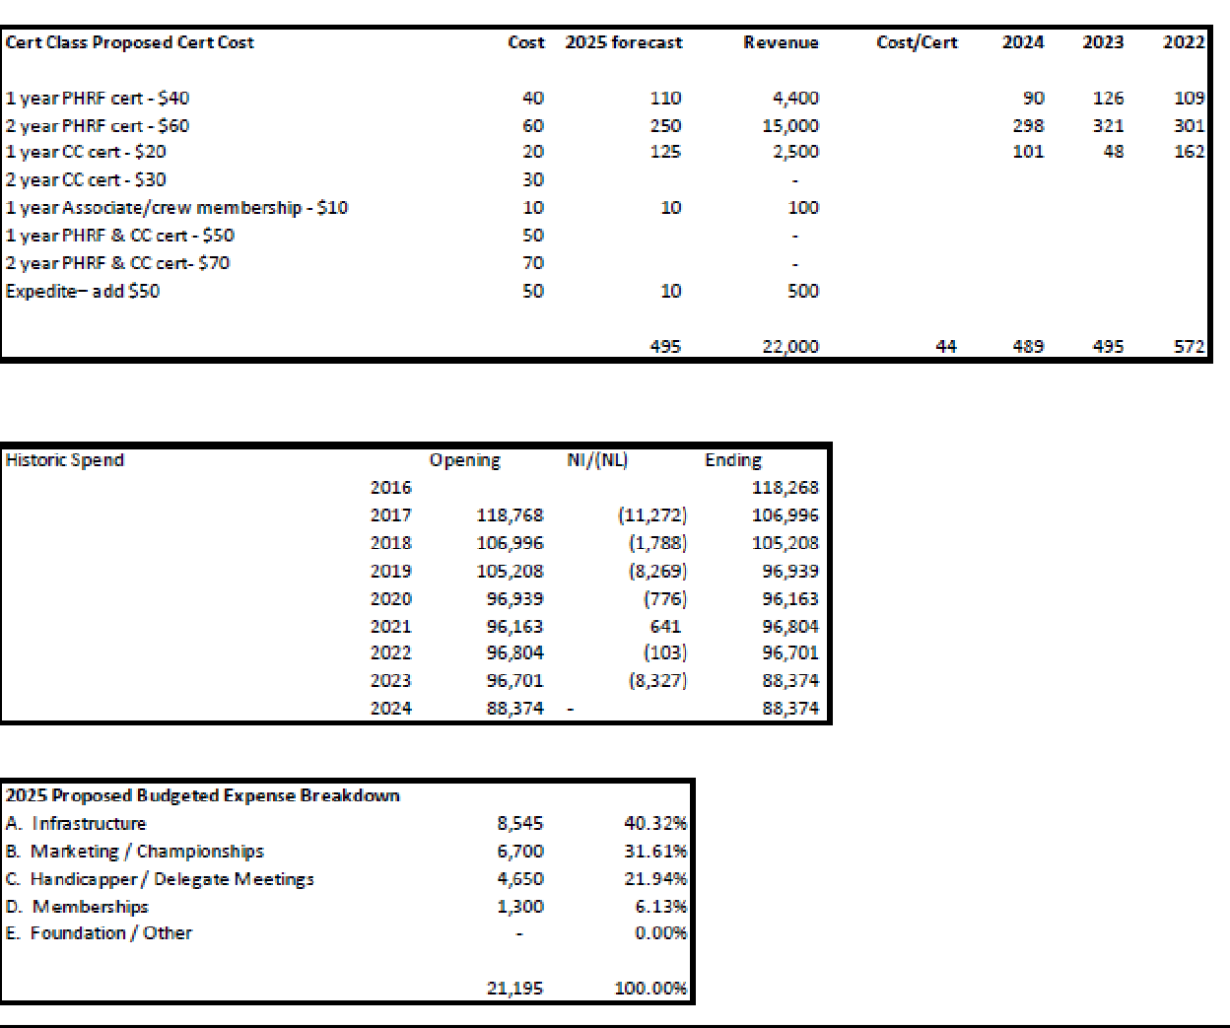

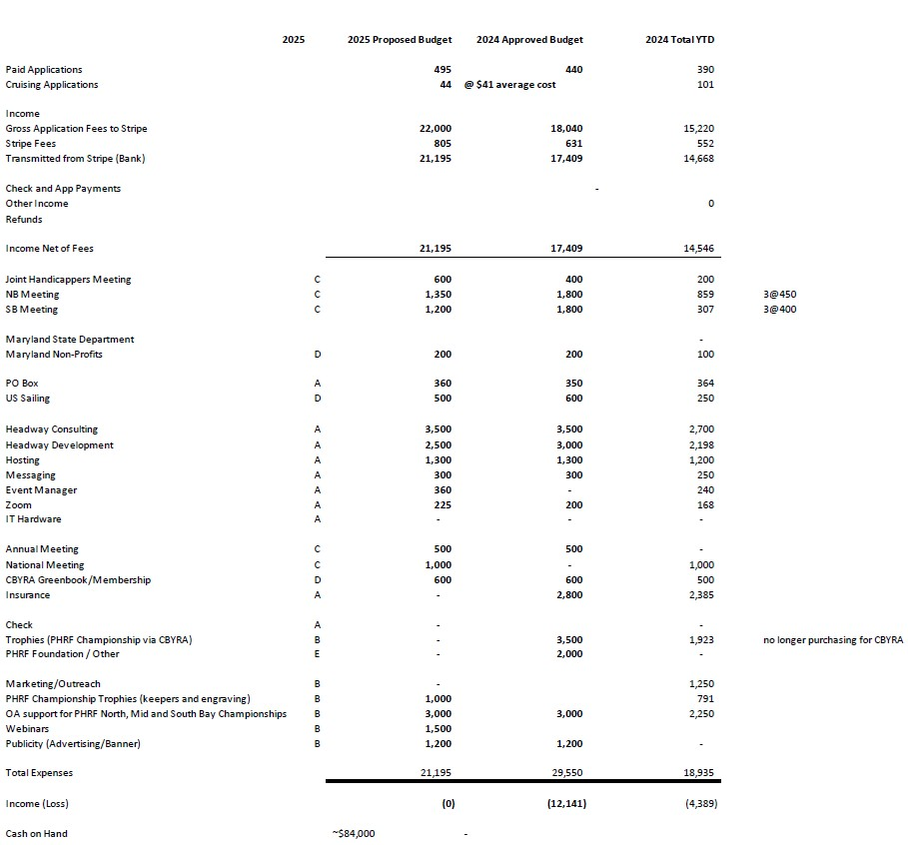

Respectfully Submitted,
Jim Raper
Treasurer
PHRF of the Chesapeake

Jim commented that the early investments our association made in web-certs were invaluable in increasing accuracy, significantly improving certificate issuance timeline and in so doing, membership value. There was a two year transition to the system we have today and despite its minor quirks, “it’s just better”. Jim brought up that the association’s 3 year investment in establishing and growing the Cruising Class by not charging for memberships/certificate processing will eventually prove to be worth it but it has reduced potential revenue by several hundred certificates. The growth of the Cruising Class is exemplified in the Fishing Bay CC start of 15 boats. Jim recommended a budgeted investment in marketing, noting that his research indicates 25% of non-profit operating revenue is a common ratio allocated to marketing and communications. Pat has been our champion of sponsoring PHRF championships in the bay by partnering with Organizing Authorities on the bay’s larger and more popular events in each region. He noted that we managed our way through COVID and consistently issued 500 certs (representing 500 membership renewals) annually. We have given our membership more options and different price points for certificates/memberships. Our revenue forecast for 2025 is conservative and does not constitute a risk to our operating budget. We need to do a better job of expense management to align with budget, however, we have not increased our cost per certificate over the past 10 years while operating expenses have increased considerably. We have the potential to have a positive operating budget for the first time in half a decade. Several delegates contributed to the discussion and agreed that it’s probably time for an increase in revenue. Only one delegate provided negative feedback on the increase in revenue. The financials discussion and the rationale for changes proposed in “new business” were well received.

Next up was the CBYRA Representative Report by Randall A. Richter
Early in 2024 the then President of CBYRA resigned due to personal medical issues. Mr. Josh Colwell the then Racing VP assumed the role Acting President as provided for in the CBYRA bylaws. While the transition was unexpected and gave Mr. Colwell no time to prepare for this transition, he has worked rigorously to provide excellent leadership.
CBYRA has continued to work this year as the unifying force of sail racing on the Chesapeake Bay. It has provided scheduling oversight to ensure that races are scheduled in an organized manner. It has also provided to clubs a vehicle for announcing upcoming races to all CBYRA members.
CBYRA has provided grants totaling more than $16000 to bay sailors and organizations to allow travel to distant regattas and the operation of major sailing events on the bay. Examples of these include the J105 Women’s Regatta, Pan American Games travel, Multiple Optimist North Americans Travel, J22 Worlds, Ware River One Design Regatta, Opti Green Fleet Clinic, Harbor 20 and others I have probably forgotten.
CBYRA also rolled the automated High Point scoring software this year. CBYRA is currently working through some kinks and twists in the system. Some issues encountered have to do with variations in the skippers name, boat name and sail numbers provided during registration. Continuing, with the high point theme CBYRA provide high point trophies and a winners reception for member classes.
Finally one of CBYRA’s biggest efforts is to provide continuing education to its members. It provide multiple seminars by Dave Dellenbaugh and others, which help members improve their racing. Additionally, CBYRA continues to support educational seminars and classes for race officers and judges to improve the quality of club race committees
Respectfully Submitted,
Randall A Richter
CBYRA Representative

In addition, Randy brought up the Judge and RC Seminars scheduled for the off-season, this winter. It was initially discussed that these would be done in January which was updated by Bruce that the Advanced Race Officer seminar would be held on the 1st weekend of March hosted by AYC and performed by Bruce Bingman and Taran Teague. The Basic Race Officer course will be hosted by EYC in February. Presenters were not identified at this time.

Next up was our PHRF of the Chesapeake Representative to US Sailing Report by Bruce Bingman
This was the Olympic year, so many of the activities of US Sailing were focused on the Olympics. Prior to the start of the Olympic Trials, as a result of internal disagreements, Paul Cayard was replaced and the responsibilities of fund raising and coaching were split. This resulted in loss of some donated funds as well as some ripples through the preparations for the Games. Fortunately, the US was able to secure one medal – a bronze in the 49er class - although there had been hopes for several more. Following the Olympics CEO Alan Ostfield resigned to transition to an advisory role and a personnel search is now underway for his replacement. Plans are now beginning to switch to the west coast and preparations for the 2028 Olympics in Los Angeles.
US Sailing key executives visited Annapolis in May and held a “Town Hall” meeting with several presentations on inshore and offshore racing as well as a number of meetings were held with individuals discussing the path forward. This included a presentation by Jim Teeters, the head of the US Sailing Offshore Office where he discussed the US Sailing vision for handicap racing with PHRF as the basic rule for most casual regattas and the measurement for the higher level and championship regattas.
In this regard, the Offshore office continues to support issuance of ORC and ORR certificates and push coordination between the various PHRF regional groups. The offshore Office along with the volunteer Offshore Committee is planning an incentive to renew emphasis in a strong numerical-statistical basis for PHRF and Portsmouth which are seen as the key pathway to get more new sailors introduced to racing. As you are aware, we recently held the “Two Bridge Fiasco” in Annapolis which successfully blended Portsmouth and PHRF using formulas I developed to allow boats from a 14’ cat boat to a J122 to successfully compete. The winner was a Viper 640 followed by several keelboats and dinghies. I will be presenting sessions at the upcoming (February 2025) National Sailing Programs Symposium in San Diego on handicapping and on alternative racing formats and development of formulas for empirical handicapping.
The rule book is updated every four years following the Olympics, thus a new book will be issued in January and the new rules will take effect on January 1, 2025. There have been some fairly extensive changes in protest and procedure areas as well as changes in the obstruction rules and tweaks to rule 18 and other Part 2 rules. It will be important for PHRF and CBYRA to sponsor seminars and classes to familiarize our sailors with the changes. Currently I am scheduled to teach an Advanced Race Management class the second weekend of next year - it will be available for sign up shortly.
The US Sailing by-laws were last updated several years ago and require a comprehensive review as we enter the next quad. A new US Sailing board member, Bob Kottler, is a local sailor and will be joining US Sailing as well so we will have good representation.
We recently held the US Sailing Team Race National Championship out of Severn Sailing Assn and will be holding the Intercollegiate National Championship (McMillian Cup) in the Fall at Navy.
Miscellaneous other business including appointment of a temporary secretary, increasing the size of the Finance committee, and submittal of a new rules case interpreting “first reasonable opportunity” were also passed.
Year to date, both income and expenses are running below original projections and are showing a slight loss. The largest loss is in the area of Olympic operations driven primarily by the loss of several major Olympic donors and smaller donors not fulfilling pledges. A strategic planning meeting was held to determine key strategies for 2025 as well as looking for sponsorship.
Membership continues below goals, particularly in the area of renewals. The membership office will begin testing renewals by mail to see if response is better than with electronic notices. They are also testing issuance of printed membership cards including any certifications held by members.
The Offshore office has been primarily focused on certificate issuance of various measurement handicap certificates and attempting to reconstruct the PHRF member organization coordination. To date over 700 ORC club, 400 ORCi, 225 ORR and 76 IRC certificates have been issued. The number of certificates was likely driven by the ORC worlds recently completed in Newport in 2024. With the combination of the Annapolis to Newport race and the Block Island Race Week next year, the office expects to issue over 1500 total certificates next year. It was also noted that ORC has begun to apply increased effort in the area of older (pre-2005) boats to improve their competitiveness. US Sailing continues to recommend use of PHRF without complex wind indexing for entry and club level competitions both from an ease of competitor to understand and ease of local clubs to use correctly. The office is also planning a “Roadshow” to better explain the rules and how they should be used by local committees. The office continues to solicit input from local areas and will assist them in application of empirical handicapping.
In the areas of race administration and judging, calendars are already beginning to schedule training seminars in 2025. The seminars are now a combined on-line/classroom format that allows an increase in scope of the material covered. US Sailing has now posted the Race Officials/Organizing Authority Connection Board which allows member officials to register and member organizations to find officials for their events.
The World Sailing Annual meeting will occur in November and will vote on the final changes to the Rule Book which will then be the standard for the 2025-2028 quad.
The US Sailing Leadership Forum and selected committee meetings will be held February 6-8 in San Diego with focus areas in race management, community sailing development, on-water safety, fundraising, and coaching.

Regional Sailing Association (RSA) end-of-year recap:
Andrew Clouston, VP of US Sailing presented an update of finances, membership, and services. He noted that 450 volunteers serve on over 35 committees. He emphasized that US Sailing’s primary interaction with the sailing community is through the RSA and Organizational (such as PHRF of the Chesapeake) memberships.
Matt Hill, Director Race Administration noted that the Race Management classes are being updated to reflect the new rules and will be ready for roll out on the first of the year.
Betsy Allison, Director of Adult Programs discussed the US Sailing desire to increase communication between the RSA’s and the US Sailing Championship Committees to improve competition and attendance at the adult championships. Two areas were highlighted: 1. The need for matched fleets of “conventional” small boats (as opposed to “Sport Boats”); 2. Better advertisement and communication of the championships.
Respectfully Submitted,
Bruce Bingman,
CBYRA/Area C and PHRF delegate to US Sailing
PHRF of the Chesapeake

Next we had our Northern Bay Chief Handicapper’s Report by Dan Trammell
The Northern Bay Board of Handicappers held monthly meetings from January through October in addition to a joint meeting with the Southern Bay Board of Handicappers in March.
Most of our meetings were virtual mainly because of the convenience to our handicappers who are scattered all over the bay. We conducted much of our business by email which was convenient especially early in the year when we had far too many applications to consider at a single monthly meeting. Our in-person meetings are valuable when we can arrange them. Less practical in some times of the year. Many applications are processed and coordinated within a week, depending on backlog.
We issued the majority of valid certificates within a week of the application date when they were simple renewals with no missing data or errors. If the applications were missing information the local handicapper contacted the applicant which delayed the issuance of the certificate. Applications that were delayed for any reason were all handled at the next monthly meeting. In a few instances where the local handicapper was informed that the applicant needed the rating before the next scheduled meeting, we issued a provisional rating and confirmed or modified it at the next meeting. We also promptly processed somewhere north of a dozen requests where expedited processing was requested.
I had the opportunity to speak with many of you during the year about your ratings either over the phone or at an after-race social gathering. Our discussions were about boat preparation, condition of the sails, crew work and last but not least tactics. As I am sure you are all aware PHRF rates boats with the assumption that the boat is well prepared for racing with good sails and with a good clean bottom. When I hear that the boat was cleaned twice a year or every other month, for example, I point out that they cannot expect to complete with a boat that is cleaned before every race and cannot expect the handicappers to gauge just how the difference between a clean or fowled bottom would affect the speed potential.
Our handicappers continually make on-the-water observations of the fleet and review race results to confirm our ratings or see if a change is indicated. If we see a problem, a handicapper appeal is entered to see if a change is warranted. If both the Northern and Southern handicap boards approve a change after hearing any input from our members, the change is made. We follow the same process if any of our members provide evidence that we have the rating incorrect for any boat in the fleet. This timely response is a huge advantage that PHRF has over other rating systems that require a modification of the formula to effect such a change.
It has been my pleasure to serve as the chief handicapper of the Northern Bay Board of Handicappers. I continue to be impressed by the depth and breadth of knowledge of the handicappers on the committee. We hope to continue issuing fair and reasonable ratings for the fleet in the coming year.
Respectfully Submitted,
Dan Trammell,
Chief Handicapper Northern Bay
PHRF of the Chesapeake

Dan reiterated that our club handicappers observe boat performance at club and inter-club races including how boats are prepared, sailed and perform. Our member have an advantage over measurement rules where they are allowed to appeal their ratings and have objective rating discussions with handicappers that could lead to handicapper appeal of ratings or owner appeals. PHRF follows the scientific method of categorization of newly rated boats by aligning/comparing characteristics of the new boat with other boats we’ve already rated. We look at the characteristics of the boat that objectively affect performance which allows us to fairly rate boats with significantly different designs. This differs from two of the more popular VPP based rating systems, ORR and ORC whose algorithms favor boats with large mainsails, fractional/non-overlapping jibs and large asymmetrical spinnakers on centerline sprits. There was an active discussion amongst delegates that noted the unfamiliarity many members have with the appeal process and the effectiveness of owner-rating appeals. Dan suggested we advertise/market our rating appeal process including description of the method of review and the effective use of objective evidence to sway the appeal consideration. Dan also brought up that while membership continues to raise the issue of dry sailed boats vs wet sailed boats, handicappers contend that they have included the dry sail performance for type/model/series boats that are usually dry sailed throughout the bay and further penalizing them for being dry sailed will not improve the fairness of racing for all members. It was discussed that appeals for boats that consistently out sail their ratings are very important to our fleet. Dan and Alan brought up that the timing of an appeal and the quality and objectivity of the evidence provided can affect the turn-around time for 1st and 2nd readings as well as giving some time for competitors to submit input. Dan and Alan requested an update to our website to make it easier to see submitted appeal status and to facilitate applying for an appeal. Clubs and members don’t know or understand the process, the data requirement and the time it takes for handicapping boards to process the information provided and supplement with other evidence that might be available in order to come up with the most reasonable analysis supporting the handicapping boards’ decision. It was also brought up that our members should understand what initiates handicapper appeals and how they have helped ensure fair racing amongst our classes. Pat will provide a short article for handicapping board review prior to publication in Spinsheet and our newsletter. Dan and Alan will provide a detailed writeup to be added to our website describing the attributes of well-prepared and the pitfalls of poorly prepared rating appeals. Delegates and handicapping Chiefs also discussed that we should publish general rules or prescriptions for Organizing Authorities when setting up courses for racing and cruising starts.

Next up was our Southern Bay Chief Handicapper’s Report by Alan Bomar.
In 2024 the Southern Bay had a good year, collaborating with the Northern Bay. We appreciate Dan and his board
In 2024, Doug Bird resigned from our team, and we added Bob Fleck. We thank Doug for several years of input and guidance in assigning and evaluating sailboat ratings. We welcome Bob, and his experience sailing and building winning racing programs to the SB Board of Handicappers.
The SB processed a lot of cruising ratings. This has brought many sailors into PHRF racing. While i skeptical of the Cruising Class in the past, I report that I believe it has been good for our efforts to promote sailing.
The Headway system allows us to process certificates quickly. It is an excellent tool for PHRF of the Chesapeake. I encourage the delegates to support upgrades to the application database including a form to capture handicapper meeting minutes and action items (e.g. appeals, & review by the SB/NB board)
I look forward to supporting PHRF of the Chesapeake in 2025.
Respectfully Submitted,
Alan Bomar
Southern Bay Chief Handicapper
PHRF of the Chesapeake

Alan also brought up that PHRF handicappers rate boats without counting “extra stuff” that are considered to be the value of CRCA’s tweaks to the ORRez VPP handicaps. The reality is that the cruising class is “self leveling” as long as we keep the trophy hunters out using our handicapping thresholds for SA/D, sail types, D/L, etc. We use comparable objective evidence methods to rate cruising class boats against other cruisers. Since most of the cruisers don’t strip down their boats prior to racing, like PHRF racers do, there is enough “extra stuff” on those boats that they are competitively rated. Alan also brought up that our website needs to add a form to facilitate the capture and publication of meeting minutes for our handicapper boards limiting the manual process we currently follow. Much of the information in the minutes are contained in the certificate system, only administrative data needs to be captured and saved to a restricted area of the website. There was also a cruising class discussion with a general consensus that the current cruising class is much better set up, understood and accepted than the Corinthian Class we used to have in our fleet.
New Business

Proposals for the 2024 Annual Meeting

- It was noted that our by-laws do not contain much guidance or restrictions on corporate governance. This topic is one of many similar topics we may want to consider including in our by-laws in the future. In order to limit the ability of this or any future board to spend from the financial reserves, Jim proposes the following Bylaw Change – “No budget shall be presented for approval by the Treasurer to the organization's delegates which results in an estimated cash on hand reduction of more than 10% for any fiscal year; without first presenting the justification for such expenditure in a preceding separate action approved by 2/3 of the votes represented by the delegates present at the annual meeting with quorum representation where the budget is to be presented. If the motion to approve the excess expenditure is defeated, the budget will be revised to eliminate the overage prior to submission for approval.” The proposal was moved for a vote, seconded and voted into effect unanimously.
- Rating Certificate Pricing for 2025 logically followed the old business treasurer report and discussion. Like everything else our operating costs have gone up and to avoid operating with a deficit in alignment with the first order of new business (above) the need for a modest increase in certificate/membership fees is warranted and necessary. For new and renewals for 2025 the following is proposed:
  - 1 year PHRF cert - $40
  - 2 year PHRF cert - $60
  - 1 year Cruising Class cert - $20
  - 2 year Cruising Class cert - $30
  - 1 year Associate/crew membership - $10
  - Expedite– add $50
There was a proposal to vote and a discussion of to proposed discounted certificate categories for those who have both Cruising Class certificates and PHRF certificates. After discussion it was decided that most cruising class owners do not desire to race in PHRF and most PHRF certificate owners do not qualify for Cruising Class certificates. The majority of our membership fall into these two categories. After revision the fee structure for the 6 categories above were proposed, seconded and voted on with the overwhelming majority voting in favor of the change – carrying the motion.

- Mayo brought up that the population of Sports Boats in our fleets can not justify their own class or starts for most club-level events. This topic was brought up by delegates and members in multiple regions as a detractor to participation by non-sport-boats when high-performance sport boats register to race. In larger events, when participation is high enough to warrant separate starts, we will provide the following guidance to Organizing Authorities to equitable provide sport boats a venue to race against other sport boats. – Proposal was mad to Delete current sport boat class rule and add the following:
“ Sports Boat is a sub-division of the Class A and may be declared by the OA when in his opinion it fits the venue and participants. Being in the class shall be if either the 100% Sail Area/displacement or Downwind Sail/Area/ displacement as shown on the PHRF certificate exceeds the selected one of the below criteria:
- Upwind 100% Sail Area/displacement exceeds 32 or downwind exceeds 110
- Upwind 100% Sail Area/displacement exceeds 30 or downwind exceeds 100
- Upwind 100% Sail Area/displacement exceeds 28 or downwind exceeds 80
Several delegates contributed to the discussion of mixing true sport boats and sporty boats with displacement boat. It was decided that this was one part of the fleet’s solution to giving sport boats a way to race in PHRF but we had to ensure sport boat participation did not have a significant negative impact on fleet participation of non-sport-boats. The motion was made and seconded, discussions were had and the change was unanimously voted into effect.

- 2025 PHRF Class Splits- After several discussions with CBYRA based on unsatisfactory class participation in subdivided classes in PHRF followed by discussions with both handicapping boards on equitable performance breaks and number of active boats at those splits, Mayo proposed we consolidate to common class splits and have only one A class for High Point. Individual OA’s my sub- divide class as fit for the venue. Any venues with separate Sports Boats class shall have the results incorporated into their normal class for High Point.
  - For regions 1,2,3, 4 North
    - A – up to 109
    - B – 110-148
iii. C – 149 and up
  - For region 4 South
    - A – up to 99
    - B – 100-148
iii. C – 149 and up
  - All Regions
    - Cruising Class Spinnaker
    - Cruising Class Non-spinnaker
    - PHRF Non spinnaker
The motion was brought up and seconded, discussions were held and after some edits the above splits were agreed upon and voted unanimously into effect.

- PHRF has historically supported charity events whose participants include one-time racers or cruisers. We have done this by providing “courtesy ratings”. Mayo proposed we add the following verbiage to codify the topic of Courtesy rating for our members and Organizing Authorities.

Courtesy Ratings – A local PHRF handicapper may issue courtesy ratings for events. Courtesy ratings cannot be issued for Sanctioned or Championship event classes. The courtesy rating shall be the base rating without any credits or penalties. The Handicapper shall encourage and help the recipient to obtain an official PHRF rating so they can take advantage of any credits due.

The proposed changed was motioned and seconded for a vote, discussions were held, and after minor adjustments to verbiage the motion was unanimously voted into effect.
- Proposal to modify club assignments to CBYRA Regions was withdrawn by Randy.
- There was a motion to integrate CHESSS into the northern bay classes. President of CHESSS noted that the organization is charging membership fees principally for carrying Officers and Directors insurance. Since CHESSS uses assigned PHRF handicaps and has a simple set of class descriptions comparable to our Cruising Class rules, it would serve the shorthanded and singlehanded sailors better for CHESSS to be a shorthanded class in the PHRF Fleet rather than a separate legal entity. Mayo proposed to establish a special committee to research and provide feedback to the delegates for a vote on the subject after the annual meeting is adjourned.

- Jim proposed the following Budget for 2025. This includes the changes that CBYRA is paying for high point trophies and accounts for changes to certificate pricing and forecast of renewals.
There was a motion and second to approve the budget and with a short discussion for clarification the budget was unanimously voted into effect for 2025.

Next was the vote to elect the proposed slate of officers to administrate and manage the association for 2025. The slate of proposed officers are as follows:
President - Mayo Tabb
VP Northern - Nelson Pemberton VP Southern - Greg Cutter
VP Communications - Pat Seidel Treasurer - Jim Raper
Secretary – open

There was a motion which was seconded and with only short discussion the motion to elect the proposed slate for 2025 was unanimously voted into effect.

Subsequent to the election, Mayo Tabb, our president for 2025 made the following Appointments for 2025:
PHRF Representative to US Sailing Offshore Council – Bruce Bingman
PHRF Representative to CBYRA – Randy Richter
At large representatives to High Point committee – Randy Richter
Standing Nominating Committee – Randy Richter (chair), Jim Raper, Allen Bomar, Dan Trammell

Our 2 VPs made the following VP Appointments for 2025:
Chief Handicapper, Northern Bay – Dan Trammell
Chief Handicapper, Southern Bay – Alan Bomar

Meeting was Adjourned at 2pm by Mayo Tabb - Thank you for attending! Have a great holiday and a happy new year! See you on the water in 2025.

