TENNESSEE VALLEY/ALABAMA REGIONS
SEDIV TIME TRIALS
CHAMPIONSHIP EVENT, TT School & PDX
September 23-24, 2017
TALLADEGA GRAN PRIX RACEWAY
Sanction # 17-TDPDX-4771-S /17-TTTT-4772-S

Chief Steward Spike and Clayton Pannell Registrar Serena Calhoun
Safety Steward Robert Russom Chief Instructor TBA
Race Chair Delanie Calhoun

Talladega Gran Prix Raceway is a 1.41-mile road course located on Alabama State Highway 21, 12 miles south of Oxford, Alabama, and 8 miles north of Talladega, Alabama. Overnight camping is permitted. The track has showers, restrooms, compressed air, and electrical hook-ups. Electricity is available through Talladega Grand Prix Raceway for $20/day per 110v outlet, $30/day per 30A and $50/day per 50A outlet. Race fuel is not available on site so plan accordingly. The track gate will be locked each evening at 10:00 p.m.. The track concession stand will be open for breakfast and lunch, Saturday and Sunday from 7:30 a.m. until 2:00 p.m.

Event Headquarters will be at the Track.
TGPR, 46 Pilgrim Lane, Munford, AL 36268 www.tgprace.com

There are several very nice hotels located 12 miles north of the track, in Oxford, AL.
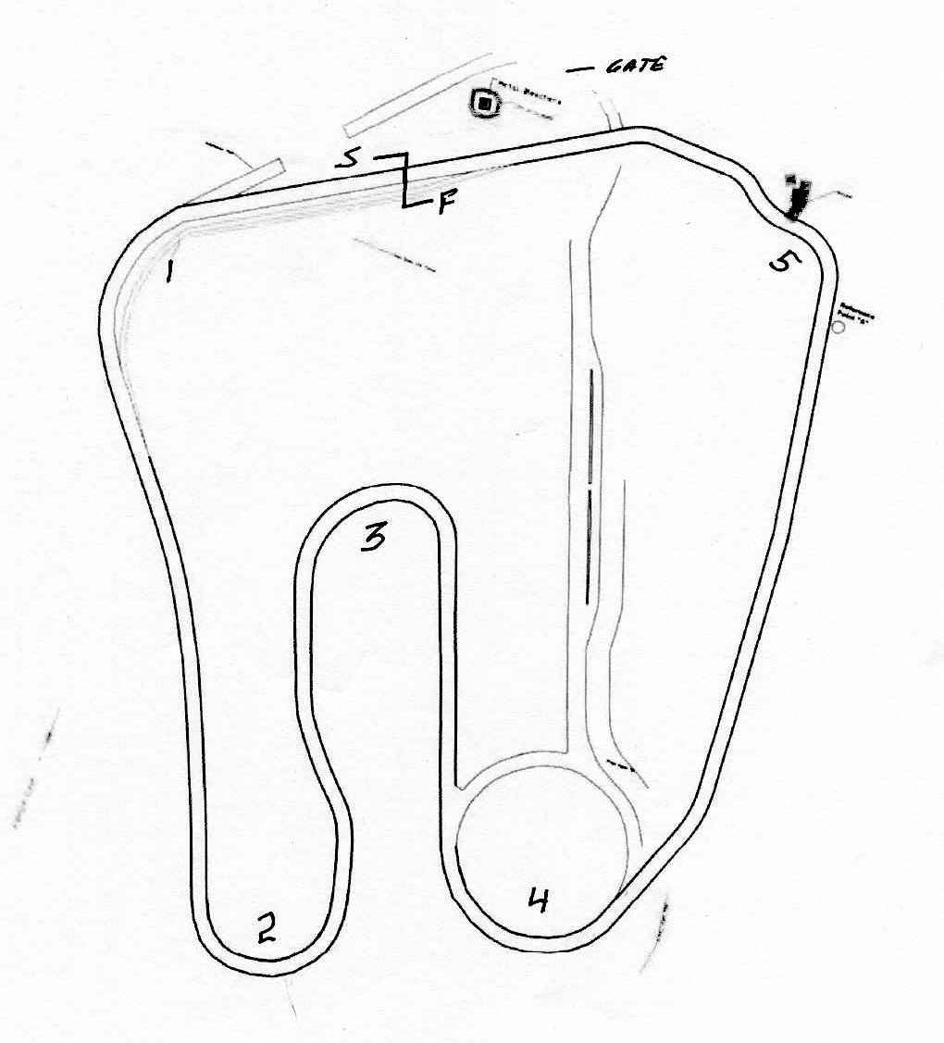

7

6
Passing Zones

Tennessee Valley/Alabama Region of the SCCA Official Entry Form
5
SEDiv Time Trials Championship Event, TT School & PDX
Talladega Gran Prix Raceway – Sept. 23-24 -- Sanction # 17-TDPDX-4771-S /17-TTTT-4772-S

======================================================================================
GCR Classes: FA, FB, FC, FE, FF, FS, FST, FV, FM, F5, ASR, P1, P2, SRF, SRF3, LC, STU, STL, GT1, GT2, GT3, GTL, AS, EP, FP, HP, T1, T2, T3, T4, ITA, ITB, ITC, ITR, ITS, Spec Miata, SM5, B Spec
Regional/TT Classes: SPECIAL (SP), VO, VC, CF, SPO, SPU, GTA, IT7, IT7R, ITO, SU, SMSE
SOLO Classes: SSP, ASP, BSP, CSP, DSP, ESP, FSP

Note: TT and PDX Groups will be adjusted race day to even out run groups.
======================================================================================

FRIDAY, September 22
5:00p – 8:00p Registration & Tech @ the Paddock Building
7:00p - 8:00p PDX & Time Trials Overview in Paddock Classroom
10:00p Track Gates Closed for the Night

SATURDAY, September 23
7:00 am Gates Open at Track
7:00 - 10:00 Registration and Tech at Paddock Building
7:15 TT & PDX Instructors Meeting in Paddock Building
7:30 WORKER’S MEETING BEHIND Paddock Building
7:30 DRIVER'S MEETING Front of Paddock Building
8:00 - 8:30 TT & PDX Student Classroom Session in Paddock Building
8:00 - 12:00 PDX and Timed TT Runs by Group
TT & PDX Student Classroom Sessions scheduled as needed in Paddock Building
12:00 – 1:00 Lunch
12:30 – 1:00 TT & PDX Student Classroom Session in Paddock Building
1:30 – 5:00 PDX and Timed TT Runs by Group
TT & PDX Student Classroom Sessions scheduled as needed in Paddock Building
5:00 - 5:30 TT & PDX Student Classroom Session in Paddock Building
5:30 Social
10:00 Track Gates Closed for the Night

SUNDAY, September 24
7:00 am Gates Open at Track
7:00 - 8:30 Registration and Tech
7:30 WORKER"S MEETING BEHIND Paddock Building
7:30 DRIVER'S MEETING at Paddock Building
7:45 - 8:15 TT & PDX Student Classroom Session in Paddock Building
8:00 - 11:00 PDX and Timed TT Runs by Group
TT & PDX Student Classroom Sessions scheduled as needed in Paddock Building
11:00 - 12:00 Lunch
11:30 - 12:00 TT & PDX Student Classroom session in Paddock Building
12:00 - 4:30 PDX and Timed TT Runs by Group
TT & PDX Student Classroom Sessions scheduled as needed in Paddock Building
4:30 TT & PDX Students meet with Chief Instructor for Final Review
7:00 Track gates closed for the weekend. All participants must be off the premises by this time.

SUPPLEMENTAL REGULATIONS
Sanction #17-TDPDX-4771-S /17-TTTT-4772-S

The Following Regulations Pertain to TT and PDX Events.
This event will be held under the 2017 SCCA General Competition Rules (GCR) and the latest SCCA Time Trials Rules (TTR) as amended by the SEDIV Time Trials Rules and SEDIV TT Class Rules. Further amendments may also be published in these Supplemental Regulations.
REGISTRATION: Register on www.motorsportsreg.com. Payment (Cash, Check, Credit Card) will be accepted at Registration. For questions contact: Delanie Calhoun (delaniecalhoun@gmail.com). Make check payable to “AL SCCA”. Late entries will be served at Registration, as per the schedule. A $50 fee will be charged for any check returned by the bank. A full refund will be made if the entry is withdrawn prior to tech. A $50 fee will be charged anyone who does not withdraw and is a no-show.
Event Schedule/Run GroupS: The event schedule or run groups may be changed at the discretion of the Chief Steward, with concurrence by the Race Chair, depending on pre-race entry counts or as needed to accommodate situations that may be encountered during the event.
PASSING: There will be multiple cars on the course at any given time. Passing will be allowed on designated straights with a point by from the driver being overtaken. The overtaking driver shall not pass without a “point-by” from the driver being passed. Passing shall be started and finished within the designated passing zones as shown herein. The beginning and end of the passing zones will be marked by cones. Specific instructions will be given at the MANDATORY Driver’s Meeting.
Off Course Excursions and Spins: Any vehicle leaving the paved course area with more then two wheels or spinning on course shall proceed safely to the Pit Area for discussion with event officials and/or vehicle inspection after receiving directions to proceed from a flag station.
SCALES are NOT available at this event.
WAIVER: Everyone entering the track must sign both the track and SCCA waiver. Passes must be shown to enter the track. No exceptions.
INSURANCE: Participant insurance will be provided in at least the minimum amount required by the SCCA.
PADDOCK: You may park anywhere in the paddock provided you do not block the main paddock roads, pit entrance, pit exit areas, concession, tower or other specially marked areas. A pit and paddock speed limit of 5 mph will be strictly enforced.
EMERGENCY LANES must be clear at all times for emergency traffic.
INTOXICANTS: Use of intoxicants prior to the end of the day’s events is prohibited. Anyone found to be using intoxicants during the event, or illegal drugs at any time while on the property, will be ejected from the property. Drivers are responsible for their crew and guests.
TALLADEGA COUNTY SHERIFF’S DEPARTMENT PHONE NUMBER IS: (256) 362-2748. In case of emergency, the Sheriff’s Department will contact individuals attending events at Talladega Gran Prix Raceway.
TGPR’S GATES will be locked at 7:00 PM of the last day of the event. Please be off the premises by that time.
GENERAL RULES: The track concession stand will be open for breakfast at 7:00 am and lunch both days. It is recommended that you not bring pets to the track. However, if you do bring your pet, it must remain restrained (leash, cage, pen, etc.) at all times. Do not dump oil, gas or coolant anywhere. Take your fluids home. You must take everything you bring to the track with you when you leave. Use caution and common sense when raising your car and supporting it on jack stands. Part of the paddock area is grass so it is recommended that you use plywood or metal plates beneath your jacks and jack stands. No glass containers are allowed on the property. Anyone riding an ATV or motorized scooter must be a licensed driver and wear a helmet.
Flags and Their Meanings:
- Yellow, standing – You are approaching an incident where your and other’s safety are at risk. The racing surface may be clear but there is immediate danger to you or others if you left the racing surface. Slow significantly and proceed thru the incident at a reduced speed. There is no passing from the flag until past the emergency incident.
- Yellow, waving - You are approaching an incident that has great danger to you and others. The racing surface may be partially or completely blocked. Slow significantly and be prepared to stop. All efforts should be made to proceed through a Waving Yellow Flag in single file order. There is no passing from the flag until past the emergency incident. The no passing zone starts at a perpendicular line across the track from the flag and ends at a perpendicular line across the track from the last component of the incident causing the yellow flag. The last component may be the car, driver, responding officials, other vehicles and/or large debris.
- Red & yellow, striped – there is debris on the track ahead, possibly oil, coolant, dirt, an errant animal and/or parts of a fellow driver’s car. Be prepared to respond accordingly.
- Red – STOP as quickly as safely possible, pull to the side of the track to allow maximum room for emergency vehicles, stay in your car and await instructions from a corner worker. We REALLY don’t want to show this flag!
- Blue / yellow stripe – a faster car is following. Allow it to pass at the next passing zone. Acknowledge the blue flag with a small wave to both the worker and the following car. This courtesy prevents tailgating, mirror driving, and promotes safety and reduces aggression. Observe the Blue/yellow striped flag.
- Black – enter the pits at the next opportunity to consult with an event official.
- Checkered - will only be shown on driver’s left at Starter stand. The session is over. Proceed on a cool-off lap by slowing down and using the brakes as little as is safe. Allow your car and yourself to cool down and relax. Proceed to pit lane and attempt to wipe that silly grin off your face.

The Following Regulations Pertain to the TT Level 3 Only.

TT STUDENTS: Instruction pursuant to obtaining a TT license will be available. If you desire to receive a Time Trials Competition License (eligible to compete at hill climbs), you should complete the Medical History using the "Physical Exam Form for Competition License" www.SCCA.org. Time Trials students will meet with the Chief Driving Instructor throughout the weekend.
TT DRIVER ELIGIBILITY: All Track Trials drivers must hold a SCCA Time Trials License or Time Trials Novice Permit www.SCCA.org. SCCA Club Racing Competition Licenses, as well as competition licenses from other sanctioning bodies per the 2017 GCR are accepted. NASA Time Trial licenses (full) are also accepted.
TT VEHICLE ELIGIBILITY: Open to all vehicles conforming to the GCR, SCCA TTR and SEDIV TTR. Rally cars will compete under the Rally America Rules and will be classed as SPU or SPO. SEDIV Time Trials reserved numbers will be held until March 25. Otherwise, numbers will be issued on a first come, first served basis. For two driver cars, add the numeral "1" to the primary driver's number.
TT HELMETS: All helmets must be SA05 or later. M-RATED OR SA-00 HELMETS WILL NOT BE ALLOWED FOR TT.
TRANSPONDERS: TGPR will have an AMB Transponder loop thus all TT Competitors are required to have a transponder. Competitors without an AMB transponder must rent one for the weekend for a fee of $60.00. Each vehicle renting a transponder will require a special bracket into which the transponder may be quickly attached. If you have not retained your bracket from previous events, they will be available for a small fee. Rental will require a $500 deposit check to be left with registration to assure return of the transponder at the end of the event.
TT TECH: All driver and vehicle safety equipment must meet current GCR and/or TTR specifications for a Level 3 Event. Driver's head/helmet to roll bar/roll cage clearance must meet the requirements of GCR and TTR. Roll bar/roll cage padding is required per the GCR and TTR. Cars must be re-inspected by the Chief of Tech if involved in an incident or if the vehicle is reported as leaking any fluids. Safety gear must meet GCR and TTR requirements. All entrants must have a vehicle log book complete with pictures and log book number. Please fill in the date and event name prior to visiting tech. Arm restraints are required on all open cars. The Championship Event entrants’ technical inspections may be conducted with "roaming" tech inspectors. Cars needing an Annual Inspection must be brought to Tech with logbook, Tech Card, and driver safety gear. Cars with a current Annual Tech will present their logbook and Tech Card at Registration.
TT CHAMPIONSHIP RUNNING ORDER: Groups will be Open Wheel and Closed Wheel as determined by the number of entrants. Groups may be combined at the recommendation of the Chief Steward. Cars will be gridded according to relative times by the Pit/Grid Marshal. An entrant may elect to waive SEDIV TT Series points by checking the appropriate box on the entry form.
PASSENGERS: Passengers are NOT permitted in any racing vehicle unless approved by the Chief Steward.

The Following Regulations Pertain to the PDX Only.

PDX DRIVER ELIGIBILITY: Entrants must be a SCCA member and have a valid state driver's license. If you have an SCCA Time Trial Participation Log Book, please bring it with you. If you do not have one, you will be issued a log book at registration. TT Participation log books must be checked by the Chief PDX driver instructor, or his designee, prior to participation. PDX entrants must wear a sleeved shirt and long pants as well as appropriate footwear covering the entire foot. No open shoes or sandals.
PDX Driver Classification Definition: Novice: One who has never driven their car on a race track or one who has never been signed off to solo at a previous PDX. Intermediate/Advanced: A driver that meets the following criteria falls into the Advanced/Intermediate category - he/she holds: 1) an SCCA Competition license; or a history of tracking events with other SCCA recognized organizations such as PCA, NASA, CHIN, BMW, PBOC, etc. or 2) has an SCCA Time Trials Participation log book that indicates the ability to "solo" and has successfully completed at least 3 SCCA PDX events or 3) receives an entry waiver from the PDX Chief Driving Instructor.
INSTRUCTION: Instructors will be assigned to each entrant and entrants may have an Instructor riding with them. The requirement for a ride along instructor may be waived by the Chief PDX Driver Instructor based on prior experience of the participant. Other than an instructor, no other passengers are permitted unless approved by the PDX Chief Steward. The Chief PDX Driver Instructor reserves the right to ride along with any participant.
PDX RUN GROUPS: PDX cars will be grouped separately and run in group rotation with the TT entrants. PDX entrants may be limited. Sessions will be as noted per the schedule and will be approximately fifteen minutes in length. It is the driver's responsibility to be ready in the Grid area at the scheduled time. Failure to be ready per the schedule may cause the entrant to be prohibited from participating in that session.
Numbers, Classification of Vehicles and Timing: Numbers must be on both sides of the vehicle, be legible and be at least 8 inches tall with a 1.5 inch stroke and in a contrasting color to the vehicle. There will be no designated classes for this event, nor will there be any “timing” of a vehicle during the event. Please provide three number choices. AMB Timing will not be used.
PDX HELMETS: All helmets must be M05, SA05 or later.
PDX VEHICLE ELIGIBILITY: All vehicles must provide factory original (or better) seats that are securely mounted, seatbelts (SFI or FIA rated are recommended), and roll over protection for both driver and in-car instructor (if used).
- Vehicles that are in compliance with road race, solo, rally or time trial rules are allowable. Formula cars are not allowed.
- Hardtop and Targa top vehicles are allowable.
- Convertible vehicles operating with the factory roll over protection system are allowable. Other convertibles must have either a factory hardtop or a 4 point roll bar. If a roll bar is used, it must meet the roll bar requirements found in the TT/HC Driver Information TTR.
- Drivers of open top vehicles should use arm restraints or run with the top up.
PDX TECH INSPECTION: will be held at the track at the times noted in the event schedule. It is recommended that PDX entrants have their vehicle “teched” on Friday. A PDX Tech Sheet is provided herein. You must take your vehicle, along with your tech card and Tech Sheet, to tech inspection.
DRIVERS MEETING: All entrants MUST attend the Saturday and/or Sunday morning drivers meeting. The times and locations are noted in the schedule. Failure to attend will disqualify the entrant from participating in the PDX and their entry fee will not be returned.
FLAGS: Flags for driver notification will be as noted and discussed at the Student Classroom Session. Failure to respond to a flag notification could cause an entrant to be prohibited from completing the remainder of the event.
PASSENGERS: with the exception of an assigned instructor or the Chief PDX Driving Instructor, passengers will not be permitted to ride along with PDX entrants, unless otherwise approved by the PDX Chief Steward.
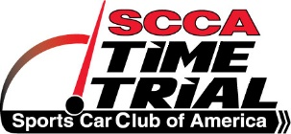 PDX TECH SHEET
Complete this sheet before coming to the track and bring it with you.
Driver: __________________________ Run Group: __________________ Car #: _________
Car Make:_________________ Model:_________________ Color:_________________ Year: _______
The entrant/participant is responsible for the safety of his/her vehicle. Neither the tech inspectors, the event organizers, nor the sanctioning body will be held responsible for the safety of this vehicle. Have a qualified mechanic check over your car and make certain everything is in good working order for an event such as this. Event tech inspectors will inspect those items listed as required. Please have all the items listed above as required items out prior to entering the inspection line, along with this form.

DRIVER SAFETY
____ Helmet (Snell M/SA 2005 or newer, SFI, FIA)
____ Shoes must be solid and in reasonable condition
____ Seatbelts/Harness must be in good condition
____ A Proper ROLLBAR when it is required
____ Rollbar padding
____ Seats bolted securely
____ Interior & trunk clear of loose items

BRAKES
____ Pads are less than half worn
____ Fluid is clear. Reservoir is full. Dot 4 recommended.
____ Pedal is firm
____ All Brake lights are working
____ Master Cylinder/Calipers are not leaking
____ Rotors have no cracks or discoloration

TIRES & WHEELS
____ Adequate tire tread, speed rating, good condition
____ All lug nuts present & torqued
____ Hubcaps removed
____ Wheels - No cracks or structural damage

SUSPENSION & STEERING
____ Wheel bearings - no play
____ Ball joints in good condition
____ No excessive steering play.
____ Shocks - no leaking

ENGINE & DRIVE TRAIN
____ Check all fluid levels, belts, and hoses. Tighten all caps
____ No fluid leaks (oil, fuel, water)
____ Battery secured (no bungees)
____ Battery terminals covered
____ Overflow containers present
____ Exhaust system functional (may have to meet sound restrictions)
____ Throttle has quick, positive return
____ Fuel cap tightened

OTHER
____ Windshield has no large cracks
____ Windshield wipers function properly
____ Outside & Rear View mirrors
____ Car numbers visible on both sides of car

Signed:

__________________________________________________
Driver or Mechanic Date

Tennessee Valley/Alabama Region of the SCCA Official Entry Form
SEDiv Time Trials Championship Event, TT School & PDX
Talladega Gran Prix Raceway – Sept 23-24, 2017 -- Sanction #17-TT-XXXX-X, 17-PDX-XXXX-X

TT ENTRY FORM

Entry: SEDIV Time Trials Championship $300
SEDIV Time Trials Championship & PDX Instruct (2 day) $175
SEDIV Time Trials School & Championship $350
I ELECT TO WAIVE SEDIV TIME TRIALS POINTS
AMB RENTAL TRANSPONDER NEEDED $60 AMB Transponder Rental Fee ($500 Deposit)

MAKE ALL CHECKS PAYABLE TO: AL SCCA Present at Registration

WORKER DONATION $__________ (include with entry check)

Make: _______________________________ Model: ________________________ Color: _____________ Year: _______

AMB Transponder Number: ______________________________ I NEED A RENTAL TRANSPONDER: YES ______ NO ______

Number Desired: 1st Choice: __________ 2nd Choice: _________ Is 1st Choice a SEDiv Time Trials Reserved Number? Yes No

Driver Name: _____________________________________________________ SCCA Member Number: ______________________

Address: _________________________________________________________ Phone: __________________________________

City: _______________________________ State: _________ Zip: ___________ Fax: ___________________________________

Comp. Lic. No. _________________ Grade: _________ Region of Record: __________ Email: ________________________________

I agree to enter under the General Competition Rules of the Sports Car Club of America, Inc., Time Trials Rules and the Supplemental Rules pertaining to this event. I further affirm that the car I have entered complies with all requirements for the class and category in which it is listed above.

Driver Signature: ______________________________________________________________________________________

Entrant Info (If different than driver)

Entrant Name: ___________________________________________________ SCCA Member Number: ______________________

Address: ____________________________________________________________ Phone: ______________________________

City: _________________________________ State: __________ Zip: ___________ Fax: ________________________________

Comp. Lic. No. ________________ Region of Record: __________ Email: _________________________________

Entrant Signature: ______________________________________________________________________________________

In Emergency, Notify:_________________________________________________ Phone Number: _________________________

Address: ___________________________________________________________________________ At Track? Yes No

OFFICIAL USE ONLY

Group No. ______________ Car No. _____________ Class _____________ Postmark _____________ Amount Paid ______________
Cash/Check No. _______________ Driver Lic. No. _______________________________ Exp. Date: _________________________
Comp. Lic. Exp. Date: ____________________________ SCCA No. __________________ Exp. Date: _________________________
Tennessee Valley/Alabama Region of the SCCA Official Entry Form
SEDiv Time Trials Championship Event & PDX
Talladega Gran Prix Raceway – Sept, 2017 -- Sanction #17-TT-XXXX-X, 17-PDX-XXXX-X

PDX ENTRY FORM

Entry: PDX (2 day) $275
PDX Drive & Instruct (2 day) $175
PDX (1 day) $160

MAKE ALL CHECKS PAYABLE TO: AL SCCA Present at Registration

WORKER DONATION $__________ (include with entry check)

Make: _______________________________ Model: ______________________ Color: ________________ Year: ______________

Number Desired: 1st Choice: __________ 2nd Choice: _________

Driver Name: _____________________________________________________ SCCA Member Number: ______________________

Address: _________________________________________________________ Phone: __________________________________

City: ________________________________ State: __________ Zip: ___________ Fax: _________________________________

Comp. Lic. No. ________________ Region of Record: ___________ Email: _________________________________

In Emergency, Notify:__________________________________________________ Phone Number: ________________________

Address: ___________________________________________________________________________ At Track? Yes No

I agree to enter under the General Competition Rules of the Sports Car Club of America, Inc., Time Trials Rules and the Supplemental Rules pertaining to this event. I further affirm that the car I have entered complies with all requirements for the class and category in which it is listed above.

Driver Signature: ______________________________________________________________________________________

Driver Info

Make: ______________________________ Model: ______________________ Color: ________________ Year: _______________

Car Safety equipment: _______________________________________________________________________________________
________________________________________________________________________________________________________

Car Modifications: __________________________________________________________________________________________
________________________________________________________________________________________________________

Driver Experience (Auto cross, Track events (where, how many days), Race licenses, signed off for Solo by what race groups (BMWCCA, Car Guys, PCA, SCCA, etc), Drivers Schools attended):
________________________________________________________________________________________________________

________________________________________________________________________________________________________

________________________________________________________________________________________________________

OFFICIAL USE ONLY

Group No. ______________ Car No. _____________ Class _____________ Postmark _____________ Amount Paid ______________
Cash/Check No. _______________ Driver Lic. No. _______________________________ Exp. Date: _________________________
Comp. Lic. Exp. Date: ______________________________ SCCA No. ________________ Exp. Date: _________________________

