Happy Birthday!!

Vera O. (Aug. 1)

Ms. Iris (Aug 3)

Austin P. (Aug. 4)

Ms. Tiffany W. (Aug 6)

Mirren K. (Aug. 12)

Isabella B. (Aug. 16)

Max F. (Aug. 17)

Ms. Lizbeth (Aug 18)

Chloe K. (Aug. 20)

Ms. Estefany (Aug 20)

Griffin A. (Aug. 21)

Sofie J. (Aug. 21)

Kanae K. (Aug. 22)

Emma A. (Aug. 24)

Ms. Nidia (Aug 27)

Connor M. (Aug. 28)

Beckett L. (Aug. 29)

2018 | August Newsletter

Bright Horizons at   
Columbus Circle News

**From the Director**

Hello Columbus Circle Families-

I hope that everyone is enjoying their summer – it is hard to believe that it is already August!

I would like to thank everyone that took time out of their busy day to join the Family Partnership Group call. This group is imperative in strengthening family partnerships and gathering parent perspectives. Based off our first call, we will be implementing stronger communication tools around staff being away from the center, defining opening and closing classrooms for each day, and how to best address concerns surrounding the stroller storage room. I encourage anyone interested in participating to join the next call!

In September we will be hosting Curriculum Nights – one for our Infant/Toddler components, and another for our Preschool/K-Prep components. This is a great opportunity to learn about World at Their Fingertips® and how it works with each age group to build on individual strengths and talents. We will send out more details soon!

Thank you.

TJ McNamara

Important Dates

August 17th – Parents Night Out

August 21st - Family Partnership Group Call

September 25th – Infant/Toddler Curriculum Night

September 27th – Preschool/K-Prep Curriculum Night

September 3rd – CLOSED for Labor Day

****Bright Horizons at Columbus Circle****

910 9th Ave. New York, NY 10019

212.399.3919 | [columbuscircle@brighthorizons.com](mailto:columbuscircle@brighthorizons.com)

Monday – Friday 7:00 am – 6:30 pm

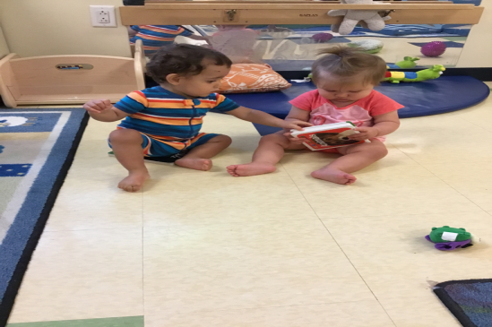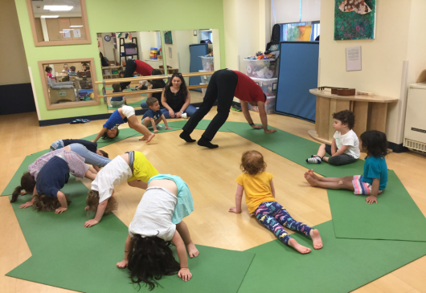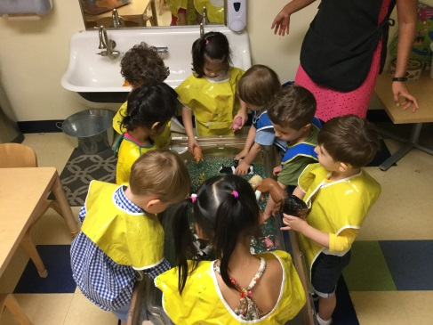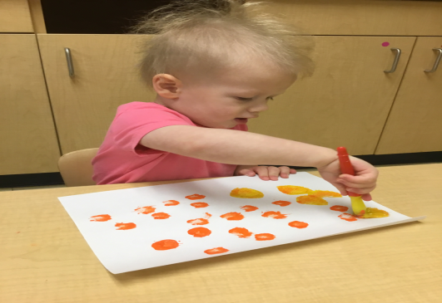

Language Works

The teachers of our Infant component are continually encouraging blossoming language skills. We learn to explore picture books, enjoy book time, intentionally grasp and manipulate books, and improve eye/hand coordination. We learn this by having daily access to age-appropriate books and listening/reading books throughout the day.

Art Smart

Early learning experiences infused with art not only nurture creative and artistic growth, but also enhance development in other areas including literacy, math, and science. Our Toddlers are learning to investigate the world through our senses, experiment with and explore color, and make deliberate markings or drawings – all while strengthening our fine motor skills. We learn this by exploring materials that engage the senses, expressing creativity in our own way without teacher direction, and using developmentally appropriate art materials.

Science Rocks

In the Preschool component, students use their sensory skills to explore their surroundings and identify physical properties such as shape and texture during science activities. Students demonstrate persistence in problem-solving by using their sense of touch to hunt for zoo animals hidden amongst water beads. They ask question words appropriately and sequentially to observe, describe, and purposefully use their sense of touch as a tool to support their discovery of the differences in physical properties between the water beads and the multiple different textures of the varied zoo animals.

Well Aware

Promoting physical development and wellness is a fundamental responsibility of any high-quality early childhood program. We learn to strengthen and refine both our small and large muscle skills, participate in physical activities with peers, and understand multi-step directions. We learn this by engaging in physical activities, such as yoga, and engaging in a variety of cooperative physical games and activities.

CLASSROOM HIGHLIGHTS

Our teachers provide a great education to your children every day and they deserve that same gift in return. We are proud to offer our teachers the best benefits in our industry so they can build a career with Bright Horizons while they continue their education.

On July 11 we launched the **Bright Horizons Early Education Degree Achievement Plan**. Through this new benefit, all full-time employees in Bright Horizons centers and schools are now eligible to earn their associate and bachelor’s degrees in early childhood education completely free with no-out of pocket costs.

Employees are eligible to start on their first day of employment with Bright Horizons. Hundreds of teachers have already signed up to start the program this fall.



Bright Horizons Teachers Can Get Their Degree for Free!

Thoughts of snuggling with kittens and tumbling with puppies make many of us want to bring home a zoo. But then we face reality. How long will the pet be alone every day? Can we afford the cost of food and care? Can the adults in the family deal with one more thing?

All pets require attention and care; however, some pets need less maintenance than cats, dogs, or rabbits. Before considering bringing a pet into your home, learn about its habitat and needs. Also consider the ages, abilities, interests, and schedules of family members.

**Below are a few ideas for lower maintenance (not no maintenance) pets:**

* Birds are social and live predominantly in cages. Many species talk and sing!
* Geckos and lizards are low-maintenance and interesting, but they may not be a good pet for young children because they eat live crickets and require very gentle handling.
* Fish are fun to learn about, watch, and name. Tanks come with lids, which protect them from toddlers.
* Hamsters and gerbils can be cuddly, playful, and amusing; however, they often have short lifespans.

If your child is asking for a pet, explain the reasons you need to say “no.” Starting by discussing what’s involved in caring for a pet teaches children valuable lessons about planning and being purposeful. Also, there are positive aspects to learning how to how to deal with disappointment.

In homes where children grow up happily without pets, family animal lovers can still experience the joy of bonding with and caring for animals by volunteering at a local human society, pet sitting for friends and family, or walking dogs for neighbors.

Is Your Child Begging for a Pet? Alternatives to Dogs and Cats

Ready for school News

BRIGHT HORIZONS NEWS

A Message from Stephen Kramer, Bright Horizons CEO

Bright Horizons Families—  
  
Two weeks ago I wrote to you after my visit to McAllen, Texas to see how the Bright Horizons family could provide support in the face of the heartbreaking crisis unfolding at our southern border. Since then we raised $25,000 through the generosity of our employees and parents in our centers, and mobilized a Bright Space in record time. I’m thrilled to announce that the Humanitarian Respite Center Restoring Dignity Bright Space officially opened last Thursday.  
  
The new space provides a warm welcome for the hundreds of babies, young children, and teens who come through the facility each week. While their parents get legal advice, clothing and supplies, these children now have a place to play, read, interact with caring volunteers and to just be children.  
   
I had some idea of what this Bright Space could be and the joy it could bring to so many children who really need it. The reality is better than anything I could have imagined. From the bottom of my heart, thank you for your incredible generosity and support. This Bright Space would not be possible with it.

With gratitude,  
http://image.info.brighthorizons.com/lib/fe8d13727c66037976/m/1/89d3e5dc-26e9-4093-a226-c2b25124d32e.png

