**From the Director**

Teacher Appreciation Week is specifically recognized May 7 to 11 at Clever Kids although it runs for the whole month. A few special treats will be provided for the teachers who work so hard to create a nurturing, fun, and learning environment for your children. Teachers will also receive those beautiful words of appreciation that many of you sent in at the end of February and early March. Thank you to all who took the time to send those nominations in. The actual awards for some teachers who receive regional recognition are not until August this year. That’s a bit later than usual for Bright Horizons, but we will have to wait!

For children enrolled in Preschool North, East and West, the 13th annual Trike-A-Thon for St Jude Hospital is May 9. There are details on the main entrance bulletin board.

****Clever Kids Learning Center managed by Bright Horizons****

Building 64 Denver Federal Center, Denver, CO, 80225

303-236-9400| [www.brighthorizons.com](mailto:seneca@brighthorizons.com)

Monday – Friday, 6:30 A.M. – 5:30 P.M.

2018 | May Newsletter

News from Clever Kids   
Learning Center

Dates of Closure for 2018

* May 28th – Memorial Day
* July 4th – Independence Day
* Sept. 3rd – Labor Day
* Oct. 8th – Columbus Day
* Nov. 11th – Veteran’s Day
* Nov. 22nd and 23rd – Thanksgiving
* Dec. 25th – Federal Observance of Christmas

Classroom Events

* May 7th – 11th – Teacher Appreciation Week
* May 9th – Trike-A-Thon for Preschool North, East, and West (8:30 – 10:30)
* May 11th – Preschool East Pre-K Graduation11:00 – 12:30
* May 17th – Preschool North Pre-K Graduation 3:00 – 4:30
* May 24th – Preschool West Pre-K Graduation 11:00 – 12:30

Preschool North

Written by: Ms. Kim

Oftentimes, in the Preschool/K-Prep classrooms you will see a group of kids playing a board game such as Candy Land or a card game such as Uno. In these photos, four children are playing a card game called, “Spot It” with Ms. C.J. There are five different ways to play. They are playing what is called, “The Tower” in which the object is to collect the most cards. There is always one and only one matching symbol between any two cards in the deck (even though the symbols may be different sizes which is the tricky part). A person needs to call out what the symbol is and quickly grab it to win that card. It’s super easy to play, very fun and there is lots of learning involved! Below are just some of the learning opportunities children get when they play.

First, it is very much a way to nurture relationships. Children learn to use successful strategies for entering into a group of children. They learn it by asking, “Can I play with you?” For example, this game was initially being played with Ms. C.J. and two other children. Others joined in by asking. Secondly, playing games encourages children to develop emotional literacy skills. Children learn to control strong emotions in an appropriate manner. They learn it by using calm-down steps like deep breathing and other strategies with a teacher’s help. This game was used specifically to help one child with that when one child didn’t get the most cards. Finally, children learn to understand one-to-one correspondence when they count how many cards each child collected at the end. There are so many more learning opportunities involved when children are involved in card games such as Spot It!

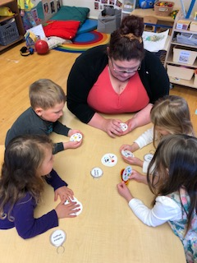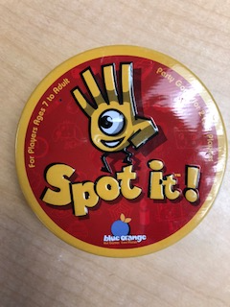

CLASSROOM HIGHLIGHTS

Toddler 2

Written by:

Miss Giovanna Mikou.

The Week of the Young Child was a special week for Toddlers, Parents and Teachers. During the whole week, the main concept was to interact with the parents who came and showed the children new activities ranging from art to cooking to sports activities to science. We played with musical instruments and had a musical parade that allowed children to experiment with instruments and sounds. We have introduced the children to visual arts, music, dance, creative movement and drama. We had physical and sports activities allowing children to develop increased body coordination and balance, yoga, walking, running, jumping, dancing, climbing and stretching skills. Moreover, children learned and were able to follow one-step directions.

We developed mathematical skills (counting and sorting) while making a fruit salad. This allowed understanding and identifying healthy foods and where they come from. We also had the chance to learn about the process of growing vegetables from seeds. Children experienced different textures, exploring materials that engage the senses, expressing creativity on their own without teacher direction. During these activities, children interacted with a familiar adult and were looking for encouragement when exploring something new. They also experienced playing with materials and toys in a group setting.

Having the parents visit allowed us to focus on nurturing relationships and trust with the adults and children in the classroom. We emphasized a harmonious classroom environment by including parents that fostered social and emotional development. We provided positive guidance practices that helped toddlers learn the skills they need to interact with peers and adults. They learned good manners by waiting for their turn. They also explored new relationships and tried new things.

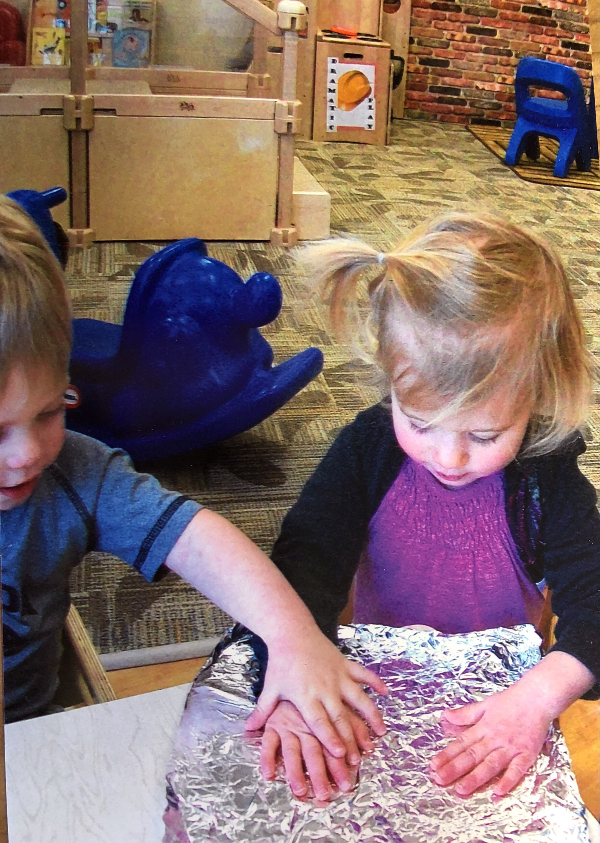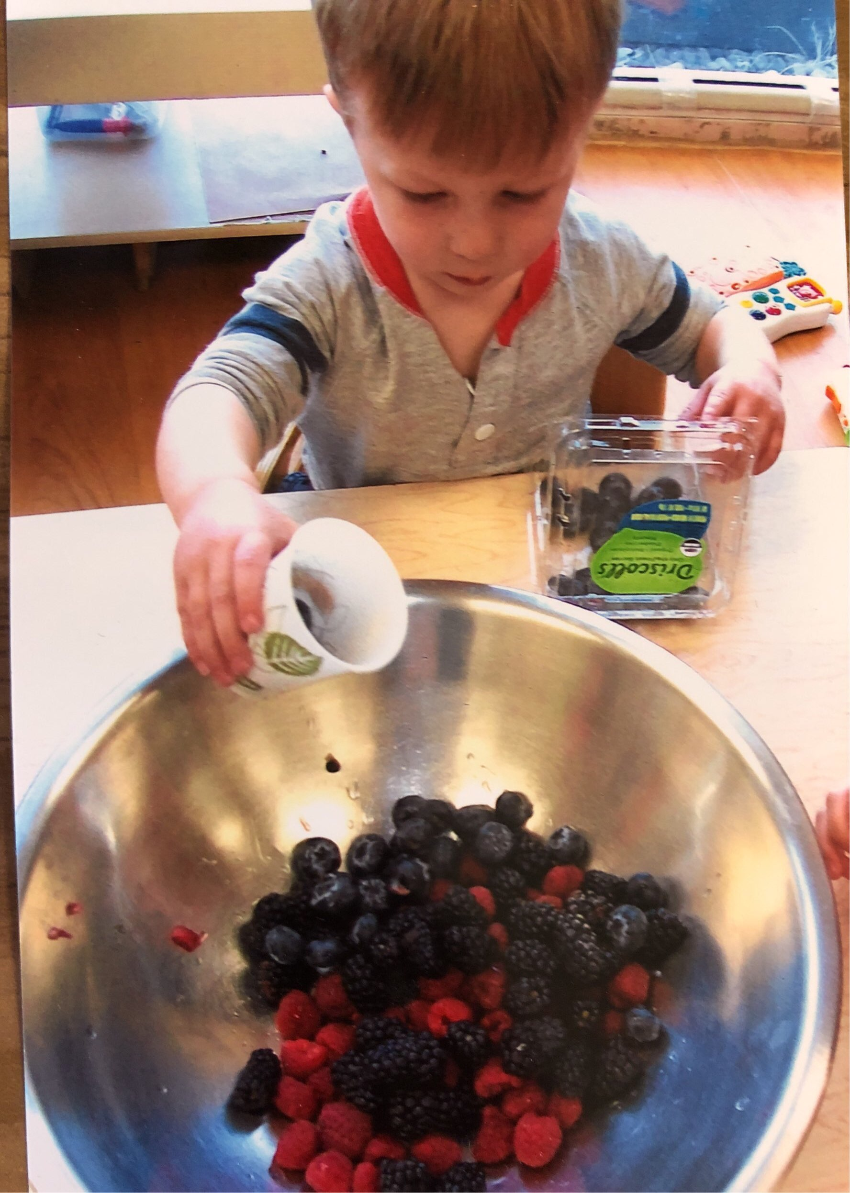

CLASSROOM HIGHLIGHTS

You’ve heard the statistics: one in five preschoolers is obese and the childhood obesity rate has tripled in the last 30 years. At Bright Horizons®, we’re passionate about children’s health and we believe this trend can be reversed. In 2011, Bright Horizons joined the Partnership for a Healthier America (PHA). As part of our PHA commitment, we’re updating physical education training materials for teachers to ensure that children get the physical activity they need every day. We’re also producing a host of resources for families. Building better health is as simple as becoming more physically active, one step at a time. Below are a few ideas for easy family fitness.

**Start a habit.**

Children aren’t particularly interested in why fitness is so important. They are interested, though, in fun family time. Establishing habits of physical activity in childhood paves the way for healthy adulthood. So, try to plan at least one physical activity on the weekend. Go for a walk, play at the park, or head to a pool. Think about building physical activity into your schedule at least three times during the week. This can be as simple as throwing a ball around before dinner or playing a quick game of hide and seek. It doesn’t have to be lengthy or complicated, but you do need to be intentional about it. Write it into your schedule so it becomes a habit.

**Get mobile.**

One of the simplest ways to get more exercise is by ditching the car. Walk, bike, or rollerblade to school, the store, the library – anywhere you can. Some areas are more “walk friendly” than others, of course, but try to walk as often as possible.

**Work it out.**

Family chores are another way to get moving. Raking leaves, weeding a garden, mopping the floor – all these activities get the body moving. Turn on some music and make chores a fun family time. Try to be consistent, as well. When children know that the family will spend an hour every Saturday working together, for example, they’re less likely to balk and more likely to see it as a predictable part of their family culture.





Family Fitness Fun

Ready for school News

Join us in celebrating our teachers & staff!

TEACHER & STAFF APPRECIATION MONTH

The greatest reward a teacher or staff member can receive is knowing that they have made a difference in the lives of children and families. Don’t miss the opportunity to celebrate and recognize all of the teachers and staff who make their classrooms a wonderful place for children and families.

Teacher Appreciation Day is May 8th but our teachers, support staff, and leadership team work hard all year long to make your child’s experience here the very best it can be. Help us celebrate them all month long!

Your thoughts make a difference – and mean a lot to all of us. Take a moment to share any stories, comments, and well wishes for those who touch your family’s life each day.

Visit our Teacher & Staff Appreciation Website to leave a special note of appreciation for your child’s teacher or exceptional staff member. The website will be open from May 1st through May 31st.

**appreciation.brighthorizons.com**





Check out all the places you can connect with us!

